Story of the week
Week Beginning 15-06-2020

This week’s story is called “What Pet Should I Get?” Written by Dr. Seuss
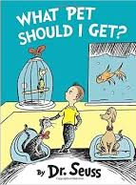
https://www.youtube.com/watch?v=psCzO1TlJlU

What do you think they chose as a pet?
Below is an activity for your child to complete, if they wish and a few special pictures that some of our Hazeldene staff have shared with us.
What is your favourite animal?
Animals
Find out 3 facts about your favourite animal, possibly what food do they eat, where do they live (land, sea, hot or cold countries), can they see in dark?
Get Creative, Please draw us a picture of your favourite animal. You could use pens, pencils, sticks, stones, dried/uncooked pasta, leaves, grass to create your picture (Please be mindful of food waste). Tweet us your picture @HazeldeneFamC
If your favourite animal could be your pet what would you name it?
Use your imagination, to create and build a home for your favourite animal, can you build a bed for your animal to sleep in, remember your animal may need a bowl for food or water, maybe you will need to give your animal a bath. You could use pillows, cushions, blankets, towels, cardboard boxes, milk cartons, sponges. Maybe you could have more than one animal, see if you can create a zoo and you could be a zoo keeper for the day!
Both these activities can be carried out indoors or outdoors.
Curricullum For Excellence: What my child will gain from this experience.
Within real and imaginary situations, I share experiences and feelings, ideas and information in a way that communicates my message.
LIT 0-09a
- Communicates and shares stories in different ways, for example, in imaginative play.
- Uses new vocabulary and phrases in different contexts, for example, when expressing ideas and feelings or discussing a text.

I use signs, books or other texts to find useful or interesting information and I use this to plan, make choices or learn new things. LIT 0-14a

- Finds information in a text to learn new things.
I enjoy exploring events and characters in stories and other texts and I use what I learn to invent my own, sharing these with others in imaginative ways.
LIT 0-09b / LIT 0-31a

- Invents own stories and characters to share with others in play, imaginative and real contexts.
- Shares feelings, experiences, information, messages or ideas in pictures, print or digital texts.

Our Pets

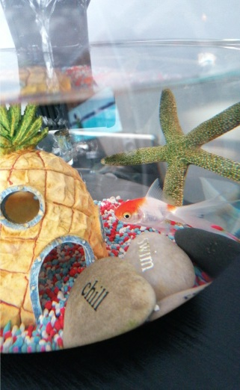

This is Chelsea’s pet fish, his name is Spike and he is 2 years old.

Meet Adele’s pet dog, his name is Harrison. Harrison has one blue eye and one brown eye.
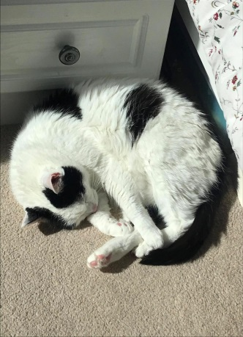

This is Mrs McGinney’s pet cat Milou, who is 13 years old and is enjoying the sunshine.

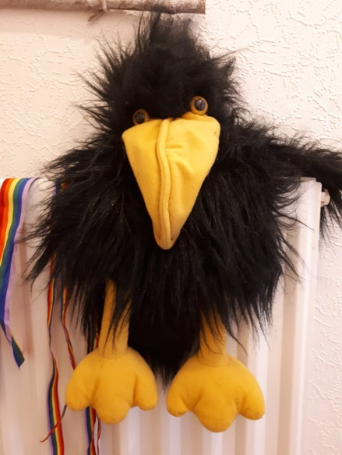
Say Hello to Colin the crow. Colin is Miss Cooke’s pet crow who is 3 years old and his favourite food is big juicy worms!

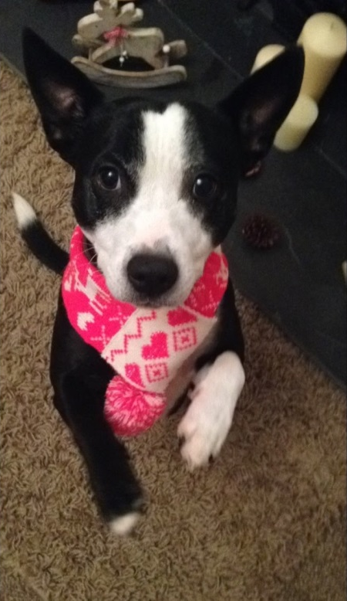

This is Kayla, keeping warm with her Christmas scarf on. Kayla is Margaret Brown’s dog and she is 9 years old.

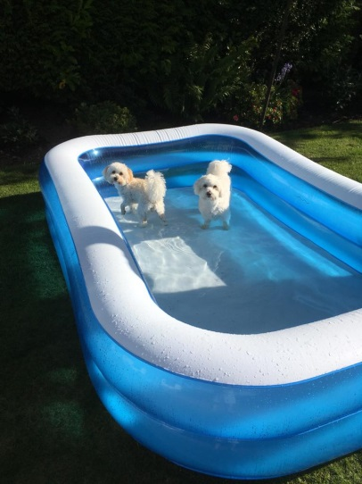

Liz Lansburgh has shared this photo of her two dogs Millie and Tilly who are cooling down in their pool!

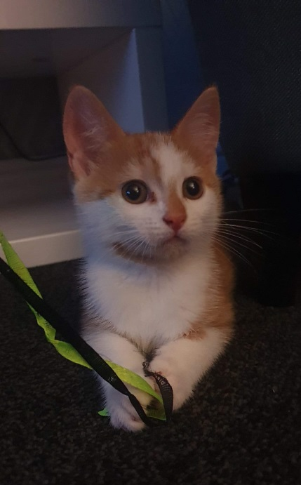

Meet Emma’s kitten, his name is Billy. Billy is 8 weeks old and loves to play with ribbon.

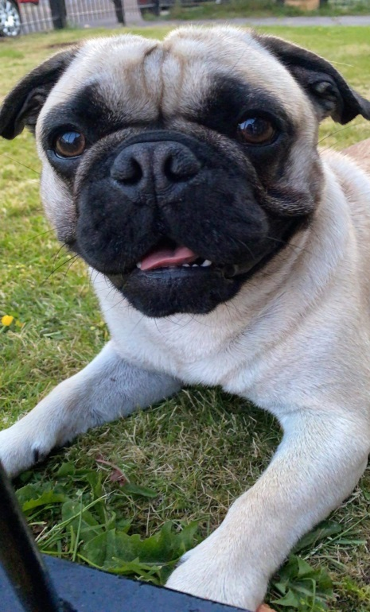

Here is Courtney’s dog Beau.
Beau is only 1 year old.

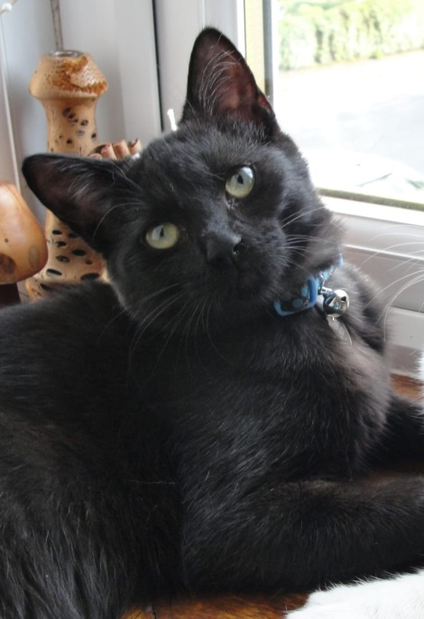

This is Karen Shepherd’s cat, Tina, who is 5 years old. Tina likes to look out the window for her doggy friends, then she rushes outside to say “hello” to them.
We would love to see photographs of your creative pictures, imaginary animal homes or if you have a pet we would love to see a photograph of you and your pet together. Please Tweet them to us @HazeldeneFamC

