**National Smile Month**

**Week 4**

KEEP ON SMILING!



A few ideas for some fun activities to celebrate National Smile Month.

Literacy activities

* Smiley sonnets.  Create a poem about what a smile means to you. You could even record yourself reciting it!
* “What makes me smile” videos. Create a video saying what is making you smile during lockdown.
* Make a video of yourself singing a song with the word “Smile” in the title.

Here is a copy of the Pam Ayers poem “Oh, I wish I’d looked after me teeth!”, written to mark the very first National Smile Month in 1977, to inspire our budding poets.

Oh, I wish I’d looked after me teeth,

And spotted the dangers beneath

All the toffees I chewed,

And the sweet sticky food.

Oh, I wish I’d looked after me teeth.

I wish I’d been that much more willin’

When I had more tooth there than fillin’

To give gobstoppers,

From respect to me chopper,

And to buy something else with me shillin’.

When I think of the lollies I licked

And the liquorice allsorts I picked,

Sherbet dabs, big and little,

All that hard peanut brittle,

My conscience gets horribly pricked.

My mother, she told me no end, ‘If you got a tooth, you got a friend’.

I was young then, and careless,

My toothbrush was hairless,

I never had much time to spend.

Oh I showed them the toothpaste all right,

I flashed it about late at night,

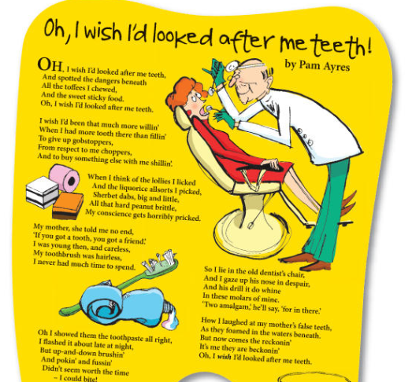But up-and-down brushin’

And pokin’ and fussin’

Didn’t seem worth the time – I could bite!

If I’d known I was paving the way

To cavities, caps and decay,

The murder of fillin’s.

Injections and drillin’s,

I’d have thrown all me sherbet away.

So I lie in the old dentist’s chair,

And I gaze up his nose in despair,

And his drill it do whine

In these molars of mine.

‘Two amalgam,’ he’ll say, ‘for in there.’

How I laughed at my mother’s false teeth,

As they foamed in the waters beneath.

But now comes the reckonin’

It’s me they are beckonin’

Oh, I wish I’d looked after me teeth.

You can hear her reading it here: <https://www.youtube.com/watch?v=H6g1I37_r1E>

Share photos on Twitter @HazeldeneFamC using #SmileMonth.  If you wish to share photos with East Renfrewshire social media you can send them to [communications@eastrenfrewshire.gov.uk](https://email.ea.e-renfrew.sch.uk/OWA/redir.aspx?C=aifYVy95UUGqIcarAUE_uGbYv6uaCNgIWRJ_bINbvXFJ2H88lI4oRu0kowNGZMnxjf2waQ4JaaI.&URL=mailto%3acommunications%40eastrenfrewshire.gov.uk)

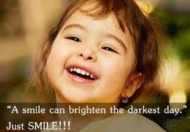

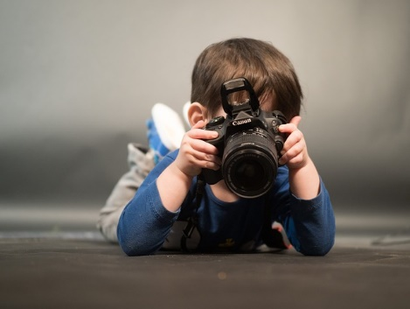

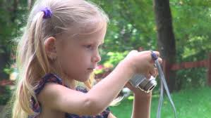



**What is my child learning from this experience?**

Experiences and Outcomes

I am developing my understanding of the human body and can use this knowledge to maintain and improve my wellbeing and health. HWB 0-15a / HWB 1-15a / HWB 2-15a / HWB 3-15a /HWB 4-15a

I am becoming aware of how cleanliness, hygiene and safety can affect health and wellbeing and I apply this knowledge in my everyday routines such as taking care of my teeth. HWB 0-33a

I enjoy exploring and playing with the patterns and sounds of language and can use what I learn. LIT 0-01a / LIT 0-11a / LIT 0-20a LTRW

I enjoy taking photographs or recording sound and images to represent my experiences and the world around me. **TCH 0-04b**

**Skills**

Describe ways of keeping healthy through, e.g. eating and drinking, exercise, sleep, keeping clean and brushing teeth.

Brush teeth using a circular motion.

Know that hands are washed after coughing, sneezing, going to the toilet or before eating.

Listen to and recite rhymes, songs and poems.

Detect, predict and generate rhyme.

Capture images using a digital camera or digital video camera.

Record sound to communicate experiences.