Eco Home School
Biodiversity.
This week we are looking at dandelions.
Sciences – SCN0-01a I have observed living things in the environment over time and am becoming aware of how they depend on each other.
Expressive Arts EXA 0-05a Inspired by a range of stimuli, I can express and communicate my ideas, thoughts, and feelings through activities within art and design. Biodiversity/being outdoors as inspiration.
The Learning
● Respond to various media to interpret and express thoughts and feelings in a creative way.
● Use picture form and three dimensions to convey thoughts and feelings.

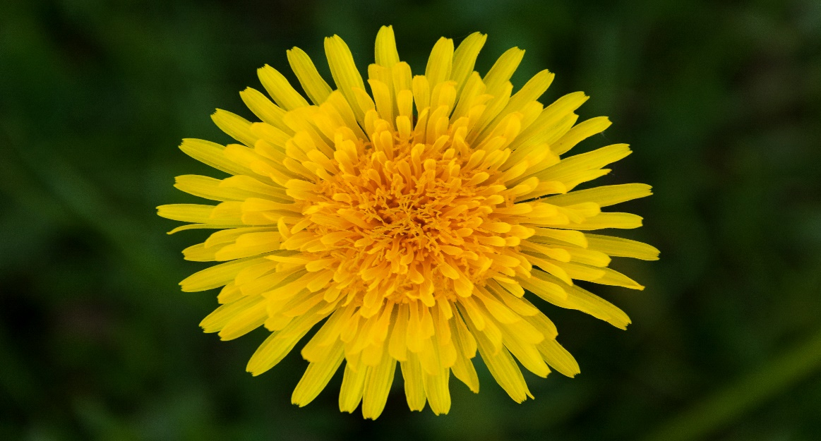

Dandelion Activity

It is dandelion time! Dandelions are widely considered terrible weeds, but they are full of wonderful properties for people and a fantastic early source of pollen and nectar for insects who have been waiting hungrily all through the winter. And did you know that their common name comes from the French dent-de-lion, which means “Lion’s Tooth” because of their coarsely toothed leaves?
You'll need:
- Paper, colouring pencils or paint
- A long bamboo skewer or stick
- Tape

Why not get inspired by this lovely and often overlooked flower, and turn it into signs with kind messages that we can spread, just like dandelion seeds? For this you will need paper, colouring pencils or paint, something like a long bamboo skewer or a stick, and tape or something that can help you fix your dandelion to your skewer or stick. To start, have a good look at a dandelion flower if you find one while you go for your daily walk. Draw a big dandelion in a piece of paper, big enough so you can write a lovely message inside its round centre. Something like “Have a lovely day”, “Hope you are well”, “Soon we will be together” could be nice. Once it is ready and you have coloured it, fix it to your skewer or stick. On your next daily walk, leave it as a surprise in someone's garden or front door.

