Scavenger Hunt!!

Have a look around your house and see if you can find the following…
Take a photo of the items you find and Tweet them to us @HazeldeneFamC
1 red item

2 blue items

3 orange items

4 yellow items

5 green items
Now can you have a look and see if you can find any other items that are the same colour? Can you count them to see how many you have?

What will my child learn?

- Recognising colours and numbers
- Touch count
- Will recognise different shapes and sizes

I am developing a sense of size and amount by observing, exploring, using and communication with others about things in the world around me (MNU 0-01a)

I have explored numbers, understanding that they represent quantities, and I can use them to count. (MNU 0-02a)

Challenge
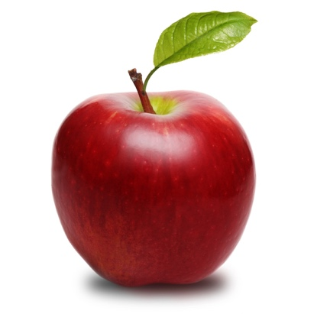
Can you make a pattern with the different items you found?
Can you put them in size order starting with the smallest item to the biggest item?
Do you have two items which are the same? Can you pair them together?

