Challenge of the Week

This week’s challenge is to load or unload your dishwasher, if you have one and if not, wash, dry, sort and put away your cutlery.
Top Tips for loading the dishwasher:
- Remember to scrape off leftover food from the dishes.
- Line up the dishes carefully to get more in.
- The adult will put the dishwater tablet or powder in and close the lid properly. (Talk with your child about kitchen safety and not touching dishwasher tablets)
- Choose the best wash to save energy. Save our planet! Talk about the numbers on the dial and what they represent.
Unloading/emptying the dishwasher:
- Take one item out at a time safely.
- Put everything back where it belongs.
Why not listen to a song to make it fun, have a dance in the kitchen too?
Washing, drying, sorting and putting away cutlery:
- Use a washing bowl or an empty sink to fill warm water in.
- Add a squirt or two of washing up liquid.
- Scrub the cutlery using a sponge. Please be careful when washing sharp objects – your adult will keep you safe.
- Once you have rinsed the cutlery, dry it thoroughly using a dish towel.
- Sort out the cutlery before putting it away.
Now pat yourself on the back for a job well done
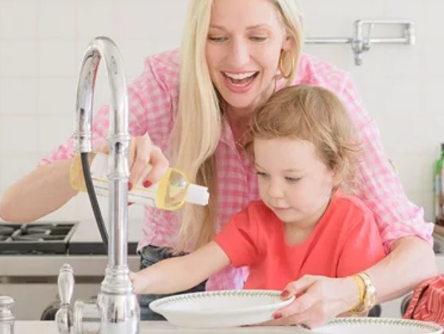
What is my child learning from this experience?

Curriculum for Excellence:
I am becoming aware of how cleanliness, hygiene and safety can affect health and wellbeing and I apply this knowledge in my everyday routines. HWB 0-33a

I understand there are things I should not touch or eat and how to keep myself safe, and I am learning what is meant by medicines and harmful substances. HWB 0-38a

I use signs, books or other texts to find useful or interesting information and I use this to plan, make choices or learn new things. LIT 0-14a

I can match objects, and sort using my own and others’ criteria, sharing my ideas with others. MNU 0-20b

I know how to stay safe when using electricity and understand the importance of electricity in our daily lives. SCN 0-09a

I make decisions and take responsibility in my everyday experiences and play, showing consideration for others. SOC 0-17a

I enjoy exploring technologies to discover what they can do and how they can help us. TCH 0-01a

