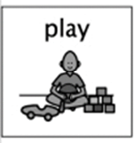
Walking Water experiment

What you need:
- 4 glasses or plastic cups of the same height
- Water
- Food colouring x 2
- 2 sheets of Kitchen roll

What to do:
- Place the empty glasses about 2 inches apart. Pour water into the first and third glasses until it is half full, then add some food colouring to the water and stir until it’s all one colour.
- Cut the sheets of kitchen roll in half. Fold each of the halves in half again length ways.
- 1st and 2nd glass place half of the kitchen roll in each, 2nd and 3rd glass place half the kitchen roll in both and repeat this for the 3rd and 4th glass.
- Keep watching and see what happens
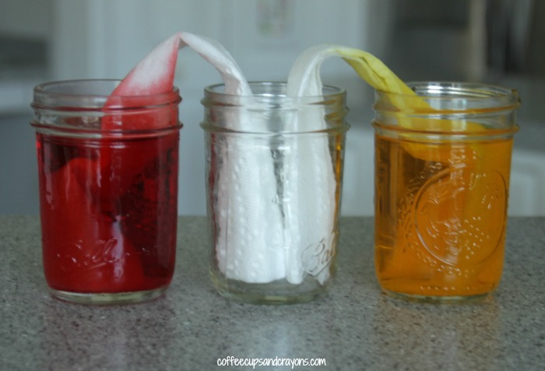
What do you think will happen to the water?
What is happening now?
Why do you think the colours are changing?

What will I learn?
- Through everyday experiences and play with a variety of toys and other objects, I can recognise simple types of forces and describe their effects. SCN 0-07a
- By investigating forces and toys and other objects, I can predict the effect on the shape or motion of objects. SCN 1-07a
- Make suggestions about what might happen.

