Story of the week
Week Beginning 08 June 2020

This week’s story of the week is called “I DON’T WANT CURLY HAIR” by Laura Ellen Anderson
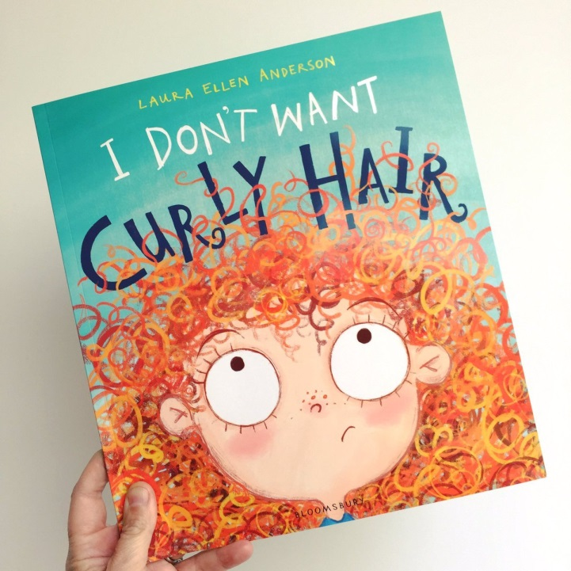

https://www.youtube.com/watch?v=n7WpeO8UJSI

(Copy and Paste the link above to view our story of the week)

Now that you’ve heard the story, here is a short animation your child may like to watch. Ask your child to tell in their own words what happens in the video. Talk about the different emotions the dog Pip is going through and explain how it makes you feel.
“Pip” animated short film presented by Southeastern Guide Dogs – A heart-warming tale for underdogs everywhere, Pip is the story of a small dog with a big dream – to become a Southeastern Guide Dog. Does she have what it takes?
https://www.youtube.com/watch?v=07d2dXHYb94

