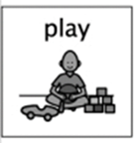Patterns

With the nice weather coming in this activity is straightforward and lots of fun for the children!

To begin with, you pick shapes to draw onto a piece of paper

or chalk on the ground. Say the names of the shapes as you draw them, so your child can begin to hear the pattern.

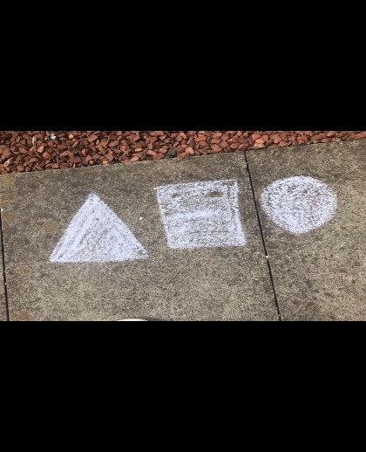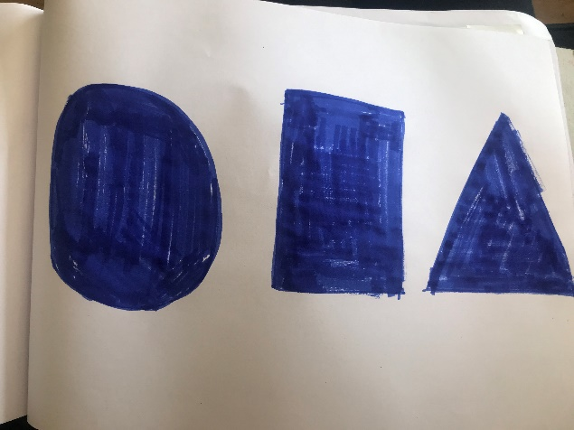

Draw the pattern again to continue it, saying the names of the shapes as you draw them. Say the pattern from the beginning. Repeat it several times. Ask your child “Circle, square … what comes next?”

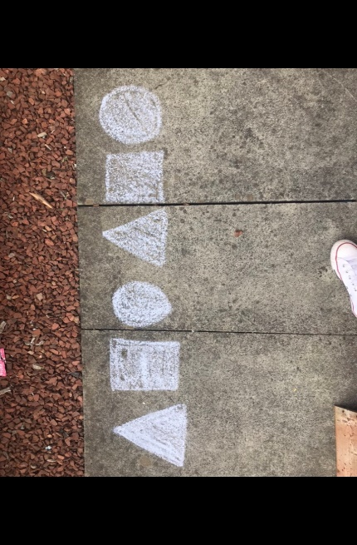Your child can now copy and continue the pattern. This can be with any type of material e.g. pens, paint, chalk. The shapes don’t need to look exactly the same as yours. Praise their efforts.

The aim is to be able to recognise and predict the repeated pattern.

What are the children learning from this experience?

**Curriculum for Excellence**

I have spotted and explored patterns in my own and the wider environment and can copy and continue these and create my own patterns. **MTH 0-13a**

**This promotes skills such as:**

* **Recognising, copying and continuing simple patterns**
* **Fine Motor Skills**
* **Problem Solving**
* **Mark Making**

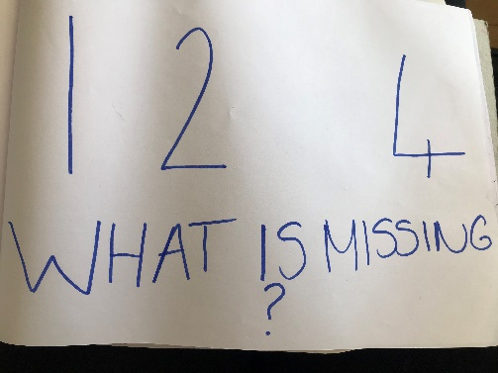**Continued Learning**

Try different shapes and numbers with your patterns and encourage the children to copy them. Try copying a clapping pattern or beats on a drum.

Add different colours to your shapes to colour match the shapes.

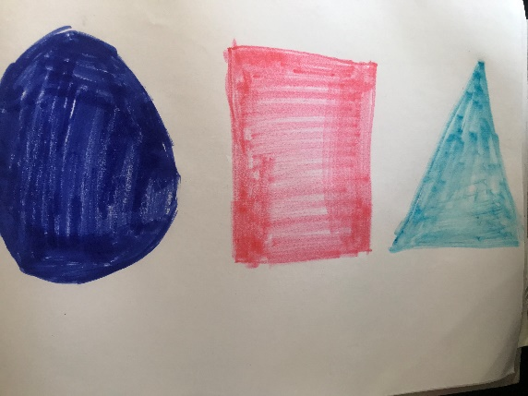

May 2020 CS