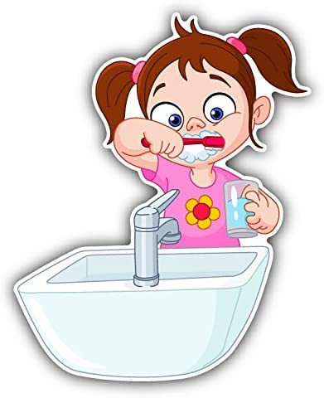
National Smile Month

Week 3

KEY MESSAGE

Remember to brush your teeth twice a day for 2 minutes with a toothpaste containing at least 1000 ppm fluoride.

Science and Health & Wellbeing activities

Egg experiments to show the impact of food and drinks on tooth enamel (see attached document for instructions). The egg in the cola drink shows how our teeth can become dirty/stained but that brushing them can clean this away. The egg in vinegar represents how acids, in things like fizzy juice, can cause acid erosion (the egg shell should start to deteriorate and come away from the egg) permanently damaging the teeth and the final egg shows how fluoride can help to protect the teeth.

Please share any photos by Tweeting us @HazeldeneFamC using #SmileMonth

Some useful websites:

http://www.child-smile.org.uk/parents-and-carers/toothbrushing/index.aspx

https://www.nhs.uk/live-well/healthy-body/how-to-keep-your-teeth-clean/

EGG EXPERIMENTS

Equipment needed
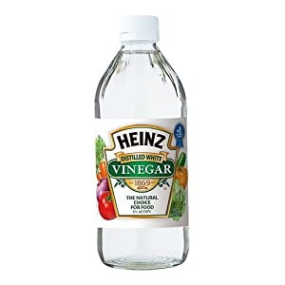
• 3 eggs (preferably with white shells) to represent the enamel on your teeth
• A saucepan
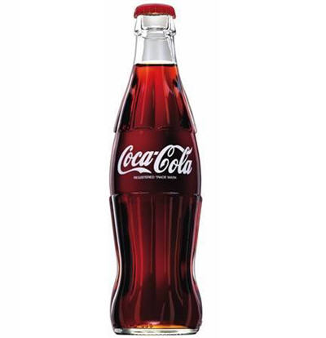
• Water
• 3 glasses each big enough to fit one egg
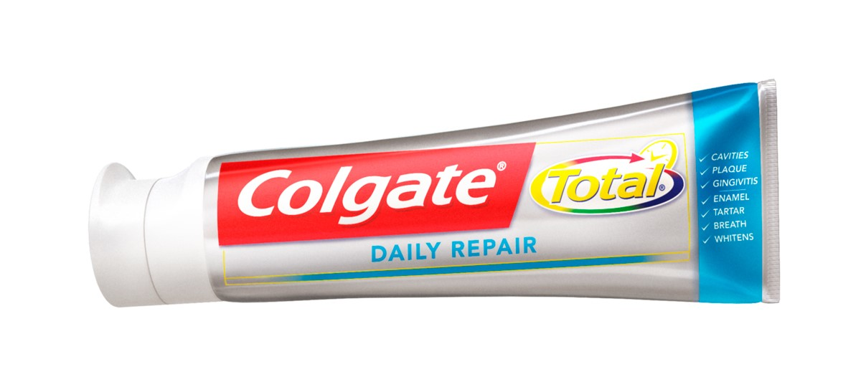
• Fizzy cola drink
• White Vinegar
• A tube of fluoride toothpaste
• Patience
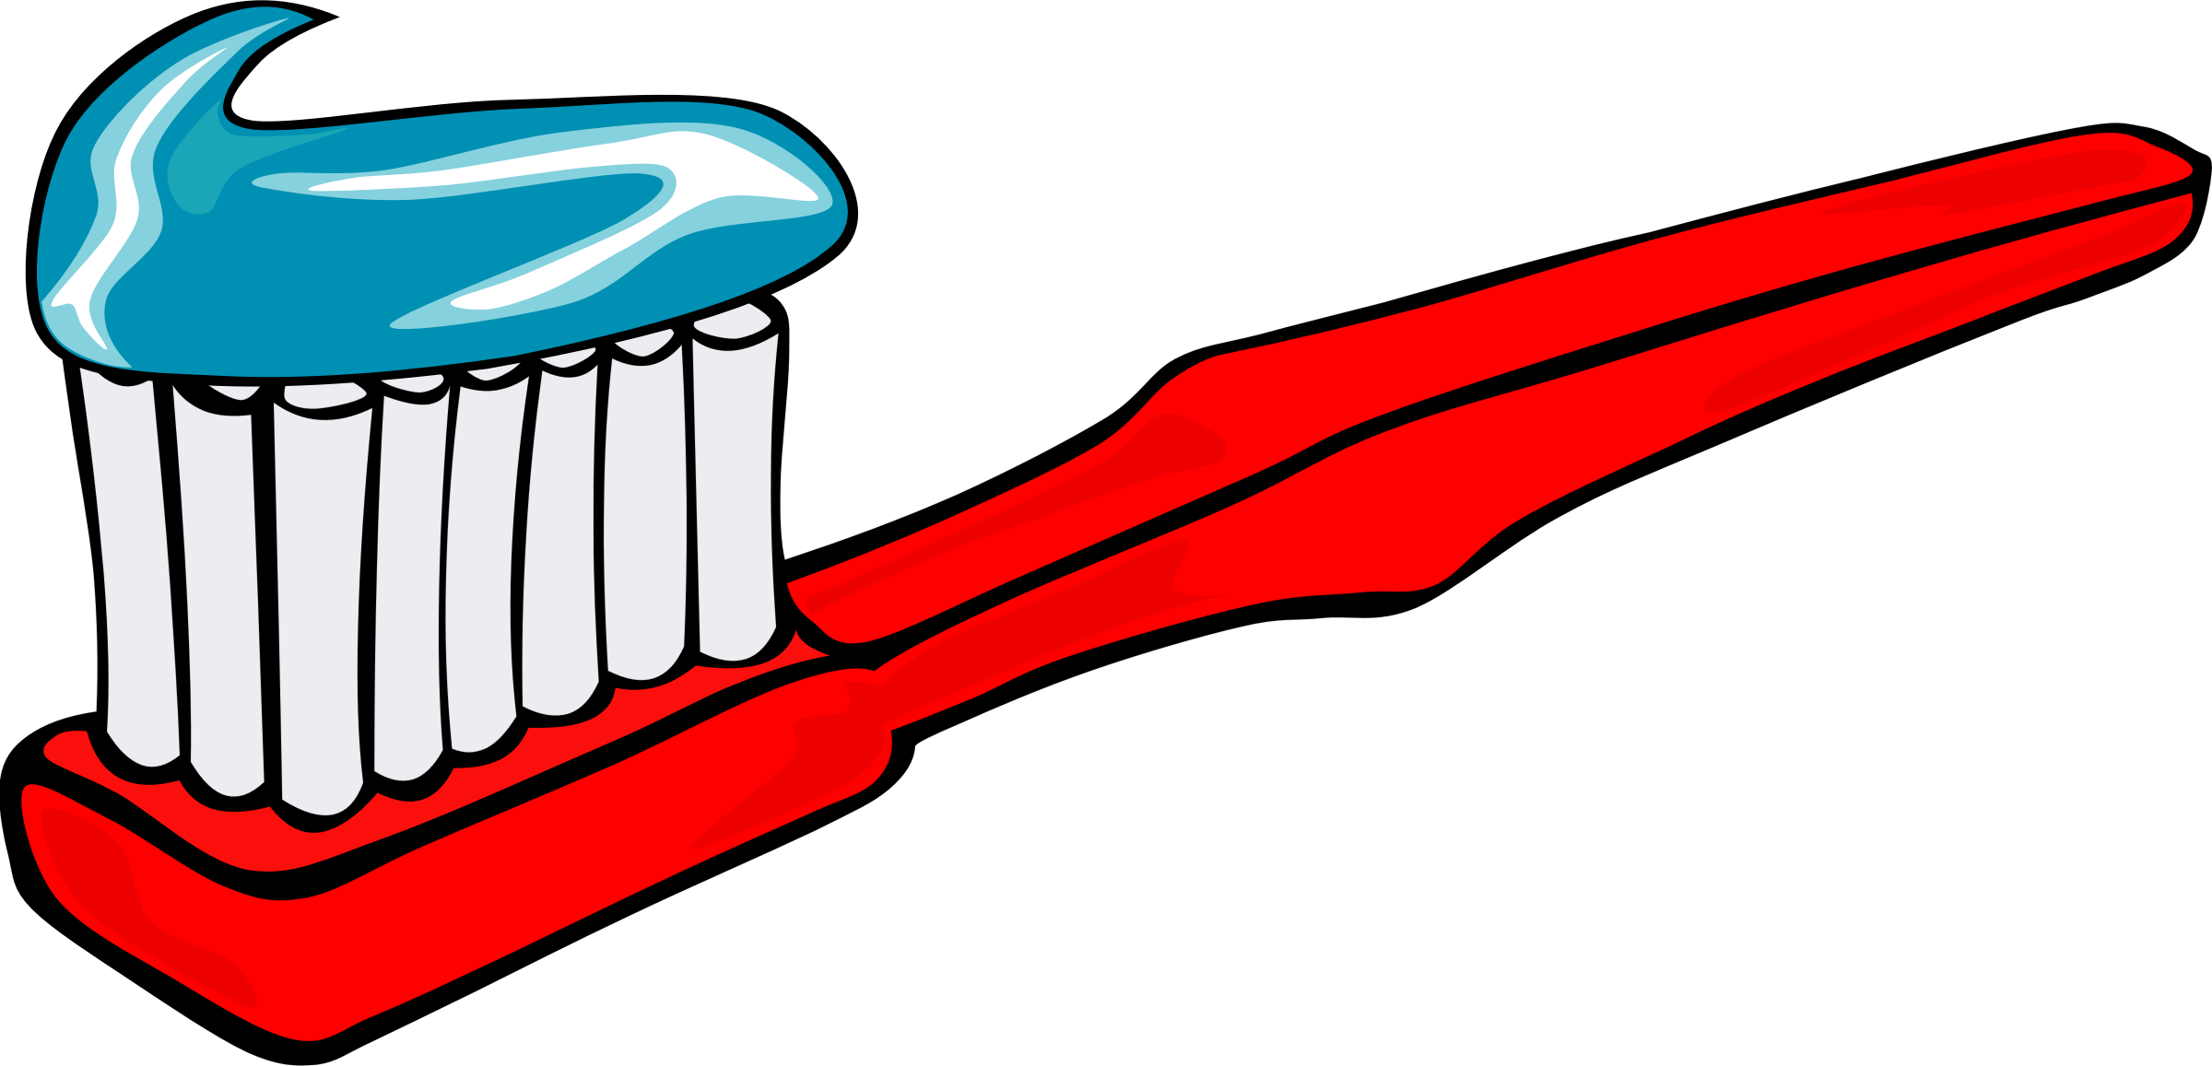
• A toothbrush

Instructions
• Place the eggs in the saucepan and cover with cold water.
• Cook the eggs until they are hard-boiled (around 10 minutes).
• Drain and allow to cool.
• Whilst the eggs are cooling answer the first question in the table below.
• Once cold, remove the eggs from the saucepan.
• Put one of the cooked eggs in a glass and pour over the fizzy cola drink until the egg is completely covered.
• Put one of the cooked eggs in a glass and cover completely with vinegar.
• Coat the third egg with a thick layer of toothpaste.
• Put this egg in the final glass and pour in vinegar until the egg is completely covered.
• Answer the second question on the table below.
• Leave for around 24 hours.
• After 24 hours take each egg out of the glasses and examine them.
• Answer question 3 in the table below.
• Using an old toothbrush gently brush the shell of each egg as you would brush your teeth.
• Answer the final two questions.

Predictions and results
Question | Egg 1  Cola drink | Egg 2  Vinegar no toothpaste | Egg 3  Vinegar and toothpaste
1) What do you think will happen to each of the eggs?
2) What can you see happening when you pour over the liquid?
3) What can you see has happened to the shells over 24 hours?
4) What happens to the shells when you gently brush them?

Conclusion – what does this tell us about brushing our teeth?

What are the children learning from this experience?

Curriculum for Excellence Experiences and Outcomes
I am developing my understanding of the human body and can use this knowledge to maintain and improve my wellbeing and health. HWB 0-15a / HWB 1-15a / HWB 2-15a / HWB 3-15a /HWB 4-15a
I am becoming aware of how cleanliness, hygiene and safety can affect health and wellbeing and I apply this knowledge in my everyday routines such as taking care of my teeth. HWB 0-33a
I can talk about science stories to develop my understanding of science and the world about me. SCN 0-20a
I can identify my senses and use them to explore the world around me. SCN 0-12a
Skills
Brush teeth using a circular motion.
Know that teeth must be brushed to protect them and to stop bacteria building up

Know that hands are washed after coughing, sneezing, going to the toilet or before eating.

Recognise simple cause and effect.

Follow simple instructions.

Use simple techniques and apparatus.

Respond to questions about the planning of an investigation.

Agree on what might happen from several suggestions provided.


