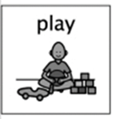
Movie maker
Week beginning 8th June 2020

At Hazeldene our ICT area is always a popular choice, as our children love to play with the Promethean board, I-Pads, computer and programmable toys. For our Science, Technology, Engineering, and Mathematics (STEM) home learning week, why not become the director and producer of your very own movie, using technology to create your own story line?
Technology equipment
- Mobile Phone – iMovie, clips apps on phone or simply use phones camera or video program.
- Ipad
- Camera
- Video camcorder

- Together with your child go on a co-adventure to create a fun and engaging storyline for the movie. (Write down your story so that you don’t forget, drawing some pictures of the ideas you have for your movie).
- Next you need to choose props for your movie and the characters, backdrops, resources/materials you want in the movie. You can choose to use figures and toys or if you want you can be the star of the show.
- Now it is time to create the movie set, having everything close. Design and make your scenery or choose a space to film in.
- Set up your recording equipment (can sit your device on a stand or get a film crew to help).
- Ready Steady Action! Now it’s time to create your movie using your characters.

Curriculum for Excellence
As I listen and take part in conversations and discussions, I discover new words and phrases which I use to help me express my ideas, thoughts, and feelings. LIT 0-10a
I can explore digital technologies and use what I learn to solve problems and share ideas and thoughts. TCH 0-01a
I enjoy exploring events and characters in stories and other texts and I use what I learn to invent my own, sharing these with others in imaginative ways. LIT 0-09b / LIT 0-31a

I enjoy playing and exploring technologies to discover what they can do and how they can help us. TCH 0-05

I explore and discover different ways of representing ideas in imaginative ways. TCH 0-11a

Skills developed
- Uses new vocabulary and phrases in different contexts, for example, when expressing ideas and feelings or discussing a text.
- Communicates and shares stories in different ways, for example, in imaginative play.
- Talks clearly to others in different contexts, sharing feelings, ideas, and thoughts.
- Recognises different types of digital technology.
- Identifies the key components of different types of digital technology.
- Uses digital technologies in a responsible way and with appropriate care.
- Discusses times when they have used different technologies.
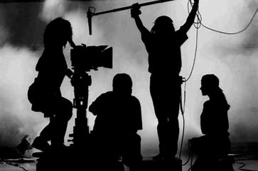
- Use different ice programs to create own movie.
Idea from https://tinkerlab.com/easy-stop-motion-animation-kids/

