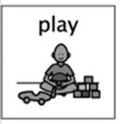
Lava Lamps!!!

You will need….
- A clean plastic bottle with smooth sides
- Some water
- Funnel
- Vegetable oil or Baby oil
- Fizzing tablets (e.g. Alka Seltzer* )
- Food Colouring

Remind your child that they should not touch medicines without supervision from you or another trusted adult.

How to do it….
- Add water to your plastic bottle until it is about ¼ full
- Pour some oil into the bottle until it’s almost full.
- Wait until the oil and water has separated
- Add a few drops of food colouring.
- Break a fizzy tablet in half and drop one half into the bottle.

Ready! Steady! Bubbles!

Did your drops of colour mix with the water or did they float between the oil and water?
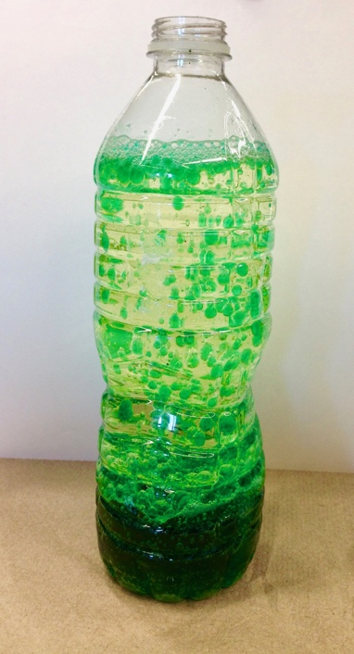

What happens if you put the lid on after dropping the fizzy tablet in?

What will happen if you use a whole tablet?

When your lava lamp stops bubbling, add some salt and see what happens.

What will my child learn?

Science will allow children many opportunities to develop different skills and attributes, including communication skills, collaborative skills, team work and perseverance. By doing this experiment it will allow your child to problem solve.
Through everyday experiences and play with a variety of toys and other objects, I can recognise simple types of forces and describe their effects. SCN 0-07a

Through creative play, I explore different materials. SCN 0-15a

I can share out a group of items by making small groups and can spilt a whole object into smaller parts (MNU 0-07a)

Skills developed….

Hand-Eye Coordination and Control. Skills in using equipment.

Problem solving. Critical thinking through exploration and discovery.

Language Development – ask questions about what’s happening around them. Predicting what might happen and reasoning.

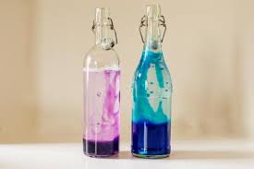
Using their senses to explore colours, shapes and sounds.

Check out this website for more science experiments -

http://www.sciencefun.org/kidszone/experiments/orange-fizz/
CR

