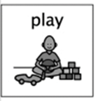Art and Design

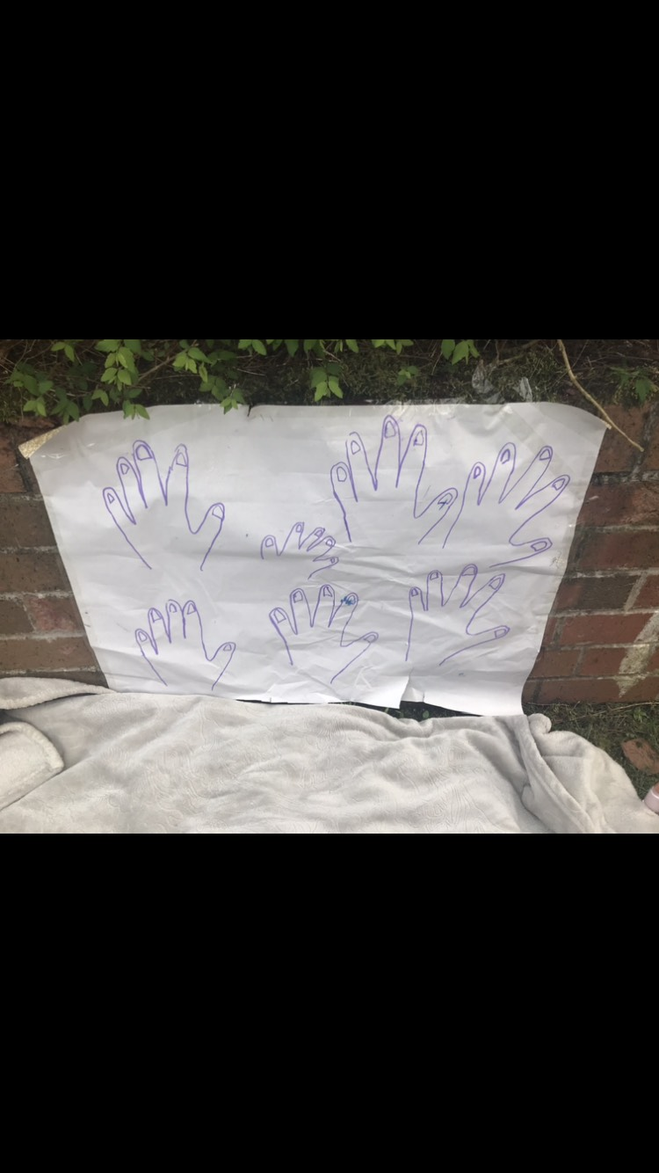

What you need to do:

* Get a large piece of paper.

(This activity can work just as well on a smaller scale)

* Draw round your hand and add some finger nails.
* Other family members can add their hand outlines.
* Sellotape the paper to a surface.
* Collect some pens/pencils/paint/glitter glue
* Use the pens/glitter glue/paint to add colour and pattern to the hands.
* How many different patterns can you add to your hands?

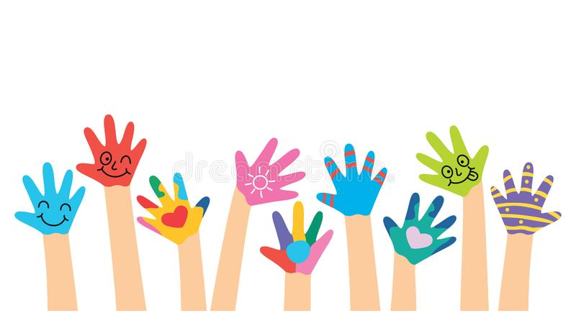

**Let the fun begin!**

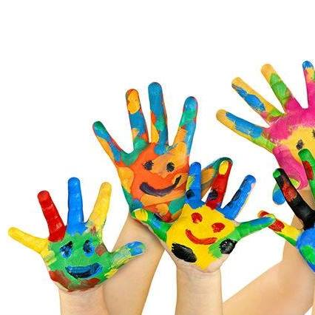

I have the freedom to discover and choose ways to create images and objects using a variety of materials. **EXA 0-02a**

What are the children learning from this experience?

**This Promotes Skills such as:**

* Selecting and using mark making materials
* Experimenting with mark making through a variety of media
* Exploring the difference between drawing and writing
* Control of the fine movements of the fingers and hands
* Hand-Eye Coordination
* Holding a writing implement effectively
* Using a writing implement to form shapes and patterns

**Continued Learning:**

* Explore drawing patterns on the nails and hands
* Add accessories e.g. watch, bracelet
* Ask your child to colour 3 fingers blue and 2 red etc. (numeracy)
* 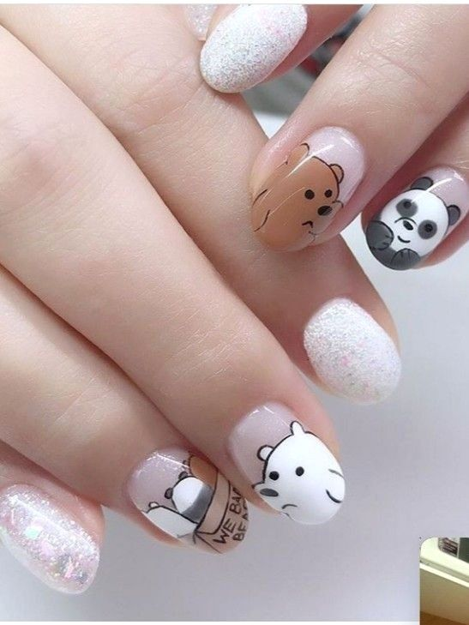Role Play a Nail Salon

May 2020 CS