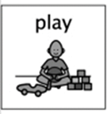
I Spy Bags
Week beginning 8th June 2020.

Idea from https://www.learning4kids.net/2015/11/25/homemade-eye-spy-sensory-bag-keeping-kids-occupied-in-the-car/
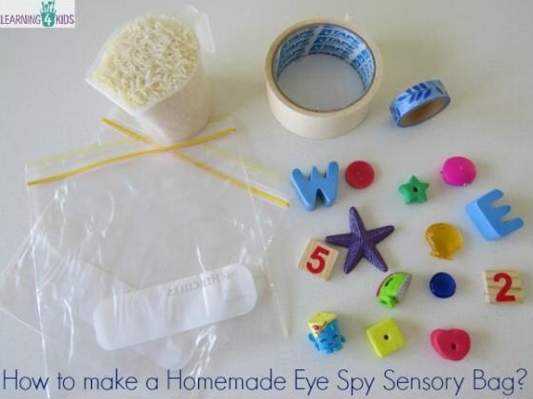
What you will need:
- 2 zip lock bags (you can re-use bags that have been used for a sandwich)
- 1 cup of rice (being mindful of when using food)
- Masking tape / Sellotape
- Small trinkets, toys, tokens or objects.

- Take a look around your house and garden, searching for 10 objects that you would be happy to put into your I spy bag.
- Put one cup of rice and your 10 objects into the zip lock bag (adding more or less rice if necessary).
- Fasten the zip-lock bag, ensuring that all the air has been pressed out of the bag.
- Place the masking tape along the opening end of the stop any of the contents from falling out of the top.
- Place the zip lock bag into the second zip-lock bag with the folded end placed inwards at the bottom of the bags.
- Fasten the zip-lock bag (pressing out the air) and add tape it shut.
- Explore the items in the bag, naming them. What sound does each item begin with? How many objects starting with that sound are there in the bag?
- Play I Spy with my little I something beginning with ……
- Create an I spy card to show everyone what they are looking for in the bag. You can practise your drawing and writing, or before you begin can take photographs of the objects and print them out.

What are the children learning from this?
Curriculum for Excellence
I explore sounds, letters and words, discovering how they work together, and I can use what I learn to help me as I read and write. ENG 0-12a

Skills developed

- Hears and says patterns in words.
- Hears and says the different single sounds made by letters.
- Hears and says blends/sounds made by a combination of letters.
- Uses knowledge of sight vocabulary/tricky words to read familiar words in context.

