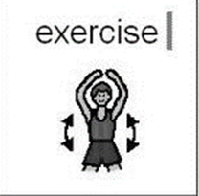
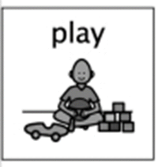
Virtual Sports Day
Week Beginning 1st June 2020

During this term at Hazeldene, we would be organising a sports day for all children to participate and for families to come along and cheer their children along - especially with the beautiful weather we have been having recently. During your daily exercise, a fun way to be active is to create your own Sports Day in your garden - or inside if you are unable to go out. (Make sure there is plenty of space and this is OK with your parents).

You can use different markers as your start and finish lines (such as stones or plant pots) or you can have fun designing your own finish line using arts and craft materials.

Minimum equipment Sports Day
Everyone in the household can take part to make it fun and interactive. Read through first to see what you will need to prepare.

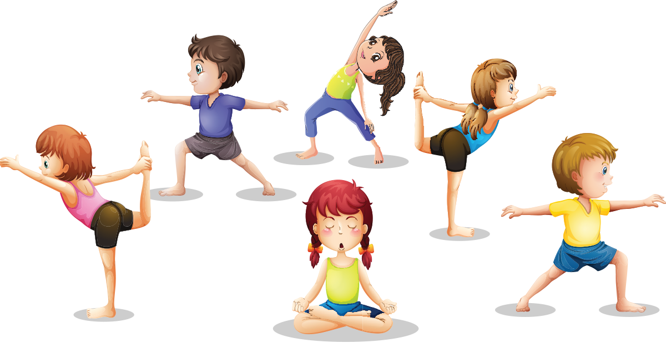
To start, we must get our bodies warmed up and ready for exercise. We need do some stretches.

- Now that we are warmed up it is time to start our first race. You will need to get a spoon and something to put into the spoon (hard boiled egg, stone etc.) Now it’s the tricky part! Can you go as fast as you can to the finish line holding your spoon steady without dropping the egg/stone? if you drop it, you need to go back and start again.
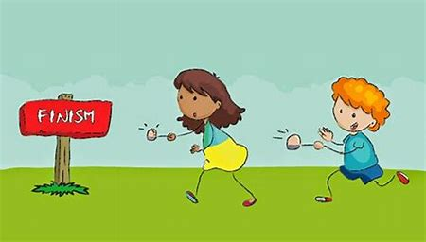

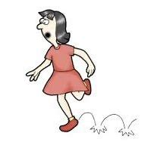
- Our second Race is a hopping race.
- Tip toe Race
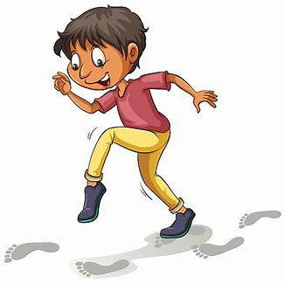

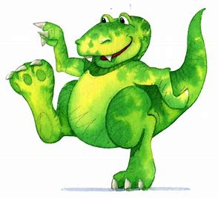

- Stomping Race (pretend to be a giant or a dinosaur and race to the finish line)
- Crawling Race
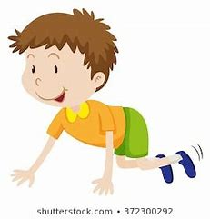

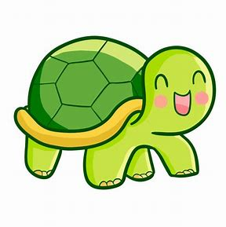
- Slow Race (this might be tricky the person who crosses the finish line last is the winner)

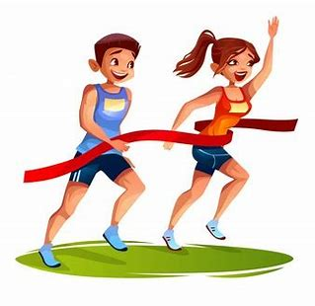
- Fast Race (make sure you definitely have your fast shoes on for this race, the first person who crosses the finish line is the winner)

Another fun idea (especially when doing races on your own) you can time each race and have a competition to try and beat your personal best.
Please tweet pictures of your sports day @HazeldeneFamC
What are we learning?
Curriculum for Excellence
I am developing my movement skills through practice and energetic play. HWB 0-22a
I am learning to move my body well, exploring how to manage and control it and finding out how to use and share space. HWB 0-21a

I am enjoying daily opportunities to participate in different kinds of energetic play, both outdoors and indoors. HWB 0-25a
I can describe how I feel after taking part in energetic activities and I am becoming aware of some of the changes that take place in my body. HWB 0-28a

I have begun to develop a sense of how long tasks take by measuring the time taken to complete a range of activities using a variety of timers. MNU 1-10c (THIS IS AT FIRST LEVEL)

Skills Developed
- Selects and uses appropriate timers for specific purposes.
- Moves at different speeds, levels and directions with others in a designated space.
- Holds balance in various shapes and maintains balance when moving.
- Links movements together (moves body or parts of body in order).
- Moves with purpose.
- Demonstrates how to use repeated patterns of movement to create simple sequences, for example, one foot to two feet jumping.
- Performs basic components of movement, for example, run, jump, gallop, transfer of weight from one foot to another.
- Is beginning to demonstrate eye/hand and eye/foot co-ordination required for movement skills, for example, pass object from one hand to the other.
- Focuses on task and pays attention to stimuli, for example, instructions from an adult.

