
Recycle week activities

What can you recycle at home?

With your mummy, daddy, sister or brother, have a Recycle Hunt. Choose one category at a time – paper, plastic, tin, cardboard, etc. Decide on a collection place e.g. kitchen table … then ‘Ready, Steady, Go’ find your first item and bring it back to the collection place. Continue till you have collected something from each category, making a note of who won every time.

Making a hat

Look around your house for different things you could recycle to make into a hat. You could use what you found in your recycle hunt. Try to use different materials – plastic tubs, paper, boxes, toilet rolls etc. You could use glue, tape, scissors or string to stick the pieces together.
Make your hat as fancy as you want and take a photo when you are finished. You could make a hat for everyone in your family, have a fashion parade and take a family photo.
You could use Mummy or Daddy’s phone, a camera or an I-pad and Tweet @ HazeldeneFamC.
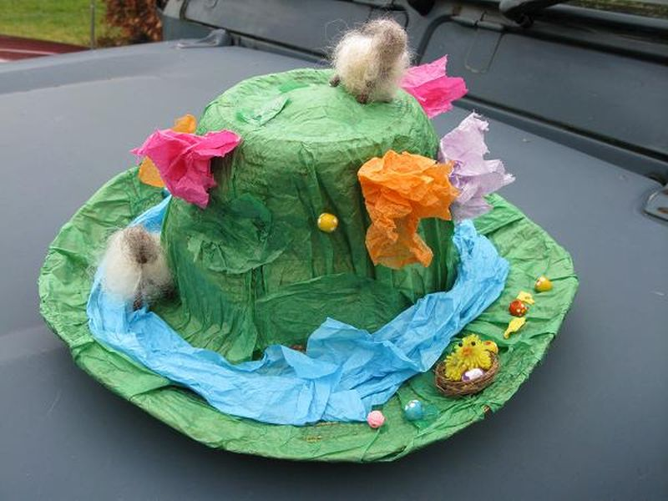

Making a boat

Instructions for making a boat are on the next page. Hopefully you will be able to take you boat to the park or even float it in your paddling pool or bucket of water. Hope is doesn’t sink!!!

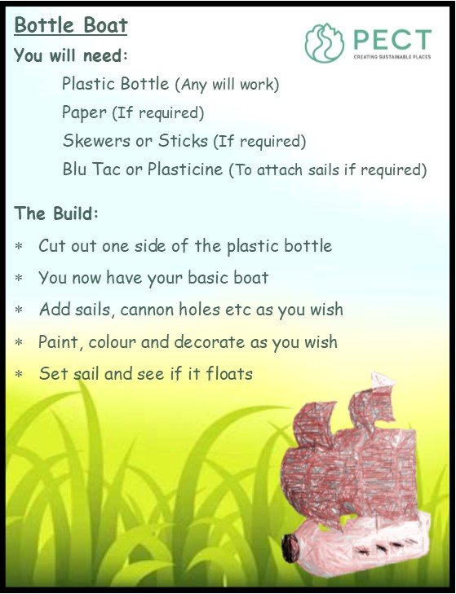

Listen to the story – Michael Recycle
https://www.youtube.com/watch?v=blQAaZl476E

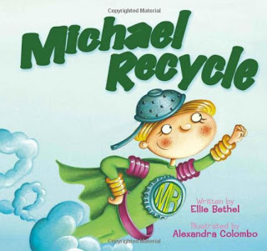

Sing our Eco song – to the tune of Twinkle, Twinkle

RECYCLE

We recycle what we use,
Separate things and you should too.
Glass and paper, plastic, tin,
Go in your recycling bin.
We must start now, we can’t wait,
QUICK, or it will be too late!

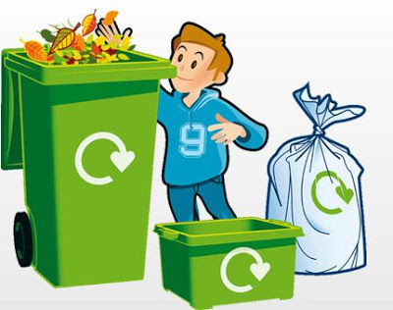

What are the children learning?

Experiences and outcomes
Within and beyond my place of learning, I can reduce, reuse, and recycle resources I use, to help care for the environment. TCH 0-02a
Recognise some familiar products; say what they are for and what they are made from
Begin to evaluate environmental issues by showing awareness of the need to recycle materials.
Within real and imaginary settings, I am developing my practical skills as I select and work with a range of materials, tools and software. TCH 0-12a
Make informed choices and decisions about recycling and the use of resources.
Think creatively and independently while carrying out tasks.
Inspired by a range of stimuli, and working on my own and / or with others, I can express and communicate my ideas, thoughts and feelings through musical activities. EXA 0-18a / EXA 1-18a / EXA 2-18a
Listen to and recite rhymes, songs and poems.
I enjoy exploring events and characters in stories and other texts, sharing my thoughts in different ways. LIT 0-01c
Understand that print is meaningful, the function of print is to convey a message and makes the link between the spoken and written word.

Ask questions to extend knowledge and understanding and to clarify thinking.

