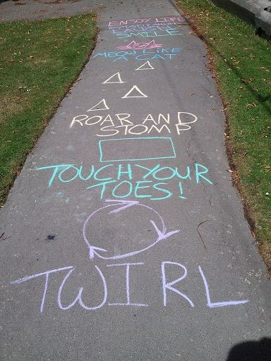
Make up your own obstacle Course
What you need:

- Slide, hula hoops, chalk, bat and ball, skipping rope, cardboard boxes or tubs, beanbags, skittles, anything else you can safely use outside.
- Outdoor space

What to do
- Make use of your outdoor space. Set up your obstacle course with the equipment you are using at different stations.
- You can set out some cardboard boxes or tubs to jump over.
- Draw different shapes on the ground with the chalk ( you can use these to jump on the spot 10 times, run on the spot for 20 seconds, do 15 star jumps, touch your toes, stretch up high, jump over, spin, balance on one foot)
- Draw zigzags, swirl shapes, straight lines etc. to walk along.
- Take turns with family members to complete the circuit, using the equipment at each station.
I am learning to move my body well, exploring how to manage and control it and finding out how to use it and share space
HWB 0-21a
I am developing my movement skills through practice and energetic play
HWB 0-22a

I am enjoying daily opportunities to participate in different kinds of energetic play, both indoors and out.
HWB 0-25a

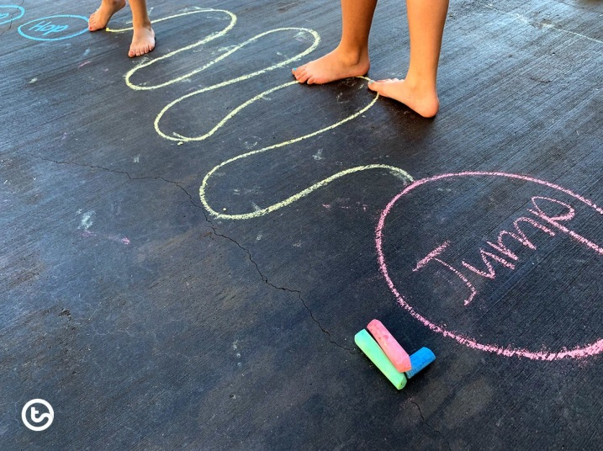

Skills that will be developed

- Perform a range of actions such as running, jumping, stretching and balancing with coordination
- Demonstrate basic control of equipment and resources
- Investigate different methods of moving body parts
- Create own ideas in movement
- Make suggestions
- Explore and play with a variety of equipment

We would love to see all of your obstacle courses. If you take pictures of your child participating in their obstacle course, please share them with us:

@HazeldeneFamC

