**National Smile Month**

**Week 2**

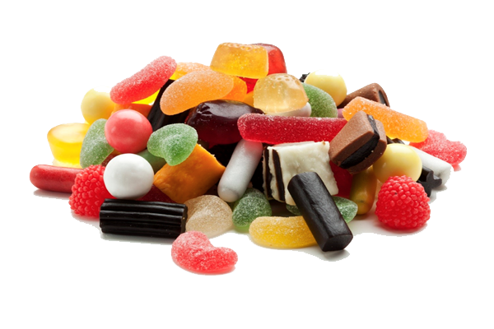

**KEY MESSAGE**

**REDUCE SUGARY FOODS AND DRINKS AND RESTRICT THEM TO MEALTIMES**

A few ideas for some fun activities to celebrate National Smile Month.

Maths and Health & Well-being activities

Sugar bags Create bags with spoonfuls of sugar to show how much sugar is in a product you enjoy. You will find the amount of sugar in the nutrition panel of the product listed under “Carbohydrate of which sugars”. 1 teaspoon=roughly 4g of sugar so divide the figure on the packaging by 4 to get the number of teaspoons.

Sugar swap Which items do you enjoy that you could swap for similar products with less sugar i.e. swap flavoured yoghurt for natural yoghurt with fresh fruit . Keep a track of the swaps and let us know how much sugar you reduced over the month.

Share photos using #sugarswap and #SmileMonth if sharing on Hazeldene’s social media pages.  If you wish to share photos of your sugar bags with East Renfrewshire social media you can send them to [communications@eastrenfrewshire.gov.uk](https://email.ea.e-renfrew.sch.uk/OWA/redir.aspx?C=aifYVy95UUGqIcarAUE_uGbYv6uaCNgIWRJ_bINbvXFJ2H88lI4oRu0kowNGZMnxjf2waQ4JaaI.&URL=mailto%3acommunications%40eastrenfrewshire.gov.uk)

Some useful websites.

[https://www.nhs.uk/change4life/food-facts/sugar](https://email.ea.e-renfrew.sch.uk/OWA/redir.aspx?C=aifYVy95UUGqIcarAUE_uGbYv6uaCNgIWRJ_bINbvXFJ2H88lI4oRu0kowNGZMnxjf2waQ4JaaI.&URL=https%3a%2f%2fwww.nhs.uk%2fchange4life%2ffood-facts%2fsugar)

[https://www.nhs.uk/change4life/food-facts/sugar/sugar-swaps-for-kids](https://email.ea.e-renfrew.sch.uk/OWA/redir.aspx?C=aifYVy95UUGqIcarAUE_uGbYv6uaCNgIWRJ_bINbvXFJ2H88lI4oRu0kowNGZMnxjf2waQ4JaaI.&URL=https%3a%2f%2fwww.nhs.uk%2fchange4life%2ffood-facts%2fsugar%2fsugar-swaps-for-kids)

[https://www.nhs.uk/live-well/eat-well/how-does-sugar-in-our-diet-affect-our-health/](https://email.ea.e-renfrew.sch.uk/OWA/redir.aspx?C=aifYVy95UUGqIcarAUE_uGbYv6uaCNgIWRJ_bINbvXFJ2H88lI4oRu0kowNGZMnxjf2waQ4JaaI.&URL=https%3a%2f%2fwww.nhs.uk%2flive-well%2feat-well%2fhow-does-sugar-in-our-diet-affect-our-health%2f)

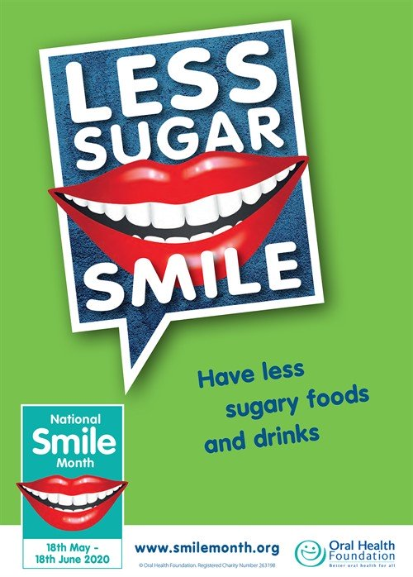

**What are the children learning?**

**Curriculum for Excellence - Experiences and outcomes**

I am developing my understanding of the human body and can use this knowledge to maintain and improve my wellbeing and health.

HWB 0-15a / HWB 1-15a / HWB 2-15a / HWB 3-15a /HWB 4-15a

I am becoming aware of how cleanliness, hygiene and safety can affect health and wellbeing and I apply this knowledge in my everyday routines such as taking care of my teeth. HWB 0-33a

I have experimented with everyday items as units of measure to investigate and compare sizes and amounts in my environment, sharing my findings with others. MNU 0-11a

I know that people need different kinds of food to keep them healthy. HWB 0-32a

Skills

* Describe ways of keeping healthy through, e.g. eating and drinking, exercise, sleep, keeping clean and brushing teeth.
* Brush teeth using a circular motion.
* Know that hands are washed after coughing, sneezing, going to the toilet or before eating.
* Describe weight using “heavy/heavier” and “light/lighter”.
* Use non-standard units to investigate measure.
* Talk about why certain foods are important to a healthy body.

