WB: 01/06/20

**Literacy & Numeracy**

**At home…**

Simple ways to enhance learning and development throughout the day, without sitting them down at a table.

***Part one***

1. **Letter and number recognition**

* Look around and you will see that your home is full of text, numbers and symbols. Make things fun and whilst helping with household chores. You could point out when you see letters that are in your child’s name. For example, loading/unloading the washing machine/dusting/cooking. Play games: First one to find the letter ‘C’ in the kitchen.

I enjoy exploring and playing with the patterns and sounds of language and can use what I learn.

LIT 0-01a / LIT 0-11a / LIT 0-20a

* Hears and says patterns in words.
* Hears and says rhyming words and generates rhyme from a given word.
* Hears and says the different single sounds made by letters.
* Hears and says letter blends/sounds made by a combination of letters.
* Participates actively in songs, rhymes and stories.
* Engages with and enjoys watching, reading or listening to different texts, including stories, songs and rhymes, and can share likes and dislikes.
* Engages with stories and texts in different ways, for example, retelling/re-enacting stories and/or using puppets/props.
* Reuse milk carton lids, or similar, to write letters and numbers on. You could play matching and sorting games with bits of pasta, cereal or stones.

I am developing a sense of size and amount by observing, exploring, using and communicating with others about things in the world around me. MNU 0-01a

* Recognises the number of objects in a group, without counting (subitising) and uses this information to estimate the number of objects in other groups.
* Checks estimates by counting.
* Demonstrates skills of estimation in the contexts of number and measure using relevant vocabulary, including less than, longer than, more than and the same.

1. **Name and number writing**

* 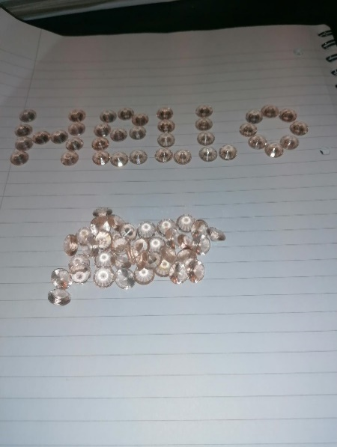Repeatedly using pencil and paper can become boring. Look for new and exciting ways throughout the day where you can encourage your child to mark-make. Baking a cake - Can your child use their finger to write in the flour? Spilt coffee or cereal - save it and use it to draw in. What else could you use?

I explore sounds, letters and words, discovering how they work together, and I can use what I learn to help me as I read and write. ENG 0-12a / LIT 0-13a / LIT 0-21a

* Hears and says patterns in words.
* Hears and says the different single sounds made by letters.
* Hears and says blends/sounds made by a combination of letters.
* Knows the difference between a letter, word and numeral.
* Reads from left to right and top to bottom.
* Uses knowledge of sounds, letters and patterns to read words.
* Uses knowledge of sight vocabulary/tricky words to read familiar words in context.
* Reads aloud familiar texts with attention to simple punctuation.
* Uses context clues to support understanding of different texts.

***Part two***

**Out and about…**

1. **Letter and number recognition**

* Look for street names and signs on your way to the shops. Can you find letters in your name?
* Car registration plates are good for involving numbers.
* Shop names can help your child to recognise environmental print.

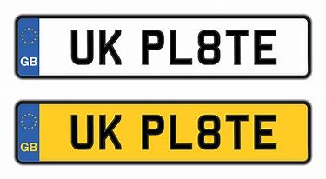[](http://www.asda.com/)

I use signs, books or other texts to find useful or interesting information and I use this to plan, make choices or learn new things. LIT 0-14a

* Finds information in a text to learn new things.

1. **Name and number writing**

* Whilst out on a walk you could collect stones, leaves and small sticks to make your name back at home. You can paint pebbles with numbers and letters.
* Can you make marks in the mud with a stick?

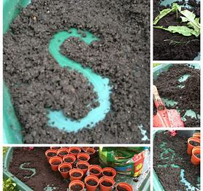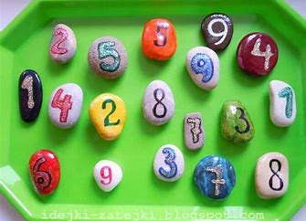

I have the freedom to discover and choose ways to create images and objects using a variety of materials. EXA 0- 02a

* Records from experiences across the curriculum, for example, through observing and remembering, makes a model or drawing based on an aspect of the natural environment such as natural items from the seashore, the countryside, a forest.
* Solves simple design problems, working on their own and with others, using a degree of trial and error, for example, designs a simple container for an agreed purpose.
* Recognises colour, line, shape and at least one more of the visual elements: form, tone, pattern, texture.
* Shares thoughts and feelings in response to the work of at least one artist and one designer, giving reasons for likes and dislikes.
* Shares views and listens appropriately to the views of others on their own or others’ work.
* When creating images and objects to express ideas, thoughts and feelings:
  + - * Uses a variety of available materials and technology;
      * Shows understanding that line can have different qualities, for example, thick, thin, broken, wavy.

*\*Please ensure that you allow your child to play with things that are safe and that do not cause unnecessary waste.*