**Let’s get creative**

As part of our learning this week, we will have a Virtual Sports Day. Why not design and create your own medals and certificates for those who have taken part?

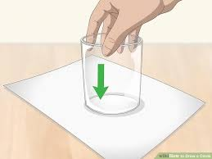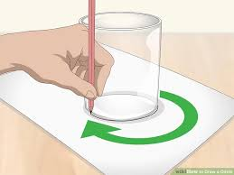You could recycle cardboard from an empty cereal box or use paper to make your medals. Use a cup or glass to draw a circle, you could then use the other end of the cup or a smaller container to create a smaller circle for the centre of your medal.

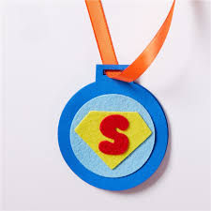

Within the centre of your medal write your own message such as “Well Done”, “You’re a Star” or you could draw a smiley face.

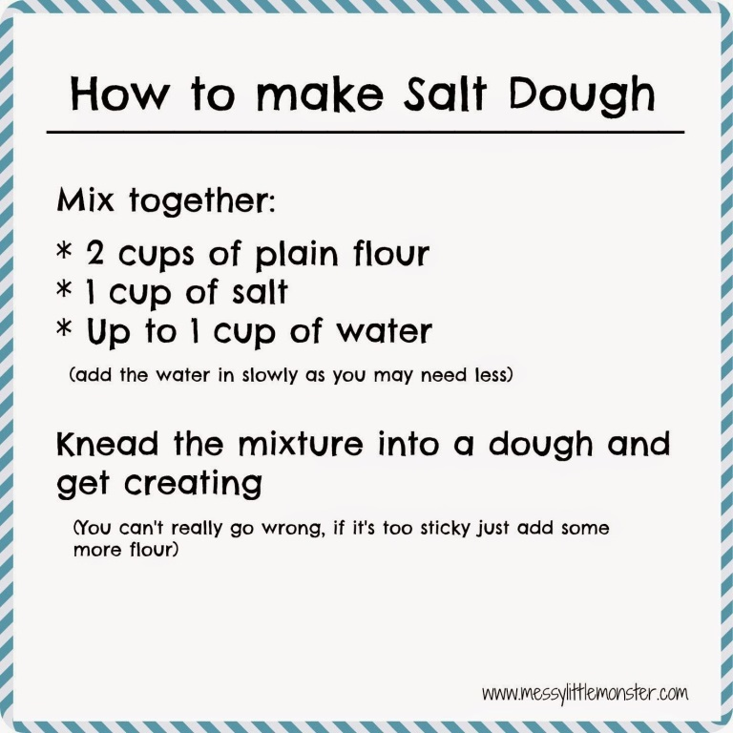Alternatively you could make salt dough to create your medal and use string or a shoe lace as your ribbon (don’t forget to put the shoe lace back when you are finished playing!)

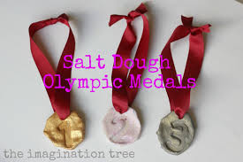

Once you have designed your salt dough medal, place in the oven at 150c/Gas 2 for approximately 3 hours or until they are completely dry.

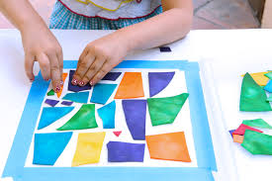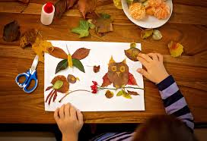When creating your certificates, why not see what is in your recycling bin? Use any cardboard, coloured paper, letters, shapes that you can find and cut them out (Remember to make sure they are clean and safe to use). Design your certificate any way you wish, you could use dried pasta, rice, flower petals, leaves, sticks etc.

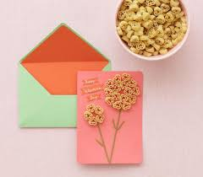Have Fun being creative but please be mindful not to waste a great deal of food, possibly use pasta/rice that has gone past its use by date.

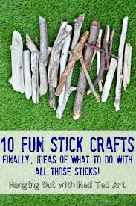

**What are we Learning? Curriculum For Excellence**:

**I have the freedom to discover and choose ways to create images and objects using a variety of materials.**

**EXA 0-02a**

* Through observing and remembering makes a model or drawing based on an aspect of the natural environment such as natural items from the sea shore, the countryside, a forest.