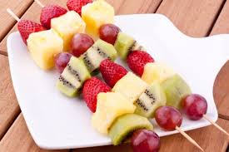

**Fruit Kebabs**

All you will need….

(Fruit of your choice or vegetables)

Skewers

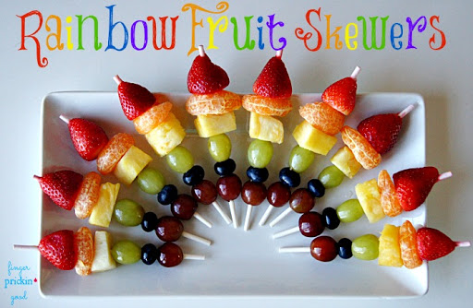

You could use….

* Strawberries
* Grapes
* Apples
* Orange
* Pineapple
* Banana
* Kiwi

You may want to use these links to enjoy some relaxation before or after making your fruit kebabs.

Cosmic Yoga – on YouTube

<https://www.youtube.com/watch?v=8fVQGRrRKPs>

<https://www.youtube.com/watch?v=xlg052EKMtk>

Relaxation Music – On YouTube

<https://www.youtube.com/watch?v=1ZYbU82GVz4>

**What is my child learning?**

I am enjoying daily opportunities to participate in different kinds of energetic play, both outdoors and indoors. **(HWB 0-25a)**

I know that people need different kinds of food to keep them healthy. **(HWB 0-32a)**

Skills developed

Fine motor skills – Good cutting skills – Can speak about why certain foods are important to a healthy body.