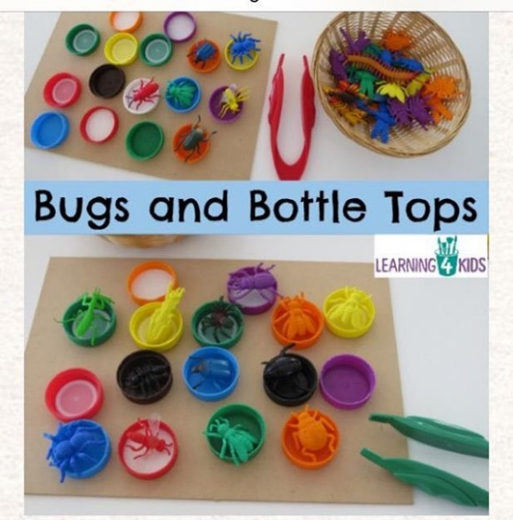
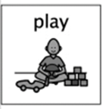
Bugs and Bottle Tops
Week Beginning 1st June 2020.

Activity from https://www.learning4kids.net/2016/03/20/bugs-and-bottle-tops/

This is a fun and engaging activity for children to play if they have a keen interest in exploring bugs. This activity aims to develop the movements in children’s hands and their hand-eye coordination.
What you need:
- Bottle top lids (links nicely with our recycle Eco week).
- Tweezers
- Play bugs (plastic bugs you may have in house, or you can make them with natural materials such as seeds or painted stones).

Ideas
- Use the tweezers to pick up the bugs and place them into the bottle top.
- Turn the bottle tops over and place the different bugs sitting on top rather than inside the bottle top.
- Have a variety of bottle top and plastic lids sizes.
- Sort and match the bugs to the same colour bottle tops.
- Introduce other items that children can place the bugs onto such as blocks.
- Problem solving – what can we do with the bugs that are too big to fit into the bottle tops?

What are the children learning from this experience?
Curriculum for Excellence
I listen or watch for useful or interesting information and I use this to make choices or learn new things. LIT 0-04a
I enjoy investigating objects and shapes and can sort, describe and be creative with them. MTH 0-16a

Skills Developed
- Fine Motor Development – strengthens hands, wrists, and fingers.
- Hand-Eye Coordination and Control
- Concentration
- Colour recognition – matching
- Sorting, matching, and classifying
- Language development – names of bugs and colours
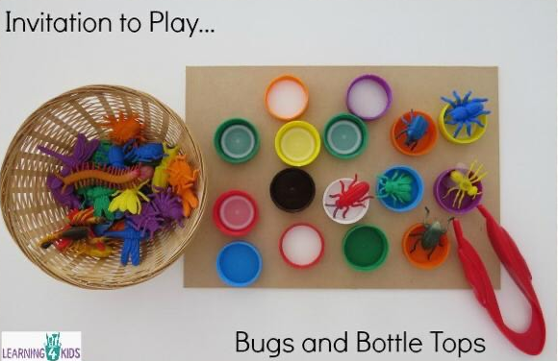
- Problem solving – overcoming challenge
