Story of the Week
Week Beginning 25-05-20

“We’re Going on a Bear Hunt”
By Michael Rosen

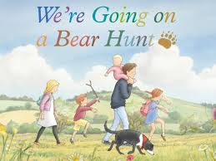

https://www.youtube.com/watch?v=Waoa3iG3bZ4
To help me understand stories and other texts, I ask questions and link what I am learning with what I already know.
LIT 0-07a / LIT 0-16a /
ENG 0-17a
Curriculum For Excellence: Experiences and Outcomes:
• Engages with texts read to them.
• Asks and answers questions about events and ideas in a text.
• Answers questions to help predict what will happen next.
• Contributes to discussions about events, characters and ideas relevant to the text.
• Shares thoughts and feelings about stories and other texts in different ways.

