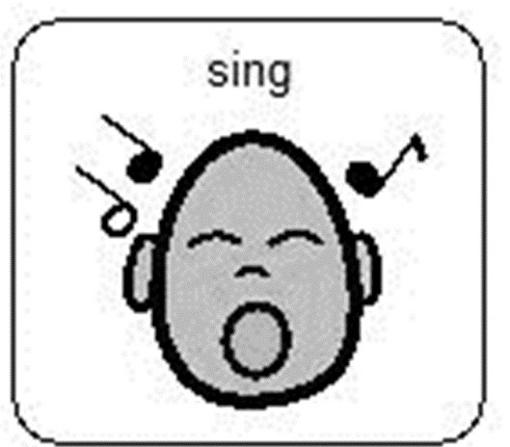

# Song of the week

Week beginning 25th May 2020.

During this term at Hazeldene we would be planting seeds in our garden to grow vegetables, fruits, potatoes, herbs, and flowers. We enjoy singing this song about a cheeky rabbit who eats up all the vegetables or fruits planted.

Ask you child what they will be planting for the song (carrots, potatoes etc.) Encourage them to mime the actions.

I dig my garden dig, dig, dig.

I dig my garden, I dig it deep.

I plant my seeds and I watch them grow,

Then along comes a rabbit OH NO!

He eats my ….(carrots etc.) Munch munch munch

He eats my …(carrots) He eats the whole bunch,

I run to my garden and I shoo shoo shoo

But the rabbit will come back, what shall I do ?

Repeat as many times as you wish

Changing the crop each time.😊



You can hear the tune at [https://www.youtube.com/watch?v=xJUl-h MUdvk](https://www.youtube.com/watch?v=xJUl-hMUdvk)

Actions

I dig my garden dig, dig, dig – Using your hands pretend you are digging up soil in the garden with a large spade

I dig it deep – Using your pretend spade do a big dig in the garden and cover the seeds up.

I plant my seeds and I watch them grow – using your fingers wiggle them and pretend you are sprinkling seeds into the ground, and use your hands and arms and wiggle them up to the sky (this is your plants growing)

Then along comes a rabbit- using your hands above your head to be bunny ears, and a shocked face for OH NO!

He eats … munch munch munch, he eats the whole bunch – using hands pretend to eat the vegetables/fruit very quickly.

I run to my garden – run on the spot as fast as possible.

Shoo shoo shoo- use your hands to shoo away the rabbit.

But the rabbit will come back what shall I do ? – rabbit eats and put arms out like you are wondering/confused.

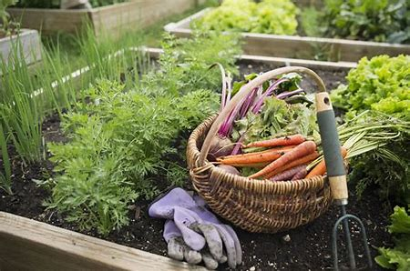You could have a conversation with your child about what a plant needs to be able to grow. Why not try and grow your own plants in the garden or in the house? Discuss the behaviours of the rabbit - do you think it was nice of the rabbit to just take the grown vegetables/fruits ? What would have been a kind way to ask if they could have some of the vegetable/fruits ? How would you feel if someone took something you were working really hard on without asking? How do you think the rabbit felt ?

Curriculum for Excellence

I enjoy exploring and playing with the patterns and sounds of language and can use what I learn. LIT 1-01a / LIT 2-01a

I am aware of and able to express my feelings and am developing the ability to talk about them. HWB 0-01a

I am learning about where living things come from and about how they grow, develop and are nurtured. HWB 0-50a / HWB 1-50a

Skills developed

* Hears and says patterns in words.
* Hears and says rhyming words and generates rhyme from a given word.
* Hears and says the different single sounds made by letters.
* Hears and says letter blends/sounds made by a combination of letters.
* Participates actively in songs, rhymes and stories.
* Gives examples of where living things come from, for example, plants from seeds, fish from eggs.
* Explains that living things need food, water and care to grow and survive.
* Can talk about a variety of different emotions that can be experienced in a variety of situations.
* I am beginning to develop an understanding of the feelings and emotions displayed by others.
* I am developing confidence in discussing my own feelings and emotions.

