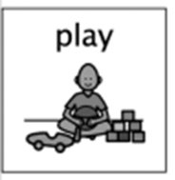
Sensory Bags
Wk Beginning 25th May 2020

What you will need….
- Food bags with a zip
- Jelly
- Shaving gel/foam
- Hair gel/bubble bath
- Spaghetti
- Coffee
- Peas

What to do……
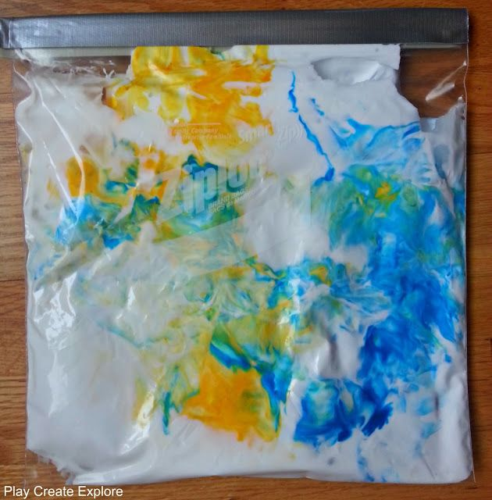
Get your food bag, carefully open it
and put in one ingredient at a time. One ingredient in each bag.

You can then explore the bag
closed up or put your hands
inside and begin to explore.
What can you feel? What does it feel
like? Does it have a smell?

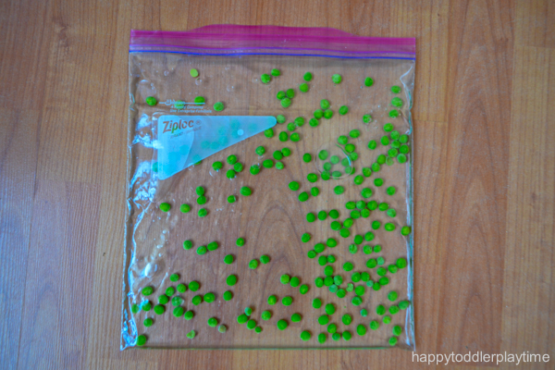

What is my child learning?

I can identify my senses and use them to
explore the world around me (SCN 0-12a)

Skills developed –
Fine motor skills
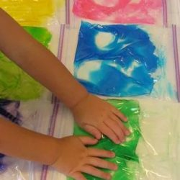
Inspires their curiosity
Allows them to explore and enhances
Their learning, language and creativity

