National Smile Month

Week 1

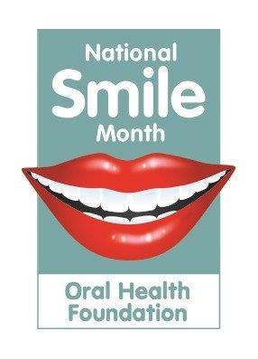

KEY MESSAGE

VISIT YOUR DENTIST REGULARLY, AT LEAST ONCE A YEAR.

A few ideas for some fun activities to celebrate National Smile Month.

Make a smiley mouth with lovely white teeth to display in your window.
You could either draw it, paint it, use collage material or even junk modelling. This is sure to make people smile when they see it in your window.
Make a poster promoting good oral health, e.g. Visit your dentist regularly, Sweets are bad for your teeth, Brush your teeth twice a day….
Remember to wash your hands before brushing your teeth.
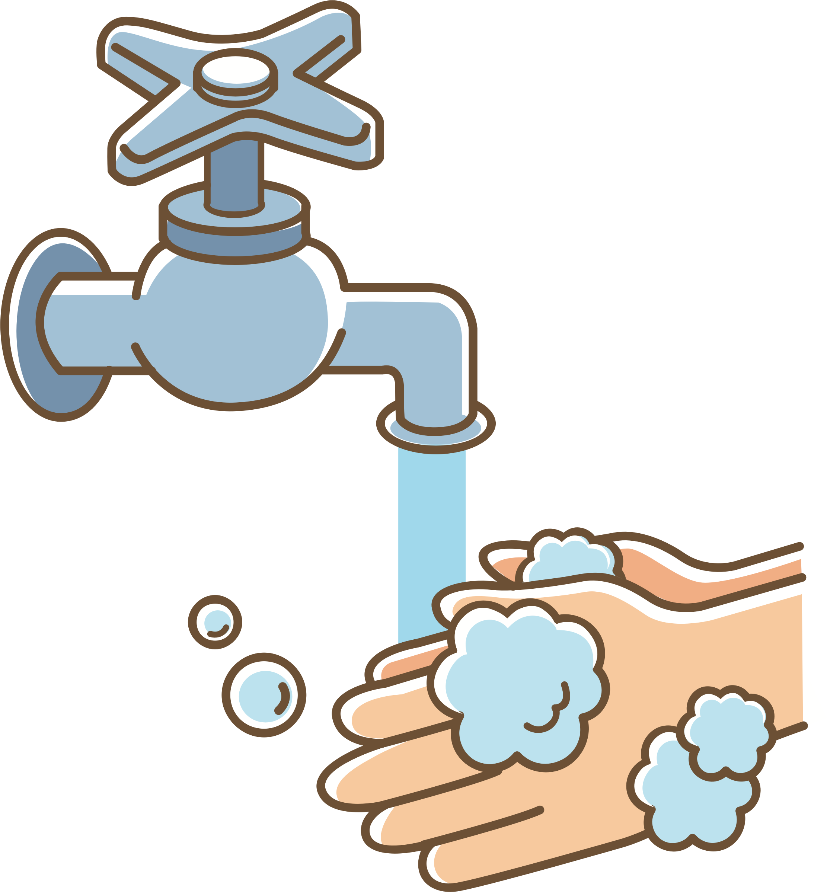

Please share any photos by Tweeting us @HazeldeneFamC using #SmileMonth

Some useful websites.

http://www.child-smile.org.uk/parents-and-carers/index.aspx

http://www.child-smile.org.uk/parents-and-carers/index.aspx

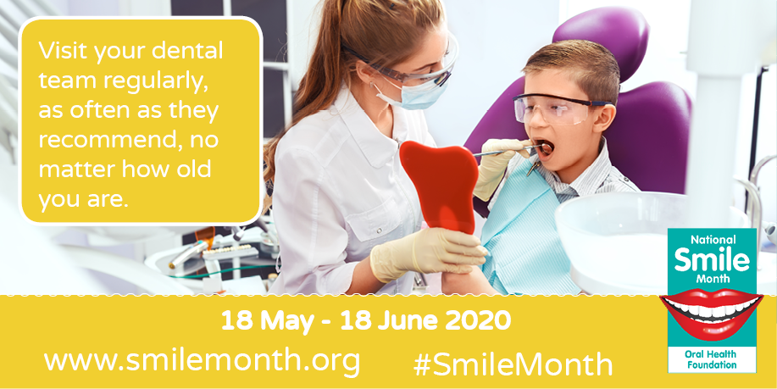

What are the children learning from this experience?

Curriculum for Excellence - Experiences and Outcomes
I am developing my understanding of the human body and can use this knowledge to maintain and improve my wellbeing and health. HWB 0-15a / HWB 1-15a / HWB 2-15a / HWB 3-15a /HWB 4-15a
I am becoming aware of how cleanliness, hygiene and safety can affect health and wellbeing and I apply this knowledge in my everyday routines such as taking care of my teeth. HWB 0-33a
I have the freedom to discover and choose ways to create images and objects using a variety of materials. EXA 0-02a
Skills
- Describe ways of keeping healthy through, e.g. eating and drinking, exercise, sleep, keeping clean and brushing teeth.
- Brush teeth using a circular motion.
- Know that teeth must be brushed to protect them and to stop bacteria building up
- Wash hands correctly and explain that clean hands stop the spread of germs.
- Know that hands are washed after coughing, sneezing, going to the toilet or before eating.
- Use tools and equipment to develop increasing control of the fine movements of fingers and hands.
- Use knowledge gained to select materials and tools to create a piece of visual art.

