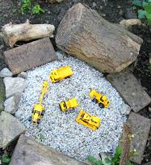
Go Outside, Go Explore and use your Imagination!

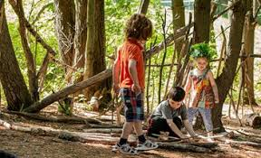
At Hazeldene we love to use our imagination. We often sit in our boat and imagine we are sailing to London to visit the Queen. Sometimes we go outside to our garden and we gather soil, stones, sticks, anything we can find and we use our imagination to become chefs in a restaurant. We can make mud pies, chocolate cupcakes and homemade soup!
When you use your imagination you can be anything you want to be!
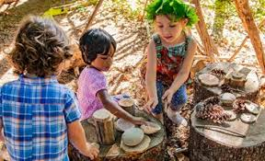
Why not imagine you have a horse and you are competing in a horse show? Or go out on a dinosaur hunt and see if you can find any mysterious footprints!
Use your imagination, have fun and don’t forget to Tweet us a picture @HazeldeneFamC (Mums and Dads too)
I enjoy exploring events and characters in stories and other texts and I use what I learn to invent my own, sharing these with others in imaginative ways.
LIT 0-09b / LIT 0-31a
Curriculum For Excellence, What my child will gain from imaginary play:

• Talks clearly to others in different contexts, sharing feelings, ideas and thoughts.

• Recounts experiences, stories and events in a logical sequence for different purposes.

• Communicates and shares stories in different ways, for example, in imaginative play.

• Uses new vocabulary and phrases in different contexts, for example, when expressing ideas and feelings or discussing a text.
Within real and imaginary situations, I share experiences and feelings, ideas and information in a way that communicates my message.
LIT 0-09a

