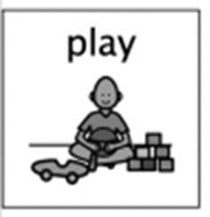
Hidden letters
Wk beginning 25th May 2020

At Hazeldene we use playful pedagogy to spark children’s curiosity throughout all curricular areas. An activity that is popular at the writing table is when all our letters get jumbled up in the sand tray and we explore for the different letters and talk about their letter names and sounds. To adapt and revisit this experience here are some ideas:
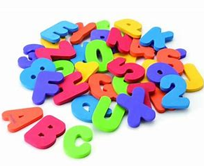
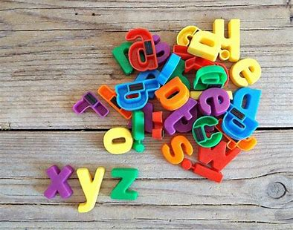
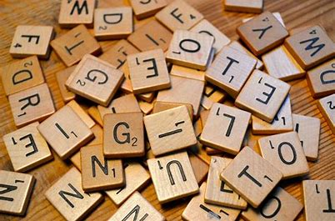
Use any letters that you may have around the house (magnetic, scrabble, foam) or you can write your own letters on strong pieces of carboard, making sure you get all the letters of the alphabet. Can you find the first letter of your name? Can you find the initial letter of other family names? Can you make the sound of the letters? (see https://www.youtube.com/watch?v=-ksblMiliA8 ) What letters have you seen before? Are there any letters you don’t recognise?
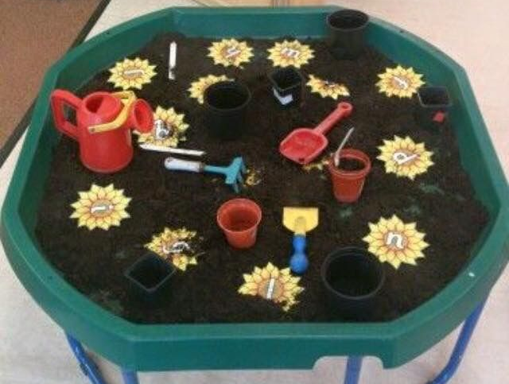
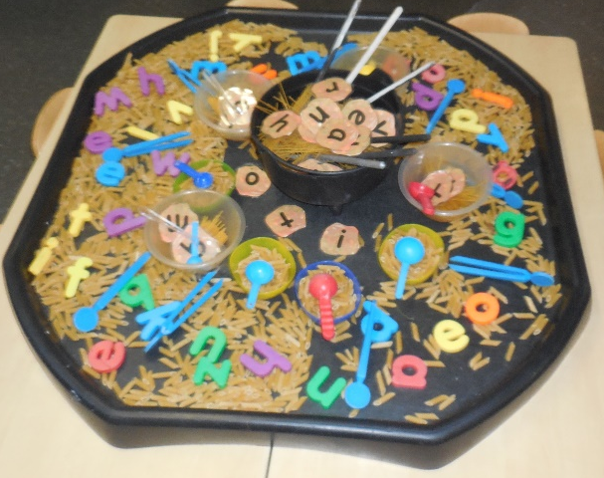
Letters lost in soup – water, Pasta (please be mindful when using food for play)
Letters lost in soil
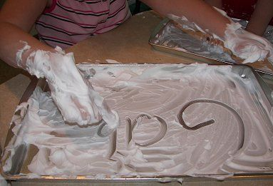
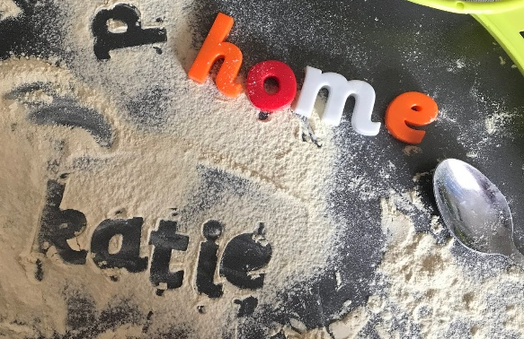

Letters lost in shaving foam, shampoo, honey etc another alternative you could use these materials to write your own letters
Letters lost in flour or sand

Offering different sensory experiences for children to find the letters within allows the children explore their five senses (smell, touch, look, hear and taste) have fun, get messy and learn !.

Curriculum for Excellence - What are the children learning from this experience?
I can identify my senses and use them to explore the world around me. SCN 0-12a
As I play and learn, I enjoy exploring interesting materials for writing and different ways of recording my experiences and feelings, ideas and information. LIT 0-21b
I explore sounds, letters and words, discovering how they work together, and I can use what I learn to help me as I read and write. ENG 0-12a / LIT 0-13a / LIT 0-21a
I enjoy exploring and playing with the patterns and sounds of language, and can use what I learn LIT 0-01a
I have the freedom to discover and choose ways to create images and objects using a variety of materials. EXA 0-02a

Skills Developed
- Hears and says patterns in words.
- Hears and says the different single sounds made by letters.
- Hears and says letter blends/sounds made by a combination of letters.
- Knows the difference between a letter, word and numeral.
- Uses knowledge of sounds, letters and patterns to read words
- Writes for enjoyment, exploring patterns and sounds, in a range of play, imaginative and real contexts
- Records from experiences across the curriculum, for example, through observing and remembering.
- Identifies specific parts of the body related to each of the senses.
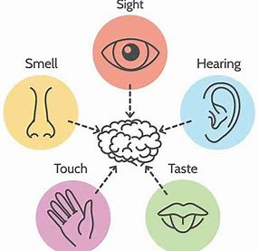
- Uses their senses to describe the world around them, giving examples of things they see, hear, smell, taste and feel.

