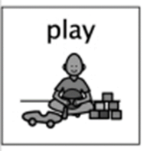
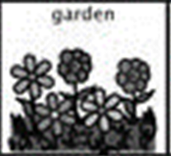
Garden Play Box
Week beginning 25th May 2020

Linking in with the Eco focus for this week of planting, this a fun way for children to get involved and learning about different plants and exploring their curiosity, inquiry and imagination. During this term, especially with the recent beautiful weather, we would be spending most of our time outdoors playing and the children would be looking after and caring for our garden, fruit, vegetables, and flowers.
What you will need:
- Large plant pot or if you don’t have a plant pot a large durable container.
- Soil or compost
- Small plants
- Small world (figures, bugs - your choice)
- Yoghurt pot

If using a plastic box, make drainage holes in the bottom before you start the activity. Next the children can fill the box with earth. Place the yoghurt pot in the earth so the top of the pot is level with the top of the earth, then plant a range of small flowers or grasses in the box. Fill the yoghurt pot with water to make a small pond. While doing this activity you can discuss with the children how plants grow and what they need to grow, the children can also continue this learning by caring for the garden themselves. Once the garden has been completed the children can play in it with small world figures or animals.
Activity idea from https://www.nurseryactivityideas.co.uk/outdoor-activities/creating-a-small-garden-play-box.html .
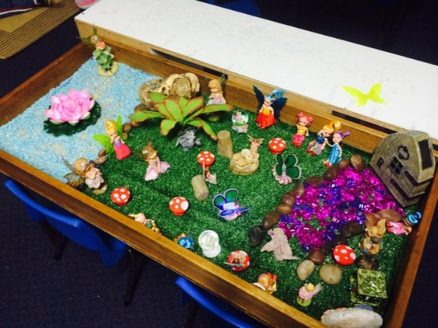
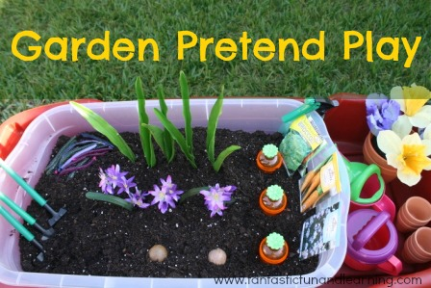

What are the children learning from this experience?

Curriculum for Excellence
Within real and imaginary situations, I share experiences and feelings, ideas and information in a way that communicates my message. LIT 0-09a
I explore and appreciate the wonder of nature within different environments and have played a part in caring for the environment. SOC 0-08a

Skills developed
- Talks clearly to others in different contexts, sharing feelings, ideas and thoughts
- Recounts experiences, stories and events in a logical sequence for different purposes.
- Communicates and shares stories in different ways, for example, in imaginative play.
- Uses new vocabulary and phrases in different contexts, for example, when expressing ideas
- Talks about something they have done to care for the environment.
