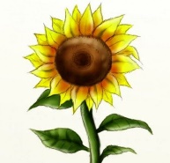
Planting Week activities
Seed Collection Activity
A little Flower of Hope
- On your daily exercise, go to Hazeldene Family Centre and collect your Little Flower of Hope seed kit. (If you didn’t manage to collect one yet, further supplies have been ordered). When collecting seed kits please be mindful of others. We have used rainbow ribbons on our fence as social distance markers – these have been placed at two metre intervals. Please wait patiently if other families arrive at same time.
- Take a photo. You could use Mummy or Daddy’s phone a camera or an I-pad and maybe they could take a photo of you collecting your seeds. Tweet your photo to us a @HazeldeneFamC
- Remember to social distance and follow good road safety when out walking.
Pot Making Activity
- Follow the Instructions to make your own seed pot from recycled materials.
- To make your pot you will need the following materials:
Old newspaper, recycled cardboard tubes (inside of kitchen/toilet roll), egg box, scissors and pens/pencils to decorate
- Find pot making instructions @ https://www.google.com/search?q=how+to+make+biodegradble+pots&oq=how+to+make+biodegradble+pots&aqs=chrome..69i57j0l7.11615j0j7&sourceid=chrome&ie=UTF-8#kpvalbx=_c169XrGZLs-ChbIP2e2vwAc34

Planting Activity

How to grow your sunflower
- Fill the pot you have made with some compost.
- Make a little hole in the compost with your finger and place the seed carefully in the hole and cover them up with some more compost.
- Remember to water the seeds gently.
- As your little seed grows and becomes a little seedling Mummy and Daddy could help you find a nice sunny spot in the garden where you could dig a little hole and carefully plant your little biodegradable pot.
- If you prefer you could plant your sunflower in a large container/plant pot instead
- Be careful, as slugs and snails like to eat the new shoots. You may like to protect the seedlings by cutting the top off a plastic bottle and placing it over your seedlings.
- As your sunflower begins to grow taller than you, you will need to help support the stem by placing a cane near the stem and loosely tying the cane to the plant with string.
- Watch your sunflower grow and grow and grow.
- Can you measure your sunflower?
- Can you draw pictures of your sunflower as it grows?
- Take some photographs of your sunflower
- Ask a grown up to take a picture of you standing beside your sunflower.
Sing this song to help your little seed grow
Happy sun high happy sun low @ https://www.youtube.com/watch?v=47OADJqBc8o

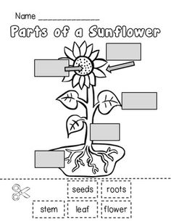
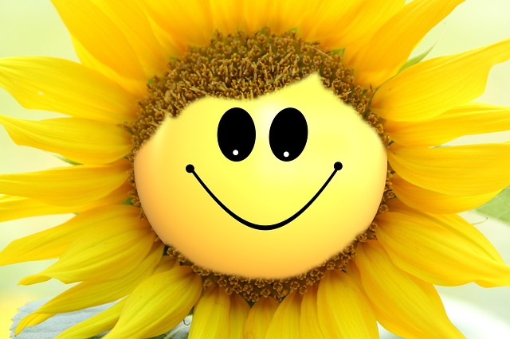
Parts of a Sunflower Activity
Can you name the parts of the sunflower? You can copy the words into the correct boxes or cut out the words at bottom of sunflower picture.
Learn about plant parts
Plant parts with Dr Bincos @ https://www.google.com/search?ei=vGm9XoeTOY2BhbIP6OG1yAc&q=dr+binocs+parts+of+a+plant&oq=dr+bincos&gs_lcp=CgZwc3ktYWIQARgBMgQIABBDMgQIABBDMgQIABBDMgQIABAKMgQIABAKMgQIABAKMgQIABAKMgQIABAKMgQIABAKMgQIABAKOg4IABDqAhC0AhCaARDlAjoFCAAQkQI6BwgAEAoQkQI6BQgAEIMBOgIIADoGCAAQChBDOgkIABBDEEYQ-wE6BwgAEIMBEEM6BAgAEANQ-0VYzWVgm4wBaAFwAHgAgAGfAYgBvAaSAQM3LjKYAQCgAQGqAQdnd3Mtd2l6sAEG&sclient=psy-ab
Story time
Listen to the storyHow to grow a dinosaur written by Caryl Hart and Ed Leaves @ https://www.youtube.com/watch?v=AtP9Ja9xMgQ
Sing – along
What a plant needs song @ https://www.youtube.com/watch?v=AtP9Ja9xMgQ
Watch Sesame Street’s Grover the Gardener @ https://www.youtube.com/watch?v=ZDjFZVqiLvY

What are the children learning from these experiences?
I know that being active is a healthy way to be. HWB 0-27a
Show understanding of importance of exercise in daily life in order to stay healthy.
I enjoy taking photographs or recording sound and images to represent my experiences and the world around me. TCH 0-04b
Capture images using a digital camera or digital video camera.
Within and beyond my place of learning. I can reduce, reuse, and recycle resources I use, to help care for the environment. TCH 0-02a
Investigate and describe how a variety of materials can be used or changed for specific purposes.
I explore and appreciate the wonder of nature within different environments and have played a part in caring for the environment. SOC 0-08a
Investigate nature and living things. Develop an understanding of the need to care for the environment. Investigate nature by caring for the environment e.g. planting seeds, growing things, caring for plants, or living things.
I have helped to grow plants and can name their basic parts. I can talk about how they grow and what I need to do to look after them. SCN 0-03a
Explores, observes, and discusses basic needs of plants and what they need to grow including water, heat, sunlight and soil. · Demonstrates understanding of how plants grow from seeds.
Respond to questions about the planning of an investigation. Agree on what might happen from several suggestions provided. Follow simple instructions. Use simple techniques and apparatus. Measure using non-standard units. Select appropriate samples. Recognise simple cause and effect. Recognise similarities and differences. Use observation skills.

Measurement I have experimented with everyday items as units of measure to investigate and compare sizes and amounts in my environment, sharing my findings with others. MNU 0-11a
Make a simple record of an investigation, e.g. drawing pictures, pictorial charts, writing captions and lists. Make a display to relate findings to everyday experience / daily life. Answer questions about what happened. Ask questions in relation to one or more observations
As I listen and take part in conversations and discussions, I discover new words and phrases which I use to help me express my ideas, thoughts, and feelings. LIT 0-10a
Use new and different words and phrases to express ideas, thoughts and feelings and show understanding of the structure and functions of language.
To help me understand stories and other texts, I ask questions and link what I am learning with what I already know. Understanding, Analysing & Evaluating LIT 0-07a / LIT 0-16a / ENG 0-17a LTR
Answer different types of questions to recall main points, retell in sequence and recognise the main idea. Ask questions to extend knowledge and understanding and to clarify thinking. Recall and describe the main idea / event(s) and the characters in texts. Retell and create stories and events orally. Share and record experiences and feelings, preferences, ideas, and information in a variety of ways
I enjoy exploring and choosing stories and other texts to watch, read or listen to, and can share my likes and dislikes. LIT 0-01b / LIT 0-11b
Listen to and recite rhymes, songs, and poems. Repeat words and phrases from familiar stories.

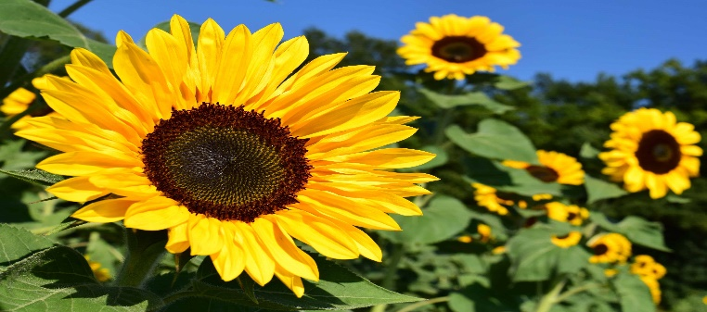

A Little Flower of Hope Seed Collection Guidance
- On your daily exercise, go to Hazeldene Family Centre and collect your Little Flower of Hope seed kit.
- Remember to take photographs and Tweet @HazeldeneFamC.
- When collecting seed kits please be mindful of others
- Follow signs.
- Rainbow ribbons have been used on our fence as social distance markers – these have been placed at two metre intervals.
- Please wait at ribbon marker if any other family has arrived at same time.
- Collect your seed kit from plastic box ( you may wish to bring your own gloves to wear)
- There is an anti-bacterial spray in bucket to spray lid of box if required.
- After successfully collecting your seed kit please replace lid securely on box.
- Please do not congregate on or around the nursery grounds.
- Always keep yourself and others safe.
- Most importantly….happy planting.

