**Make your own cheerios Bird Feeder**

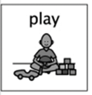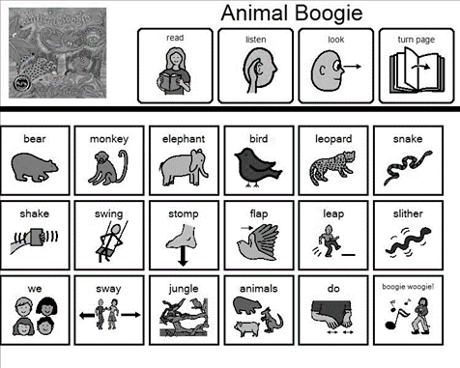

**How to make:**

1. Make a small loop at one end of the pipe cleaner.
2. Thread the Cheerios onto the pipe cleaner.
3. Once the pipe cleaner is full of Cheerios twist each end of the pipe cleaner together and bend it into any shape your child wishes to make.
4. Go outside and find a spot. to hang your bird feeder.

**What you will need:**

Cheerios or similar cereal loops

Pipe cleaners

I explore and appreciate the wonder of nature within different environments and have played a part in caring for the environment. **(SOC 0-08a)**

I have observed living things in the environment over time and am becoming aware of how they depend on each other **(SCN 0-01a)**

**Skills that will be developed:**

Fine motor skills

Investigate nature and living things

Looking at the different types of birds

Understanding why it’s important to care for animals

How many different birds did you see?

Did any other animals visit the bird feeder?

