Story of the Week
Week Beginning 18-05-2020

Boogie Bear by David Walliams
https://www.youtube.com/watch?v=tphBBay1q5k
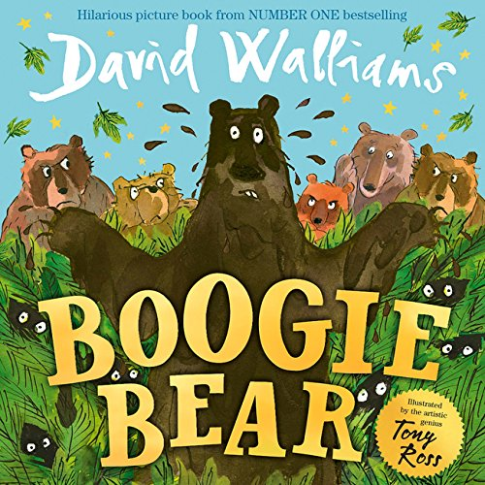

Linking in with our Eco group, here is an animated video that will help your child see the damage our litter can do to animals in the sea.

“A Whale’s Tale”: https://www.youtube.com/watch?v=xFPoIU5iiYQ
A whale helps smaller sea creatures who are trapped in plastic waste. On land a young boy seeks support to clear the sea in his area. Fishermen come to his aid and many boats start to help clear the plastic from the sea.
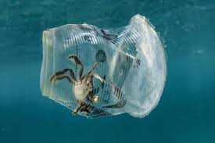
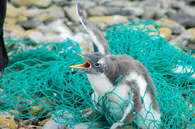
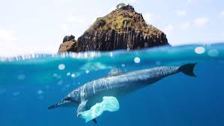

Curriculum For Excellence
Literacy & English: Reading, Listening and Talking

Enjoyment and choice:
I enjoy exploring and choosing stories and other texts to watch, read or listen to, and can share my likes and dislikes.
LIT 0-01b / LIT 0-11b

- Participates actively in songs, rhymes and stories.
- Chooses a story or other texts for enjoyment, making use of the cover, title, author and/or illustrator.
- Engages with and enjoys watching, reading or listening to different texts, including stories, songs and rhymes, and can share likes and dislikes.

I enjoy exploring events and characters in stories and other texts, sharing my thoughts in different ways.
LIT 0-01c

- Engages with stories and texts in different ways, for example, retelling/re-enacting stories and/or using puppets/props.

Tools for listening and talking:
As I listen and talk in different situations, I am learning to take turns and am developing my awareness of when to talk and when to listen.
LIT 0-02a / ENG 0-03a

- Makes an attempt to take turns when listening and talking in a variety of contexts.
- Makes an attempt to use appropriate body language when listening to others, for example, eye contact.
- Listens and responds to others appropriately.
- Asks questions and responds relevantly to questions from others.
- Follows and gives simple instructions.

