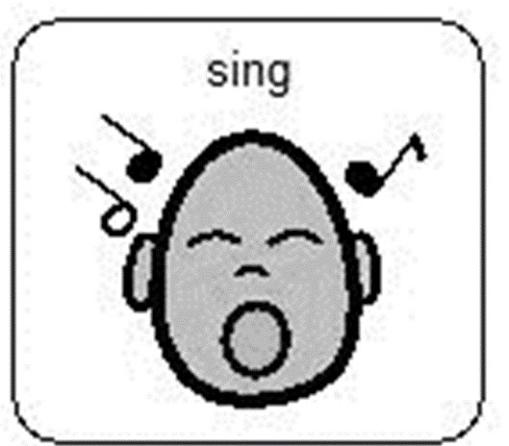

Song of the week
Week beginning 18th May 2020

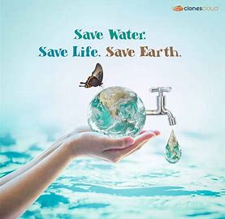
This week our home learning Eco Committee focus is litter week. Here is a song about Keeping Scotland Beautiful and remembering to save water. We hope you have fun enjoying this song and look forward to hearing you sing it when we are back at nursery .

(Sung to the tune of Twinkle, twinkle little star)

Water, water we must save!
Water, water’s not to waste.
We use water every day, we must use it carefully.
Water, water comes from rain. Drinking water helps our brain.
Water, water we must save!
Water, water’s not to waste.
Water, water is so pure. Turn the taps off to be sure.
Water, water everywhere. Please be mindful and let’s share.

Repeat as many times as you wish

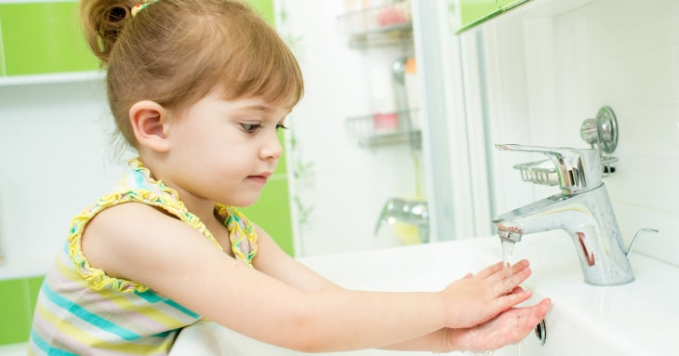

What is my child learning from this experience?

Curriculum for Excellence
I enjoy exploring and playing with the patterns and sounds of language and can use what I learn. LIT 1-01a / LIT 2-01a

By investigating how water can change from one form to another, I can relate my findings to everyday experiences. SCN 0-05a / SCN 1-05a
To help care for the environment, I reduce, re-use and recycle the resources I use. TCH 0-06a

Together we enjoy handling, tasting, talking and learning about different foods, discovering ways in which eating, and drinking may help us to grow and keep healthy. HWB 0-30a

Skills developed
- Hears and says patterns in words.
- Hears and says rhyming words and generates rhyme from a given word.
- Hears and says the different single sounds made by letters.
- Hears and says letter blends/sounds made by a combination of letters.
- Participates actively in songs, rhymes and stories.
- Understands what can be reduced, re-used and recycled.
- Identifies how much water should be consumed in a day
- Talks about water in nature and how it influences their everyday lives
