Let’s talk
Ask everyone in your house the question “How are you feeling today?” It is so important to talk to one another.
Whilst you and your child are playing together remember to encourage your child to talk about their feelings and emotions.

It is extremely important that your child knows they can express their feelings towards you or someone they feel comfortable with.

Talk to your child, tell them how you are feeling today this will allow your child to see that it is safe to talk about your feelings out loud and this will allow children to hear how you describe your feelings.

Now is a very important time for children to know that they can openly talk about how they are feeling as this is a difficult time for your child as well as there has been a lot of changes happening within their lives.

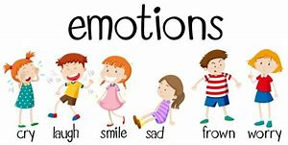
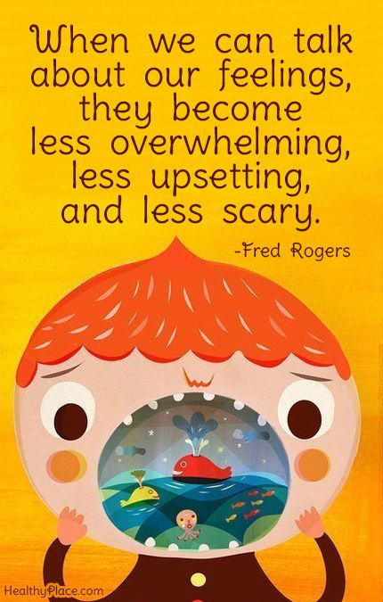
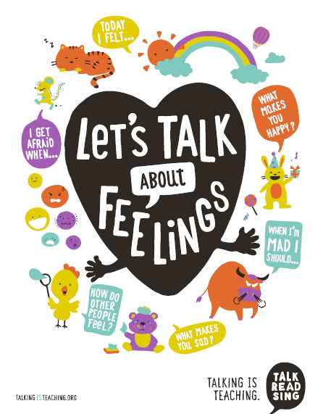
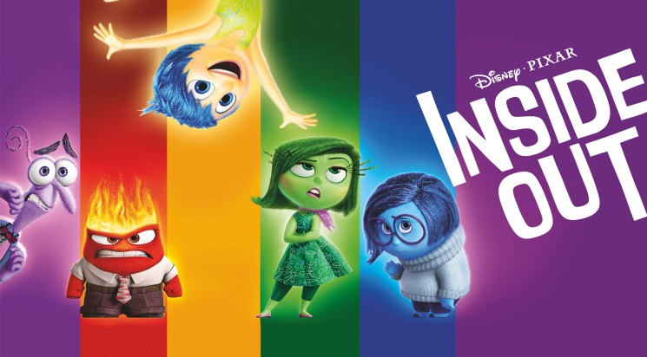
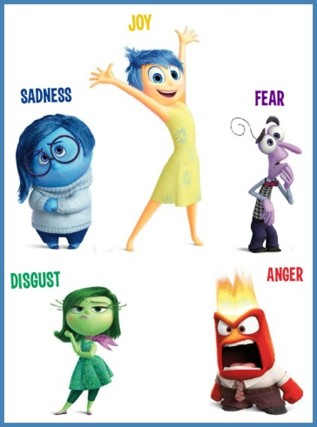
Here is a story that children can enjoy and hopefully will be encouraged to express their own feelings:

https://www.youtube.com/watch?v=xIfLgHBwYx4

If you have access to Disney Plus, Netflix or Amazon Prime at home, then I am sure your child would enjoy the film below.

Feeling a little tired? Why not have some time out and watch a film together? Below is a film that will help children and adults understand children’s emotions and how they are feeling.
Feelings and emotions

What is my child learning from this experience?

Listening and talking:
Curriculum for Excellence

Within real and imaginary situations, I share experiences and feelings, ideas and information in a way that communicates my message.
LIT 0-09a
As I listen and take part in conversations and discussions, I discover new words and phrases which I use to help me express my ideas, thoughts and feelings. LIT 0-10a
Skills Developed:
- Talks clearly to others in different contexts, sharing feelings, ideas and thoughts
- Recounts experiences, stories and events in a logical sequence for different purposes
- Communicates and shares stories in different ways, for example, in imaginative play
- Uses new vocabulary and phrases in different contexts, for example, when expressing ideas and feelings or discussing a text.

