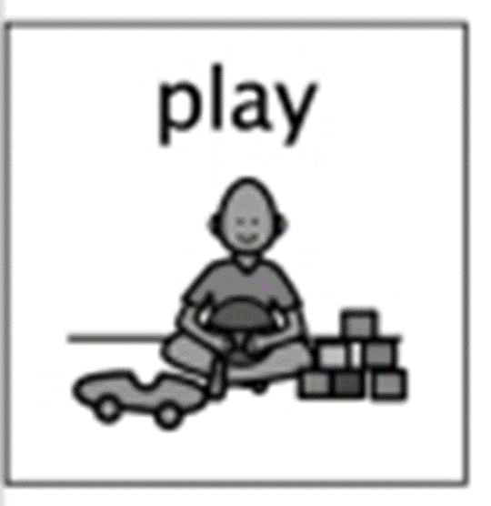
Fun with Shapes
Week Beginning 18th May

Shape Hunt at Home
How many shapes can you find?
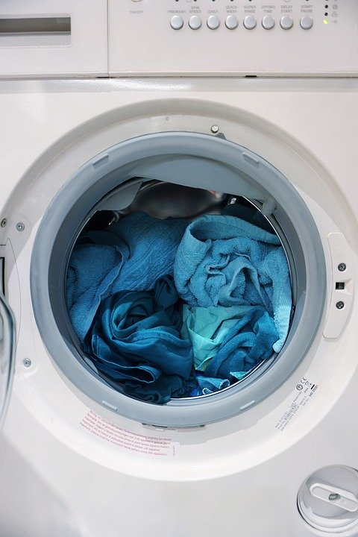 |  | 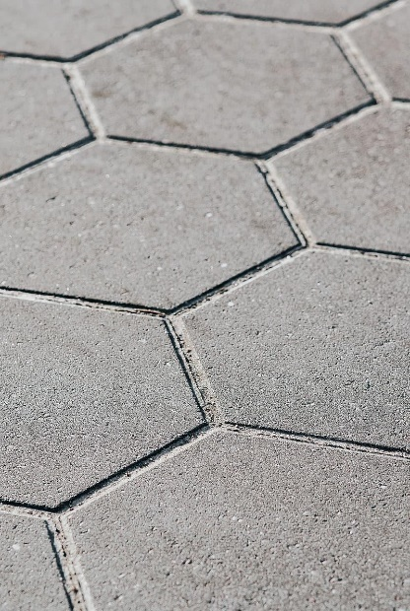
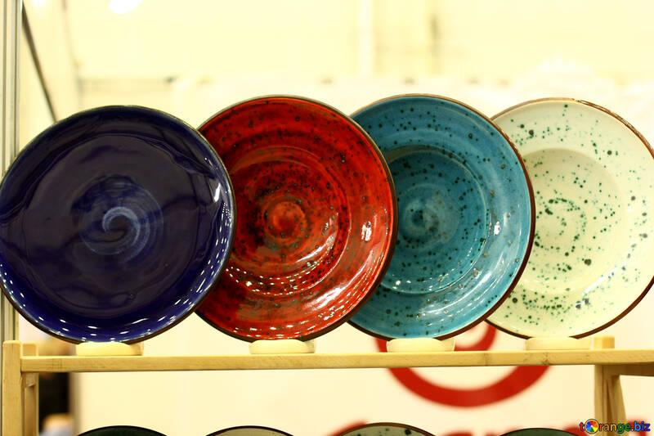 | 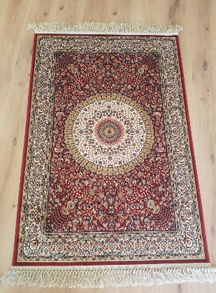 | 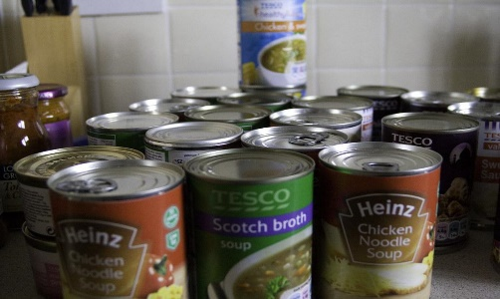
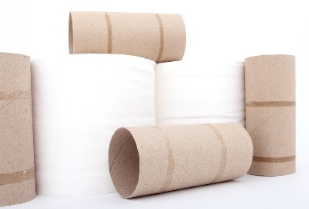 |  | 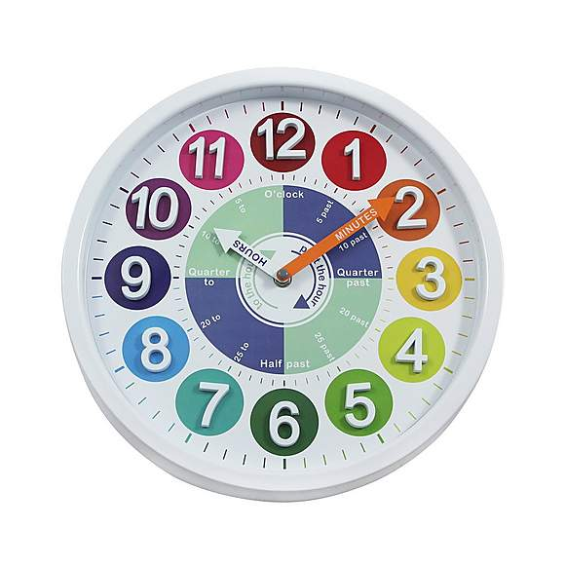
What is my child learning from this experience?
Curriclum for Excellence
I enjoy investigating objects and shapes and can sort, describe and be creative with them. (MTH0-16a)

Skills Developed:

- Describe the properties of a range of 2D shapes, e.g. sides, corners.
- Identify and name 2D shapes in the environment e.g. stars, circles, squares, rectangles, hexagons and triangles.
- Identify and describe 3D objects: e.g. cubes, cuboids, cones, cylinders, spheres, pyramids.
Now it’s time to learn a rhyme…
How many cubes can you find in your house?
How many spheres can you find?
Find out what a cuboid is and how this is different from a cube.

Take some photos of the different shapes you find and Tweet them to us @HazeldeneFamC
3-D Shapes
3-D shapes are fat not flat.
A cone is like a party hat.
A sphere is like a bouncy ball.
A prism is like a building tall.
A cylinder is like a can of fizzy pop.
A cube is like a dice you drop.
3-D shapes are here and there.
3-D shapes are everywhere!

