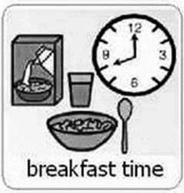
Fruit Smoothies
Week beginning 18th May 2020.

Recipe from Oxford University Press, (2012), Fruit smoothies @ https://cdn.oxfordowl.co.uk/2013/06/28/10/44/27/909/fruit_smoothies.pdf (last accessed: 14.05.20).
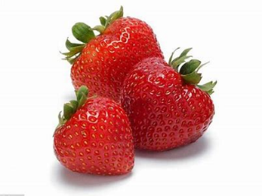
What you will need.
8 strawberries
1 banana
2 peaches
285 ml apple juice
1 cup of ice cubes

Chop, chop, chopp-idy chop! Chop off the bottom and chop off the top.

With some help from an adult, you will need to chop all of your fruit into small to medium pieces

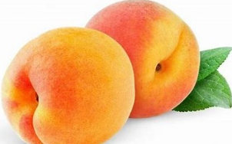

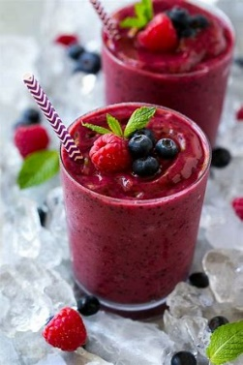
Place all of your chopped-up fruit and juice into a blender. With some adult help, blend the ingredients until they are smooth, then enjoy your tasty smoothie.

Why not become inventive and create your own flavours of smoothies using different fruit and vegetables?
Don’t forget to send in a picture of your great creations to schoolmail@hazeldene.e-renfrew.sch.uk (please reduce the size of photos if emailing) or Tweet us @HazeldeneFamC
What are the children learning through this experience?

Curriculum for Excellence
I am becoming aware of how cleanliness, hygiene and safety can affect health and wellbeing. HWB 0-33a
I have experimented with everyday items as units of measure to investigate and compare sizes and amounts in my environment, sharing my findings with others. MNU 0-11a

Skills developed
- Shares relevant experiences in which measurements of lengths, heights, mass and capacities are used, for example, in baking.
- Describes common objects using appropriate measurement language, including tall, heavy and empty.
- Compares and describes lengths, heights, mass and capacities using everyday language, including longer, shorter, taller, heavier, lighter, more and less.
- Estimates, then measures, the length, height, mass and capacity of familiar objects using a range of appropriate non-standard units.
- Demonstrates how to perform daily hygiene routines, for example, hand washing.
- Gets ready to prepare food, for example, wash hands, tie hair back, wear an apron.
- Demonstrates an understanding of basic food hygiene and safety through, for example, washing fruit and vegetables, storing perishables in the fridge.
- Works safely when using simple kitchen equipment.
