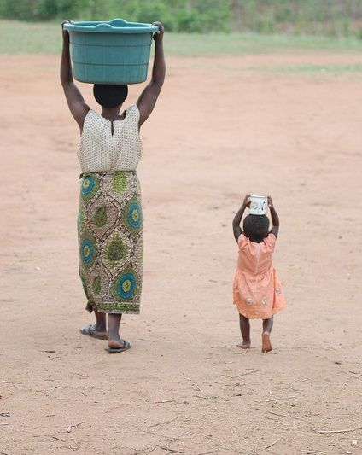Please take photos of your children participating in any home learning and send them to [schoolmail@hazeldene.e-renfrew.sch.uk](mailto:schoolmail@hazeldene.e-renfrew.sch.uk) or Tweet them @Hazeldene FamC

Water Week Activities

Water Investigations

How do we get clean water in our houses?

We are very lucky in Scotland to have clean water in our homes. We turn on a tap to get the clean water and a wastewater system then takes all the dirty water away and cleans it so that it can be used again.

In some countries children and their families must walk a long way to collect their water and then carry it home in a bucket or container.

**Water is heavy. Have you ever had to carry a bucket of water very far?**

In your garden make some numbers 0-10/20 (you could use chalk, number cards or write your numbers on paper.)

Space the numbers around the garden. Ask a grown up for some different size containers you can fill with water. Start with the smallest container can you carry it to number 4? Which is the biggest number you can carry it too? How many times can you carry it up and down the garden? Choose a different size container and repeat.

**How far can you carry the water? Which container can you carry the furthest?**

When you have tried all the different size containers have a drink of fresh tap water to cool you down.

Sing along to the drink water song @ <https://www.youtube.com/watch?v=gvuhAVH-BU8>

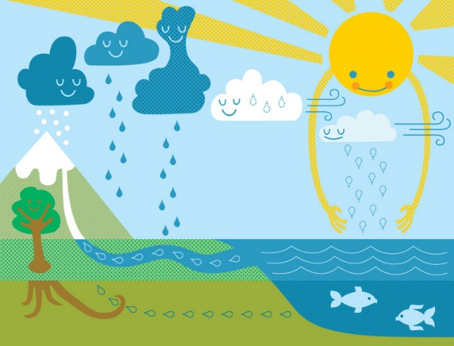

How Much Water?

We may be unaware of how much water we use as it is so easy to turn on a tap. How many times does each person at home use water in one day?

You can make a guess, put up a tally sheet. Print our chart (on the next page) or make your own.

Ask everyone to tick the sheet every time they use water and what they used it for.

Washing dishes brushing teeth, hand washing, washing machine, filling kettle, drinking, filling pet bowls etc. Ask everyone in the family to record their water usage for a day/week.

Take photo of your results and send them to us.

Sing- along

Sesame Street Water song @ <https://www.youtube.com/watch?v=CwpHMPH-WbM>

Short educational film

Watch raindrops birth @ <https://www.youtube.com/watch?v=0L0xct8JDPw>

Watch save water animation @ <https://www.youtube.com/watch?v=rl0YiZjTqpw>

Story Time

Listen to the story Little Raindrop written by Melanie Joyce @ <https://www.youtube.com/watch?v=try9T7dPLR4>

Learn about the Water Cycle

Water cycle with Dr Binco @ <https://www.youtube.com/watch?v=ncORPosDrjI>

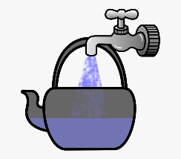Chart for How Much Water- Activity

|  |  |  |  |  |  |
| --- | --- | --- | --- | --- | --- |
| Activity | Person 1 | Person 2 | Person 3 | Person 4 | Person 5 |
| Dish washing |  |  |  |  |  |
| Washing machine |  |  |  |  |  |
| Hand washing |  |  |  |  |  |
| Fill kettle |  |  |  |  |  |
| Drink of water |  |  |  |  |  |
| Flush toilet |  |  |  |  |  |
| Shower or bath |  |  |  |  |  |
| Gardening |  |  |  |  |  |
| Car washing |  |  |  |  |  |
| Other |  |  |  |  |  |

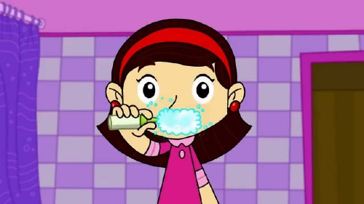

Encourage your child to switch off the tap while brushing their teeth to save water.

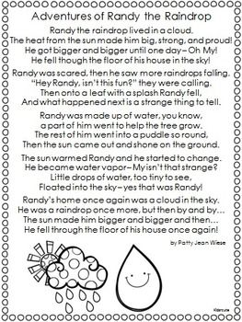

**Make a Rain Catcher**

You can use recycled plastic bottles or any waterproof material to create a rain catcher. Invite your child to decorate the outside of the bottle, You can either cut the top off the bottle so it leaves space for water to be collected or cut the bottom off, turn it upside down and when it is full place a container under rain catcher, unscrew the bottle top and let the rain run into the container. You can use string, twine, or cable ties to attach your rain catcher to the garden fence, shed etc.

Encourage children to write numbers up the side of the bottle (use a ruler to help them mark off in centimetres). Each day you can check to see if any water has been collected. You can use the recycled water to water the garden or keep it for next week’s Eco activities.

Create a rain water chart and check the rain catcher at the same time of each day, recording the amount of rain water in the bottle over the course of the week, to identify if there are any patterns. Help your child to count on from the previous number recorded to work out how much rain has fallen each day. Compare daily amounts and ask your child is there is more, less or the same amount collected as the previous day. This will help your child to develop their mathematical language.

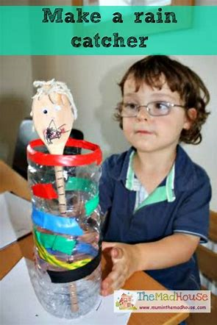

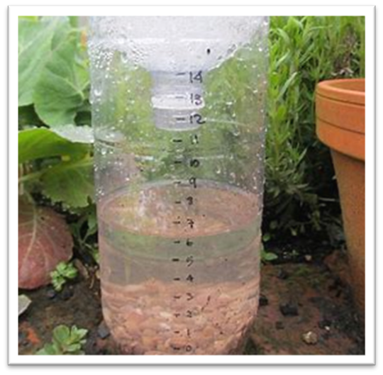

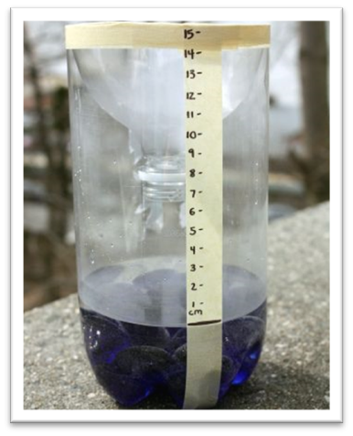

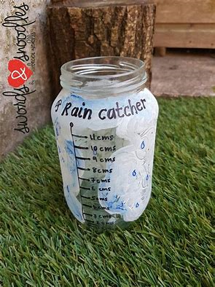

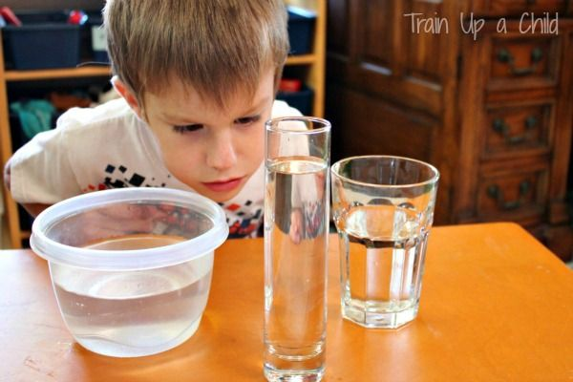

Water Investigations – What are the children learning?

**Curriculum for Excellence**

**MNU 0-02a**

Number and number processes, I have explored numbers, understanding that they represent quantities, and I can use them to count, create sequences and describe order.

* Recognise numerals from zero.
* Sequence numbers in order from zero

**MNU 0-01a**

I am developing a sense of size and amount by observing, exploring, using and communicating with others about things in the world around me.

* Checks estimates by counting.
* Demonstrates skills of estimation in the contexts of number and measure using relevant vocabulary, including less than, longer than, more than and the same.

**MNU 0-11a**

I have experimented with everyday items as units of measure to investigate and compare sizes and amounts in my environment, sharing my findings with others.

**MNU 0-11a**

* Shares relevant experiences in which measurements of lengths, heights, mass and capacities are used, for example.
* Describes common objects using appropriate measurement language, including tall, heavy and empty.
* Compares and describes lengths, heights, mass and capacities using everyday language, including longer, shorter, taller, heavier, lighter, more and less. Estimates, then measures, the length, height, mass and capacity of familiar objects using a range of appropriate non-standard units.

Water Story and Song Learning

**LIT 0-01b / LIT 0-11b LTR**

Enjoyment & Choice

I enjoy exploring and choosing stories and other texts to watch, read or listen to, and can share my likes and dislikes.

Describe and sequence personal past and present experiences / events and prior knowledge in conversations and discussions and when listening to, watching, or reading texts.

Listen to and recite rhymes, songs and poems.

Give a personal response e.g. likes, dislikes when listening to, watching, or reading texts

**LIT 0-07a / LIT 0-16a / ENG 0-17a LTR**

Understanding, Analysing & Evaluating

To help me understand stories and other texts, I ask questions and link what I am learning with what I already know.

Answer different types of questions to recall main points, retell in sequence and recognise the main idea.

Ask questions to extend knowledge and understanding and to clarify thinking.

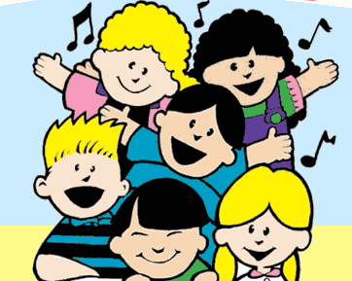

Rain Catcher and How Much Water Learning

I am developing a sense of size and amount by observing, exploring, using, and communicating with others about things in the world around me **MNU 0-01a**

* Checks estimates by counting.
* Demonstrates skills of estimation in the contexts of number and measure using relevant vocabulary, including less than, longer than, more than and the same.

I have experimented with everyday items as units of measure to investigate and compare sizes and amounts in my environment, sharing my findings with others. **MNU 0-11a**

* Shares relevant experiences in which measurements of lengths, heights, mass and capacities are used, for example.
* Describes common objects using appropriate measurement language, including tall, heavy and empty.
* Compares and describes lengths, heights, mass and capacities using everyday language, including longer, shorter, taller, heavier, lighter, more and less. • Estimates, then measures, the length, height, mass and capacity of familiar objects using a range of appropriate non-standard units.

I can collect objects and ask questions to gather information, organising and displaying my findings in different ways. ***MNU 0-20a***

* Asks simple questions to collect data for a specific purpose.
* Collects and organises objects for a specific purpose.
* Applies counting skills to ask and answer questions and makes relevant choices and decisions based on the data.
* Contributes to concrete or pictorial displays where one object or drawing represents one data value, using digital technologies as appropriate

To help care for the environment, I reduce, re-use and recycle the resources I use. **TCH 0-06a**

* Understands what can be reduced, re-used, and recycled

Together we can keep Scotland beautiful.

