# Cake pops

Week beginning 18th May 2020

Recipe from <https://www.bbcgoodfood.com/recipes/cake-pops>

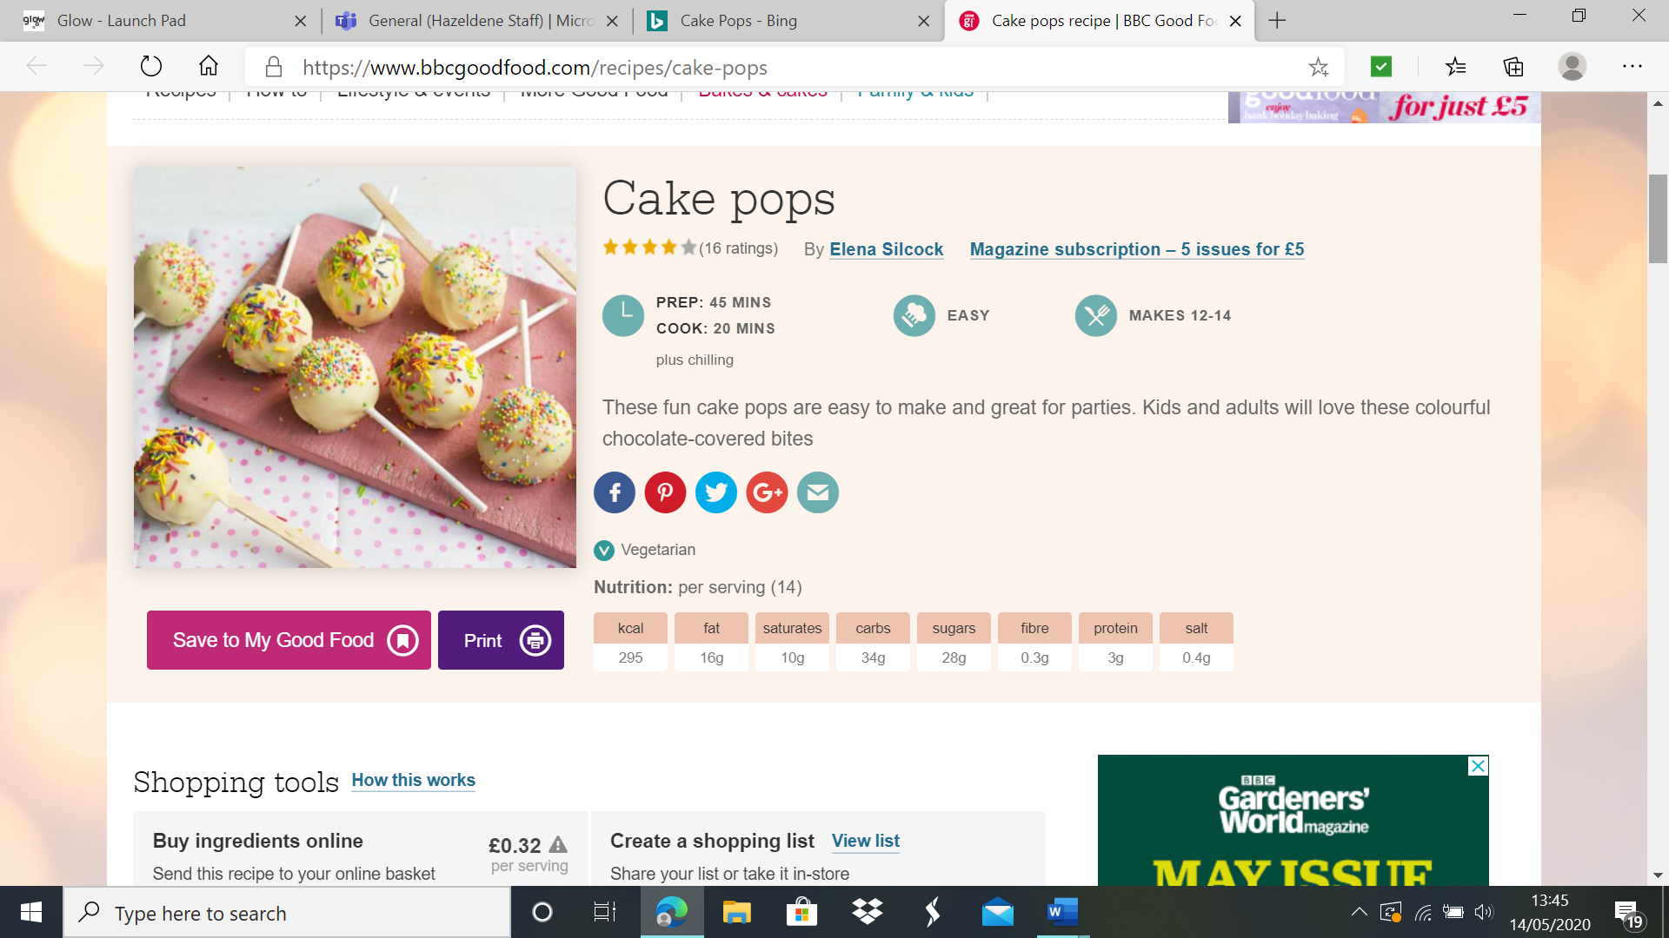





Ingredients for the Buttercream:

* 75 grams butter
* 150 grams icing sugar
* ½ tsp vanilla extract
* 1 tbsp milk
* 200 grams white chocolate melted to dip.
* Sprinkles to dip

Ingredients for the cake:

* 100 grams of butter
* 100 grams of caster sugar
* ½ tsp vanilla extract
* 2 eggs
* 100 grams self-raising flour

Method

1. First make the cake. Heat oven to 190C/170C fan/gas 5. Grease and line the base of a 20cm sandwich tin. Place the butter, sugar and vanilla extract into a bowl and beat well to a creamy consistency. Slowly beat in the eggs, one by one, then fold in the flour and mix well. Tip into the cake tin and bake for about 20 mins until risen and golden brown. Set aside to cool completely.
2. While the cakes are cooling, make the buttercream. In a large bowl or the bowl of a food mixer, beat the butter and icing sugar together until smooth. Add the vanilla extract and milk and beat again.
3. Once the cake is cooled, crumble into large crumbs. Add the buttercream and stir together. Take chunks of the cake mixture and roll into balls, transferring each ball to a lined tray or plate. Push a lollypop stick into each, then put into the fridge for an hour to set.
4. Melt the white chocolate in the microwave, on a high heat and stirring at 10 seconds intervals until smooth. Tip the sprinkles into another bowl.
5. Take each of the chilled cake pops and dip into the white chocolate, allowing it to drip off a little over the bowl. Dip into the sprinkles, then stand upright in a mug to dry at room temperature for an hour, or in the fridge for 30 mins.

***Curriculum for Excellence***

I have experimented with everyday items as units of measure to investigate and compare sizes and amounts in my environment, sharing my findings with others. MNU 0-11a

I am becoming aware of how cleanliness, hygiene and safety can affect health and wellbeing. HWB 0-33a

Skills Developed

* Shares relevant experiences in which measurements of lengths, heights, mass and capacities are used, for example, in baking.
* Describes common objects using appropriate measurement language, including tall, heavy and empty.
* Compares and describes lengths, heights, mass and capacities using everyday language, including longer, shorter, taller, heavier, lighter, more and less.
* Estimates, then measures, the length, height, mass and capacity of familiar objects using a range of appropriate non-standard units.
* Demonstrates how to perform daily hygiene routines, for example, hand washing.
* Gets ready to prepare food, for example, wash hands, tie hair back, wear an apron.
* Demonstrates an understanding of basic food hygiene and safety through, for example, washing fruit and vegetables, storing perishables in the fridge.
* 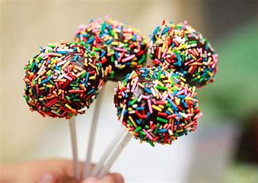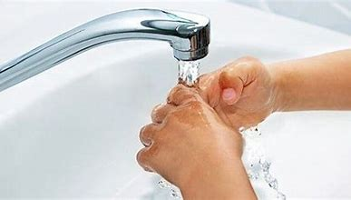Works safely when using simple kitchen equipment.