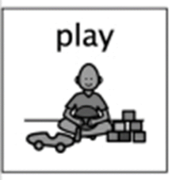
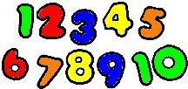
Hiding and Finding Numbers

Hiding and finding is a game often enjoyed by many children. Having fun in this way fits very nicely with learning to recognise numerals. You and your child can make a set of numbers using whatever materials you have to hand (paper/card/recycled boxes or packaging/pens/chalk etc You could make a set of number pebbles if these are available to you.)
You can hide the numbers around the house or garden, giving the child clues –“You’re getting warmer/colder” as they search for a number. Alternatively, little boxes with lids or upturned plant pots containing the hidden numbers ignites curiosity. The children will enjoy the discovery as they open the lid or lift the pot! You can use clues here also saying, “This number is the one after3 (or before 6 or between 8 and 10) etc.” to extend the learning.
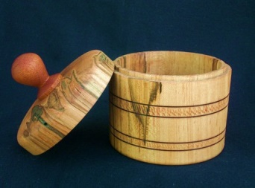


You know best the amount of challenge to meet the needs of your child. Once the numbers have been found, you could make a little washing line to hang them in sequence! You can ask your child to close their eyes and you can remove a number or mix them up. Children love finding deliberate mistakes!
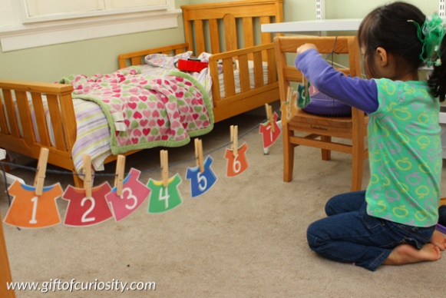
I have explored numbers, understanding that they represent quantities, and I can use them to count create sequences and describe order. MNU 002a

Skills include -

- Distinguish numbers from letters.
- Recognise numerals from zero.
- Sequencing numbers in order from zero.
- Identifying the number ‘before’ and ‘after’
- Identifying a missing digit from a sequence.

https://www.topmarks.co.uk/ordering-and-sequencing/caterpillar-ordering

