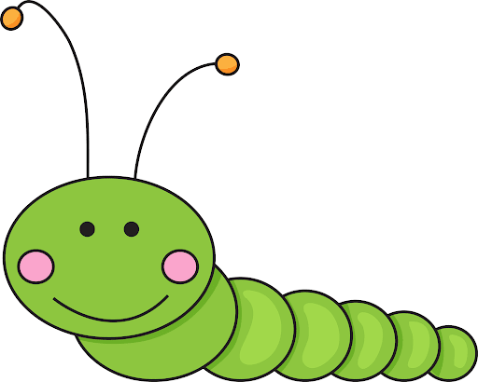
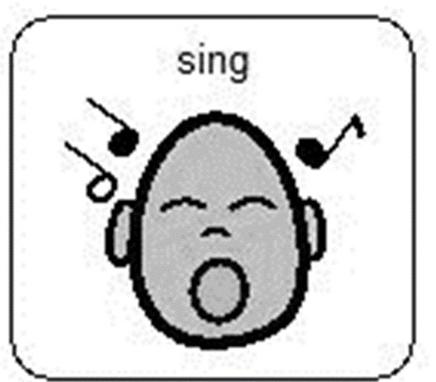

Song of the week
Week beginning 4th May 2020.
(sung to the tune of She’ll Be Coming Round the Mountain)
(sung to the tune of She’ll Be Coming Round the Mountain)
There’s a tiny caterpillar on a leaf (wiggle, wiggle)
There’s a tiny caterpillar on a leaf (wiggle, wiggle)
There’s a tiny caterpillar, tiny caterpillar,
There’s a tiny caterpillar on a leaf (wiggle, wiggle)
He will eat the leaves around him ‘til he’s full (munch, munch)
He will eat the leaves around him ‘til he’s full (munch, munch)
He will eat the leaves around him, eat the leaves around him
He will eat the leaves around him ‘til he’s full (munch, munch)
A cocoon is what he’s spinning for his home (spin, spin)
A cocoon is what he’s spinning for his home (spin, spin)
A cocoon is what he’s spinning, cocoon is what he’s spinning,
A cocoon is what he’s spinning for his home (spin, spin)
Then he’ll be a butterfly and fly away (flap, flap)
Then he’ll be a butterfly and fly away (flap, flap)
Then he’ll be a butterfly, be a butterfly,
Then he’ll be a butterfly and fly away (flap, flap

So that tiny caterpillar went like this wiggle, wiggle, munch, munch, spin, spin, flap, flap.
So that tiny caterpillar went like this wiggle, wiggle, munch, munch, spin, spin, flap, flap.
So that tiny caterpillar, tiny caterpillar, tiny caterpillar went like this
Wiggle, wiggle, munch, munch, spin, spin, flap, flap.

During this term at Hazeldene we would be looking at the life cycle of a caterpillar/butterfly. There is an activity sheet available to further consolidate your child’s learning. We love singing this song in the nursery and hope you enjoy singing it with your child. Remember to join in with the actions:
Tiny caterpillar on a leaf – put your palm out (Leaf) and using you index finger (caterpillar) wiggle it over your palm. And wiggle your whole body.
He will eat the leaves around him munch munch – using your hands pretend you are eating leaves put them up to your mouth.
A cocoon is what he is spinning - using your arms spin them round and round.
He will be a butterfly and fly away – create a butterfly using your hands and make it fly away (this can be tricky).

To extend learning, ask you child what sounds they can hear in the song. Are there any rhyming words they can think of that will rhyme with home, fly etc.? Ask your child, “what do you think caterpillars need to grow?”

Curriculum for Excellence
I enjoy exploring and playing with the patterns and sounds of language and can use what I learn. LIT 1-01a / LIT 2-01a

I am learning about where living things come from and about how they grow, develop and are nurtured. HWB 0-50a / HWB 1-50a

Skills developed
- Hears and says patterns in words.
- Hears and says rhyming words and generates rhyme from a given word.
- Hears and says the different single sounds made by letters.
- Hears and says letter blends/sounds made by a combination of letters.
- Participates actively in songs, rhymes and stories.
- Gives examples of where living things come from, for example, plants from seeds, fish from eggs.
- Explains that living things need food, water and care to grow and survive.

You can order caterpillars and watch them develop into butterflies. These can be purchased from
https://www.insectlore.co.uk/
