# Missing Number

Write out numbers 0 to 10 (and beyond) leaving some of the numbers out for example 0, 1, 2, 3, 5, 6, 8, 9 , 10. (You can write on any material you have in the house; paper, lollipop sticks, carboard etc.) If you have any clothes pegs free (Or any other material that works) write out the missing numbers onto the pegs for the example these numbers would be 4 and 7, children can have great fun putting the pegs into the correct number sequence. You can also try doing it with the numbers going backwards.

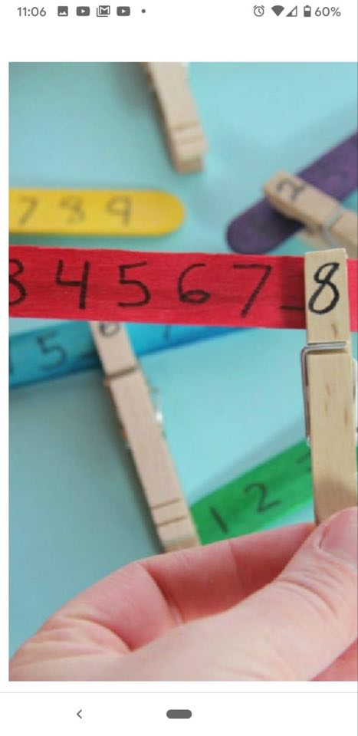 Curriculum for Excellence

I have explored numbers, understanding that they represent quantities, and I can use them to count, create sequences and describe order. MNU 0-02a

Skills developed

* Explains that zero means there is none of a particular quantity and is represented by the numeral
* Recalls the number sequence forwards within the range 0 – 10 and beyond , from any given number.
* Recalls the number sequence backwards from 10 and beyond .
* Identifies and recognises numbers from 0 to 10 and beyond.
* Orders all numbers forwards and backwards within the range 0 – 10 and beyond
* 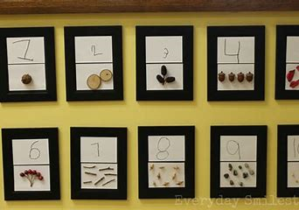 Identifies the number before, the number after and missing numbers in a sequence within 10 and beyond.