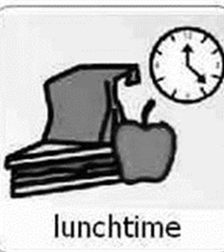
Mini Pizza Quiches

Recipe from : https://www.bbcgoodfood.com/recipes/mini-pizza-quiches

Similar to breakfast time routine, children enjoy helping out and preparing snack at Hazeldene. To lead from their interests, it can be fun to bake and cook meals with your child. They develop many skills through cooking and baking including listening; talking and (pre)reading (as they follow the recipe); communicating with each other about cooking or socially; developing deeper thinking and mathematical skills (measuring out ingredients, sizes, amounts, estimating, simple addition and subtraction) and learning about maintaining a healthy balanced diet. Children may be willing to try new foods if they have been involved in the preparation.

YOU CAN USE ANY RECIPE OF YOUR CHOICE but here is an idea:
Ingredients
2 Large Tortilla Wraps
4 eggs
Selection of chopped vegetables
3 cherry tomatoes, halved
Handful of basil leaves (If you have them)
Vegetable sticks (for serving)
Salami (OPTIONAL)

Nutritional information –
You could have a chat with your child about what the different nutritional categories mean and have a look at the eatwell plate together.

Method
- Heat oven to 180C/160C fan/gas 4. Using a 12cm cutter (or a small plate) cut circles from the large tortilla wraps – you should get 6. Use the circles to line 6 holes of a muffin tin, pushing them into the holes to make cases.
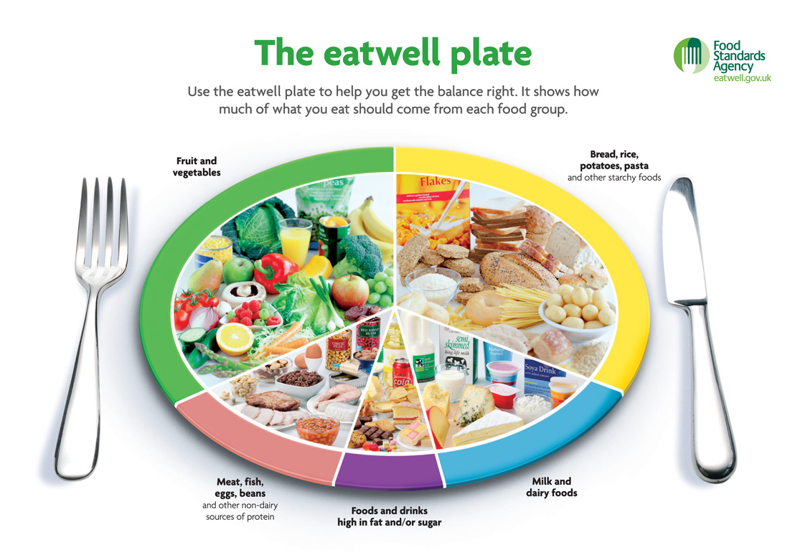
- Beat the eggs and pour into the tortilla cases ,you can add some chopped vegetables too, Top each case with a slice of salami (if you like ) and 1/2 a cherry tomato. Bake for 15 mins until the egg has set. Top with a few basil leaves, if you like, and serve with extra tomatoes and vegetable sticks.
I enjoy eating a diversity of foods in a range of social situations HWB 0-29a
Curriculum for Excellence
I am becoming aware of how cleanliness, hygiene and safety can affect health and wellbeing and I apply this knowledge in my everyday routines such as taking care of my teeth. HWB 0-33a / HWB 1-33a
I have experimented with everyday items as units of measure to investigate and compare sizes and amounts in my environment, sharing my findings with others. MNU 0-11a
I explore and discover where foods come from as I choose, prepare and taste different foods. HWB 0-35a
Together we enjoy handing, tasking, talking and learning about different foods, discovering ways in which eating and drinking may help us to grow and keep healthy HWB 0-30a

I am developing a sense of size and amount by observing, exploring, using and communicating with others about things in the world around me. MNU 0- 01a.

As I listen and talk in different situations, I am learning to take turns and am developing my awareness of when to talk and when to listen. LIT 0-02a / ENG 0-03a

Skills developed
- Eats socially with others.
- Recognises that we eat different foods at different times of the day and on different occasions.
- Prepares and tastes a range of familiar and unfamiliar foods.
- Recognises and respects that others’ food choices may be different from their own.
- Recognises that eating more of some types of foods and less of others is good for health.
- Identifies, prepares and tastes a range of foods, for example, fruit, vegetables.
- Demonstrates how to perform daily hygiene routines, for example, hand washing,
- Gets ready to prepare food, for example, wash hands, tie hair back, wear an apron.
- Describes which foods come from plants and which come from animals when working with and tasting foods.
- Recognises the number of objects in a group, without counting (subitising) and uses this information to estimate the number of objects in other groups.
- Checks estimates by counting.
- Demonstrates skills of estimation in the contexts of number and measure using relevant vocabulary, including less than, longer than, more than and the same.
- Shares relevant experiences in which measurements of lengths, heights, mass and capacities are used, for example, in baking.
- Describes common objects using appropriate measurement language, including tall, heavy and empty.
- Compares and describes lengths, heights, mass and capacities using everyday language, including longer, shorter, taller, heavier, lighter, more and less.
- Estimates, then measures, the length, height, mass and capacity of familiar objects using a range of appropriate non-standard units.
- Makes an attempt to take turns when listening and talking in a variety of contexts.
- Makes an attempt to use appropriate body language when listening to others, for example, eye contact.
- Listens and responds to others appropriately.
- Asks questions and responds relevantly to questions from others.
- Follows and gives simple instructions.

