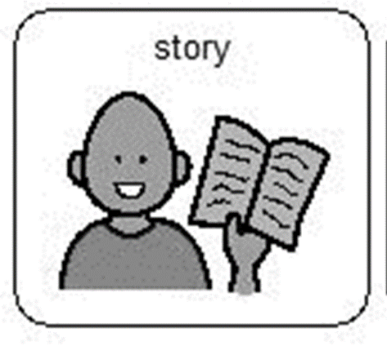
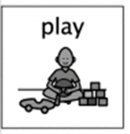
Life cycle of a butterfly

Usually during this time at Hazeldene, we would begin looking at the life cycle of a butterfly. We would be getting our caterpillars and learning about how to care for them. The children would observe the caterpillars as they grow and become beautiful butterflies.

To begin this activity, you could listen to the story The Very Hungry Caterpillar by Eric Carle. There is a nice animation of the story available on YouTube https://www.youtube.com/watch?v=75NQK-Sm1YY
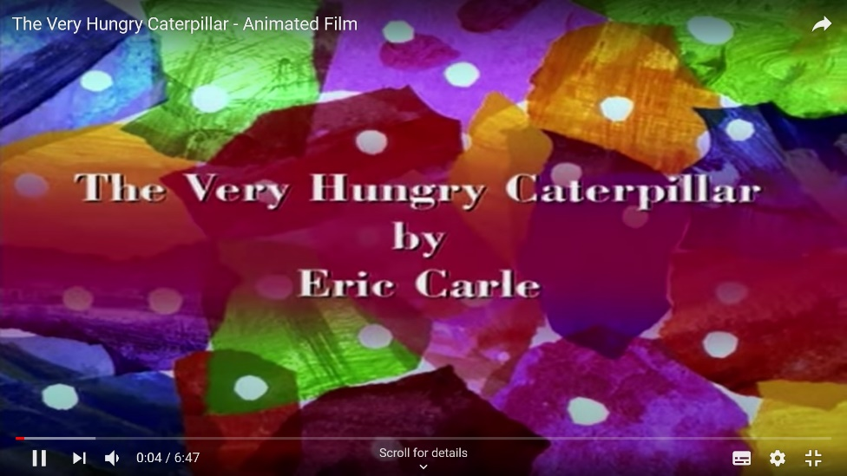

If you have the book at home, you could read this to your child. Talk with your child about the title, the spine of the book, the blurb which gives a summary on the back. Shob them that in English print is read from left to right. Discuss the role of the author, illustrator and publisher. Before reading the story ask your child what they already know about caterpillars. Whilst reading the story look at the different letters and words in the story. Do any words rhyme? Can they find any letters they are familiar with? To consolidate your child’s learning, ask them to retell the story in their own words. (Not all facts need to be accurate) Invite them to draw or write their version of the story on a piece of paper. Revisit the story and the themes that occur within the story. If possible, look for other stories about caterpillars and butterflies.

In the garden you can go on a bug hunt to see if there are any signs of a caterpillar being in your garden (remembering to take care of little bugs and return them back to their homes).

To extend the learning experience, together you can create a butterfly feeder and watch to see if there are any visitors. Instructions are below.

I heart crafty things on Facebook have a nice video on how to make a caterpillar craft – here is a link to the video instructions https://www.facebook.com/123363624425953/videos/663651031078735/
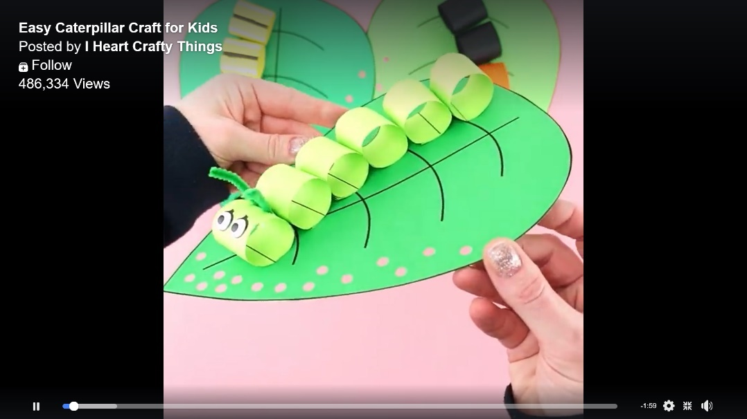

Curriculum for Excellence
I am learning about where living things come from and about how they grow, develop and are nurtured. HWB 0-50a / HWB 1-50a
I enjoy exploring and choosing stories and other texts to watch, read or listen to, and can share my likes and dislikes. LIT 0-01b / LIT 0-11b

I enjoy exploring events and characters in stories and other texts, sharing my thoughts in different ways. LIT 0-01c
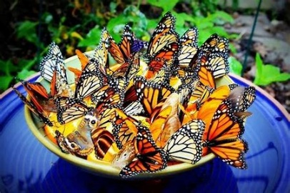
I listen or watch for useful or interesting information and I use this to make choices or learn new things. LIT 0-04a

I have the freedom to discover and choose ways to create images and objects using a variety of materials. EXA 0-02a
As I play and learn, I enjoy exploring interesting materials for writing and different ways of recording my experiences and feelings, ideas and information. LIT 0-21b
To help me understand stories and other texts, I ask questions and link what I am learning with what I already know. LIT 0-07a / LIT 0-16a / ENG 0-17a

Skills developed

- Participates actively in songs, rhymes and stories.
- Chooses a story or other texts for enjoyment, making use of the cover, title, author and/or illustrator.
- Engages with and enjoys watching, reading or listening to different texts, including stories, songs and rhymes, and can share likes and dislikes.
- Engages with stories and texts in different ways, for example, retelling/re-enacting stories and/or using puppets/props.
- Asks questions and responds relevantly to questions from others.
- Asks and answers questions about texts to show and support understanding
- Makes simple predictions about texts.
- Uses new vocabulary and phrases in different contexts, for example, when expressing ideas and feelings or discussing a text.
- Relates information and ideas from a text to personal experiences.
- Shares feelings, experiences, information, messages or ideas in pictures, print or digital texts.
- Listens and responds appropriately to others in a respectful way, for example, by nodding or agreeing, asking and answering questions.
- Identifies the main ideas of texts
- Gives examples of where living things come from, for example, plants from seeds, fish from eggs.
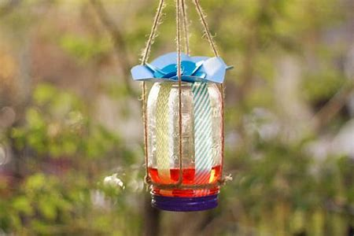
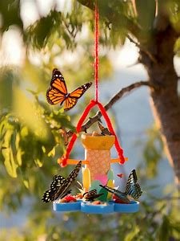
- Explains that living things need food, water and care to grow and survive.

