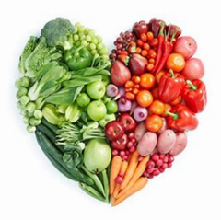
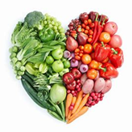
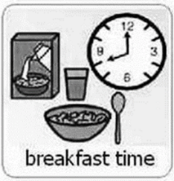

Breakfast time can be fun when children become involved in preparing their own breakfast in the morning, which will support their independence.
Invite your child to measure out their own cereal and milk using different tools for measuring (scales, measuring jug, measuring spoons). Estimating – ask them how much will be needed (too much, too little, a little more, I need a lot more). They will be developing mathematical language in everyday experiences.
If your child enjoys toast, play a game of timing how long it takes for the toast to be ready (it needs more time, Oh no that was too long - it is burnt!) By spreading their own butter or jam onto their toast, your child will be developing self-help skills and their fine motor skills as this can be tricky for little hands.
For a treat, you could make your own pancakes. On other days you could make French toast and estimate and measure ingredients. You could boil eggs and use an egg timer.
Environmental print – Look at the packages of food in kitchen. Can your child recognise different letters, sounds and words? Can they work out what’s inside the tin or package?

Curriculum for Excellence
Together we enjoy handling, tasting, talking and learning about different foods, discovering ways in which eating, and drinking may help us to grow and keep healthy. HWB 0-30a
I explore sounds, letters and words, discovering how they work together, and I can use what I learn to help me as I read and write. ENG 0-12a / LIT 0-13a / LIT 0-21a
I have experimented with everyday items as units of measure to investigate and compare sizes and amounts in my environment, sharing my findings with others. MNU 0-11a

I am aware of how routines and events in my world link with times and seasons and have explored ways to record and display these using clocks, calendars and other methods. MNU 0-10a

Skills Developed
I explore sounds, letters and words, discovering how they work together, and I can use what I learn to help me as I read and write. ENG 0-12a / LIT 0-13a / LIT 0-21a
- Can hear and say patterns in words.
- Can hear and say different single sounds made by letters.
- Can hear and say blends/sounds made by combination of letters.
- Begin to develop understanding of difference between letters, word and numerals.
- Develop and understanding of that in English we read left to right and top to bottom.
- Uses Knowledge of sight vocabulary/tricky words to real familiar words in context (Environmental Print E.G. ASDA, Pombears, Warburtons etc. )
I have experimented with everyday items as units of measure to investigate and compare sizes and amounts in my environment, sharing my findings with others. MNU 0-11a
- Shares relevant experiences in which measurement of lengths, heights, mass and capacities are used ( as they prepare their own breakfast).
- Describes using appropriate measurement language, including tall, heavy and empty.
- Compares and describes lengths, heights, mass and capacities using everyday language including longer, shorter, taller, heavier, lighter, more and less.
- Estimate, then measure, the length, height, mass and capacity of familiar objects using a range of appropriate non-standard units.
I am aware of how routines and events in my world link with times and seasons and have explored ways to record and display these using clocks, calendars and other methods. MNU 0-10a.
- Can Link daily routines to a time sequence (morning, afternoon and evening).
- Recognises , talks about and where appropriate, engages with everyday devices used to measure or display time, including clocks, calendars, sand timers and visual timetables.
Together we enjoy handling, tasting, talking and learning about different foods, discovering ways in which eating, and drinking may help us to grow and keep healthy. HWB 0-30a
- Recognises that eating more of some types of foods and less of others is good for health
- Identifies, prepares and tastes a range of foods, for example, fruit, vegetables.

These learning outcomes can be achieved through helping to make lunch and dinner also.
