1.All You need is paper and a pen 2. Cut your paper into two small piles of ten pieces.

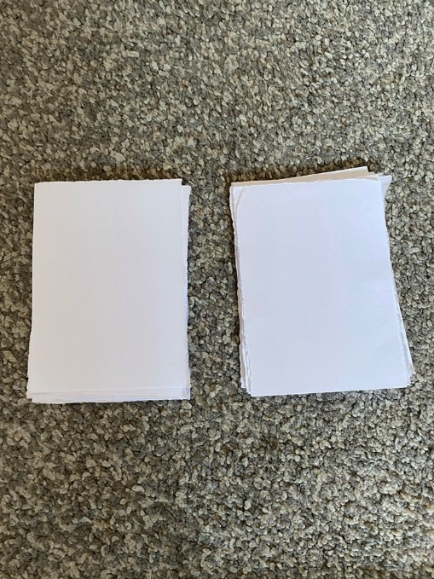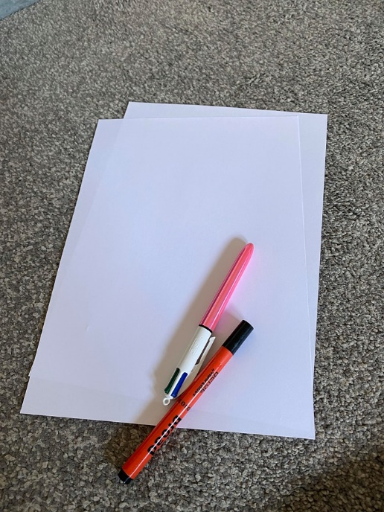

3. Write the numerals 1-10 on one set of 10. You can also try and

write the number word i.e. one, two, three etc.

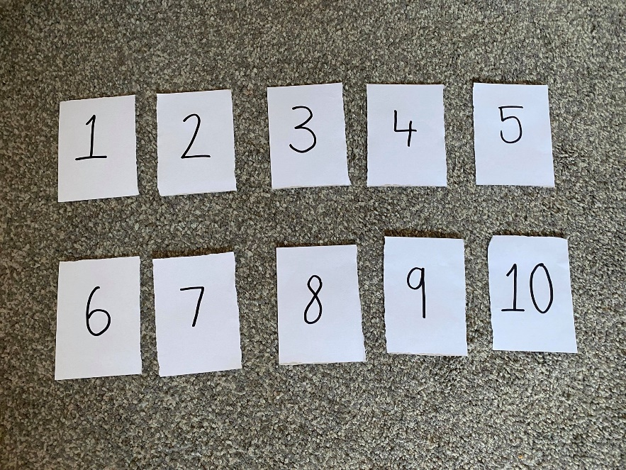

4. On the other set of 10, draw dots from one 1 to 10.

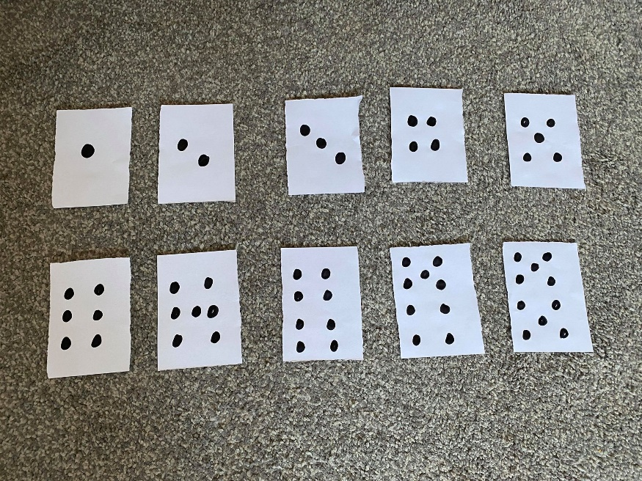

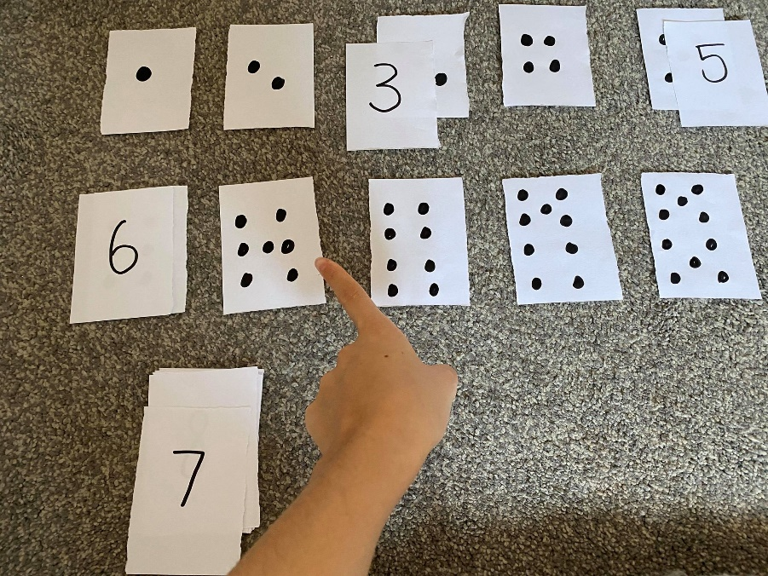

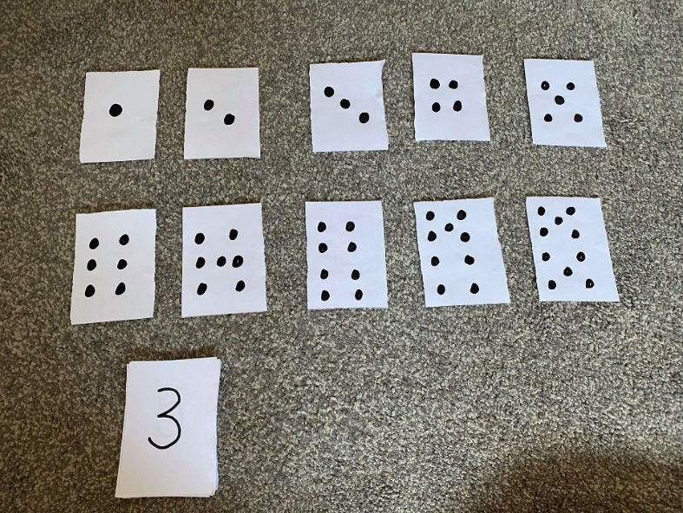5. Then have fun! Can you match the numerals to the same number of dots?

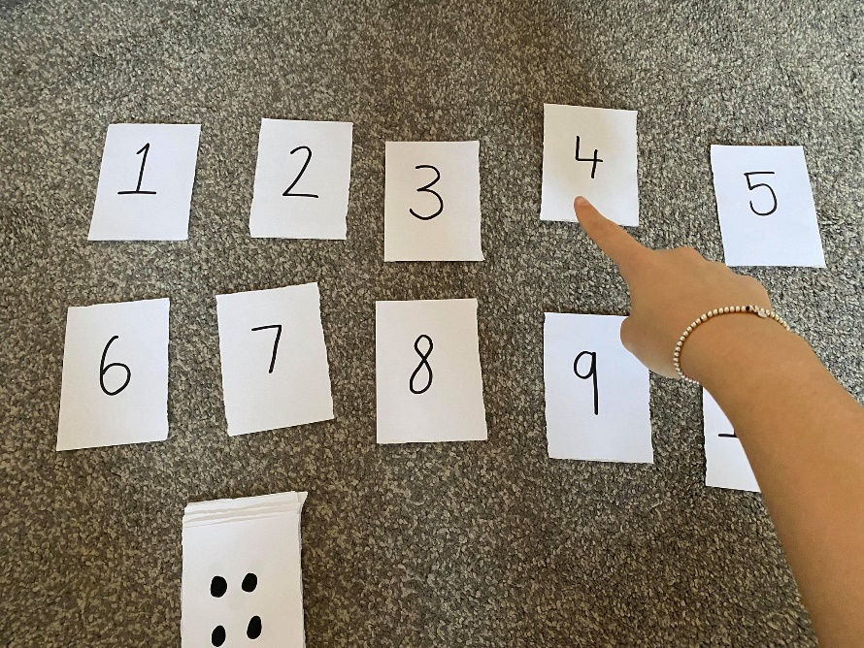

Why not challenge yourself and create more cards to a higher number? 😊

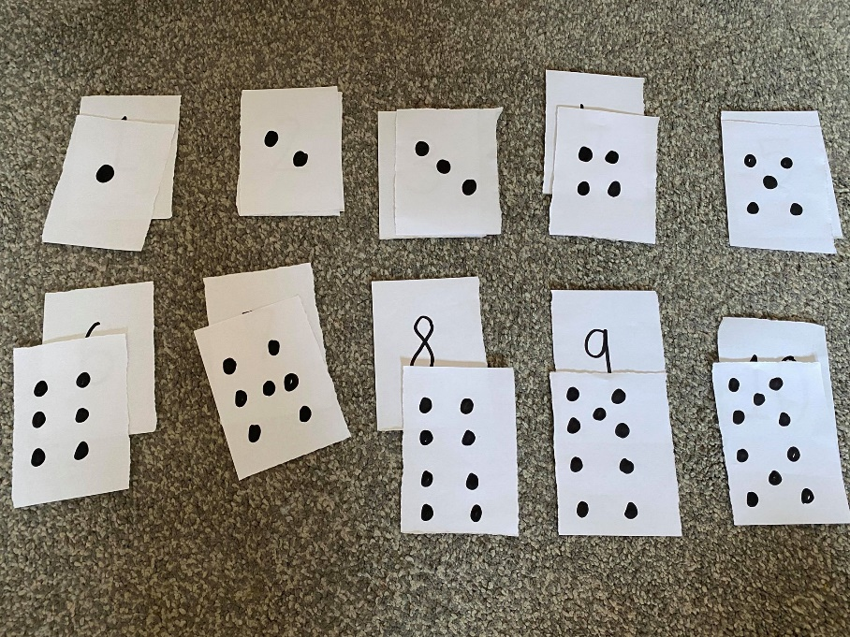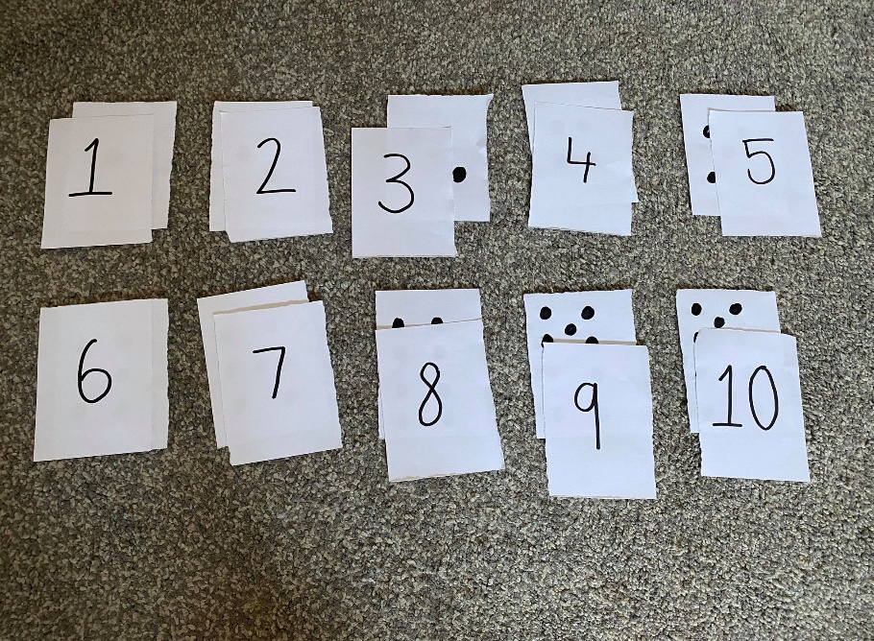 You can also try with the alphabet, matching upper- and lower-case letters i.e. Aa, Bb 😊

Courtney Russell