Material | Prediction | Results
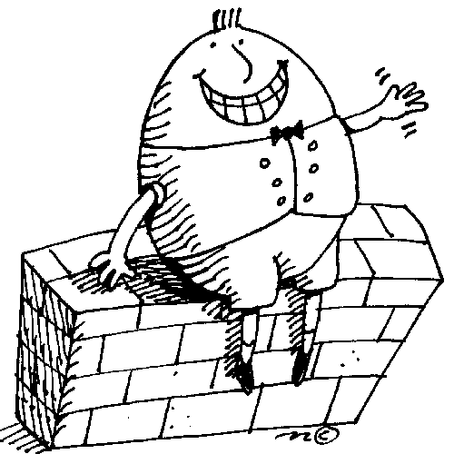
Will Humpty Dumpty crack when he falls of the wall? Fill 6 sandwich bags with different materials e.g. cornflakes. Add a boiled egg to the centre of each bag. Draw or write the material in the first column. Predict what will happen to the egg when each bag is dropped. Colour the eggs in column 2 to show if you think it will break or not. Test it out and then record the results by colouring the eggs in column 3. Enjoy eating the eggs.

