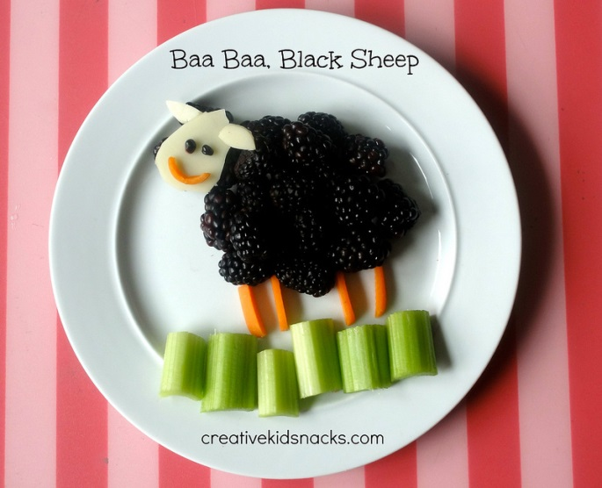
Bramble Black Sheep

Ingredients:
- handful of fresh blackberries/brambles
- 1 slice white cheddar
- 2 baby carrots
- 2 stalks celery

Directions:
- Place the brambles/blackberries in a large circle in the centre of the plate. Add a few extra blackberries where a head would be as you will use this area as a surface on which to lay the face.
- Slice a large teardrop along with two small teardrop shapes out of the white cheese. Place those on the head area to make the face and ears of your sheep.
- Slice a baby carrot in half and then into 4 thin strips out of one of the halves. Arrange the 4 strips of carrot below the sheep’s body to look like legs. Take your knife and carefully slice a little smile out of your remaining half of a baby carrot. Place the smile on the face.
- Use two tiny blackberry/bramble fruit bits for eyes, and finish the look by adding small chunks of celery to look like the grass in which the sheep is grazing.

Nutritional Benefits of this Snack
Blackberries contain Vitamin C, Vitamin A, Vitamin E, Vitamin K, Manganese and fibre. They are one of the top 10 antioxidant foods, known to contain polyphenols that helps reduce the risk of cancer and heart disease. They also help to reduce inflammation.
Celery is a fantastic source of fibre.
Carrots contain beta carotene and lots of Vitamin A which helps with eyesight. Nutrients in carrots are also linked to great skin, cleansing of the body, and lowered risk of stroke and heart disease.
http://www.creativekidsnacks.com/2013/06/11/baa-baa-black-sheep/

