One, Two, Buckle My Shoe
One, two, buckle my shoe.
Three, four, shut the door.
Five, six, pick up sticks.
Seven, eight, lay them straight.
Nine, ten, a big fat hen.
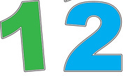
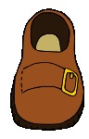
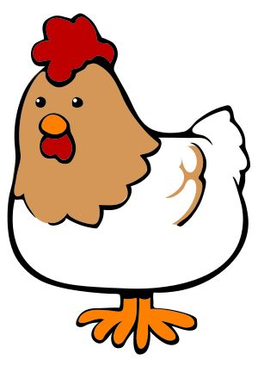
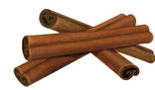
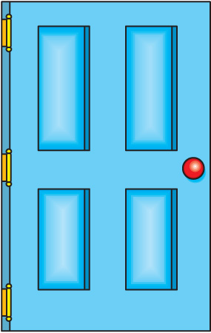
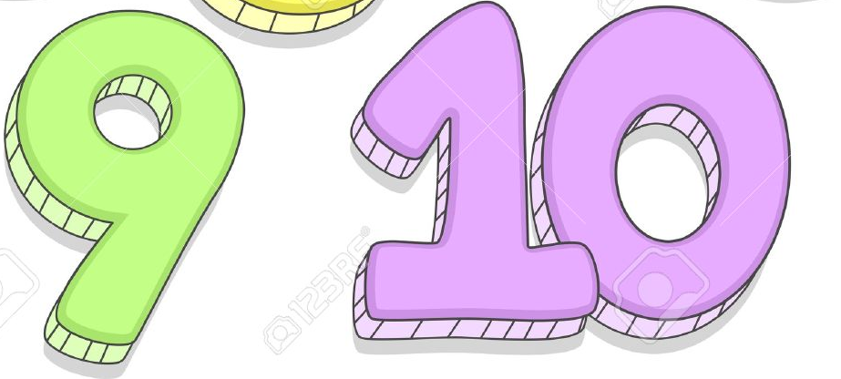
Card 25

One, Two, Buckle My Shoe
Card 25

One, two, buckle my shoe.
Three, four, shut the door.
Five, six, pick up sticks.
Seven, eight, lay them straight.
Nine, ten, a big fat hen.

