Incey Wincey Spider
You will need a flower baseboard and ladybird picture cards.
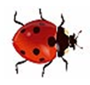
Put 6 ladybirds on one flower and 3 on the other.
How many do you have all together?
2 ladybirds fly away. How many are left?
How many different ways can you make 7 by moving the ladybirds between the 2 flowers?

Little Bo Peep

Road signs can help us to find the way.
Find some road signs with numbers near your home.
Which numerals can you see? Write them down.

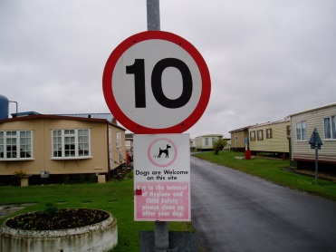
Which is the highest number?
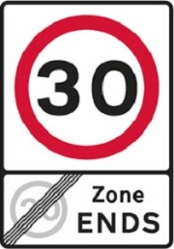
Which is the smallest?
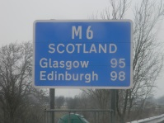
How many signs did you see?

Little Boy Blue
To make scented playdough, you will need :
2 Cups of Plain Flour
½ Cup of Salt
1 Cup of water with 3 drops of blue (or other) food colouring
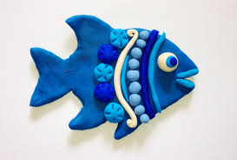
1 Tablespoon of cooking oil
1 Tablespoon of Hand Lotion
Mix all of the ingredients in a bowl.
Knead the dough until it is a soft ball.
Roll it out, cut and shape it to make models.

Twinkle Twinkle
How many different lights can you find around your home?

How many are on?

How many are off?

How many lights are in your bedroom?
Draw a picture of one.

Which is most? Which is least?
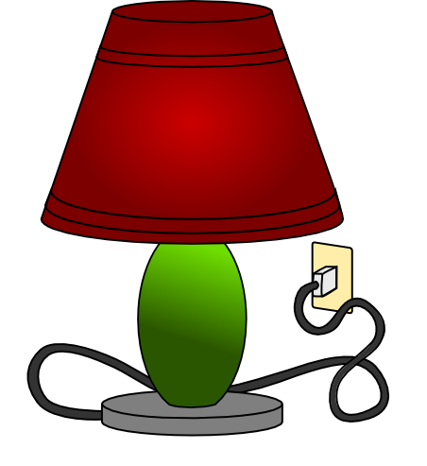

Old Mother Hubbard
How many tins of food are in your kitchen cupboard? Count them
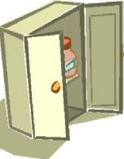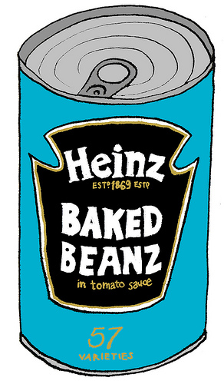
Are there more or less than 10?
How many more or less?
Which cans do you have the most of?
Draw a picture.

Two Little Dickie Birds
Say the rhyme. Use your index fingers to pretend to be the birds.
- What other names do you know which begin with P?
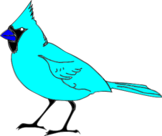
- Find objects beginning with the letter P
How many did you find?

Once I Caught a Fish Alive
You will need: Fish sorting cards, fish basket baseboards, instructions to play the game.
- Follow the instructions to play the game.
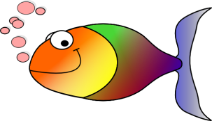
- Use the fish cards to make up patterns. Draw your own fish and decorate it with different patterns.

See-Saw, Marjorie Daw
Draw around some different coins.
Which is the largest?
Which is the smallest?

What numbers can you see?

Write them down.

Draw a picture of a brown
coin and a silver coin.
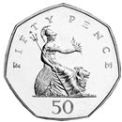
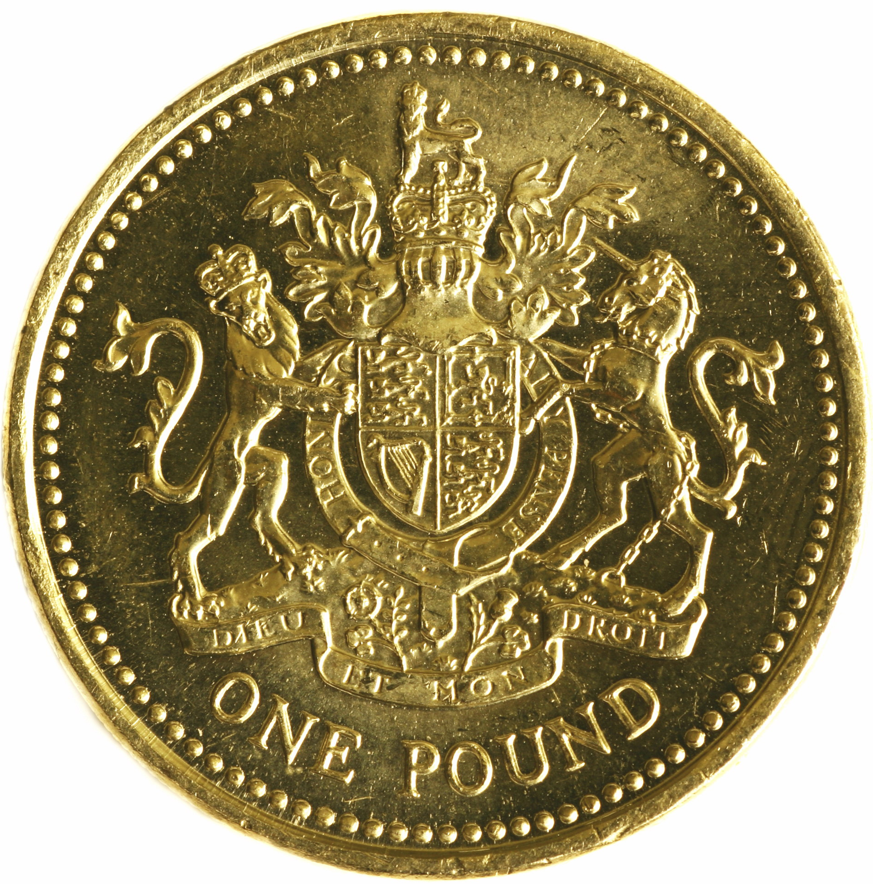

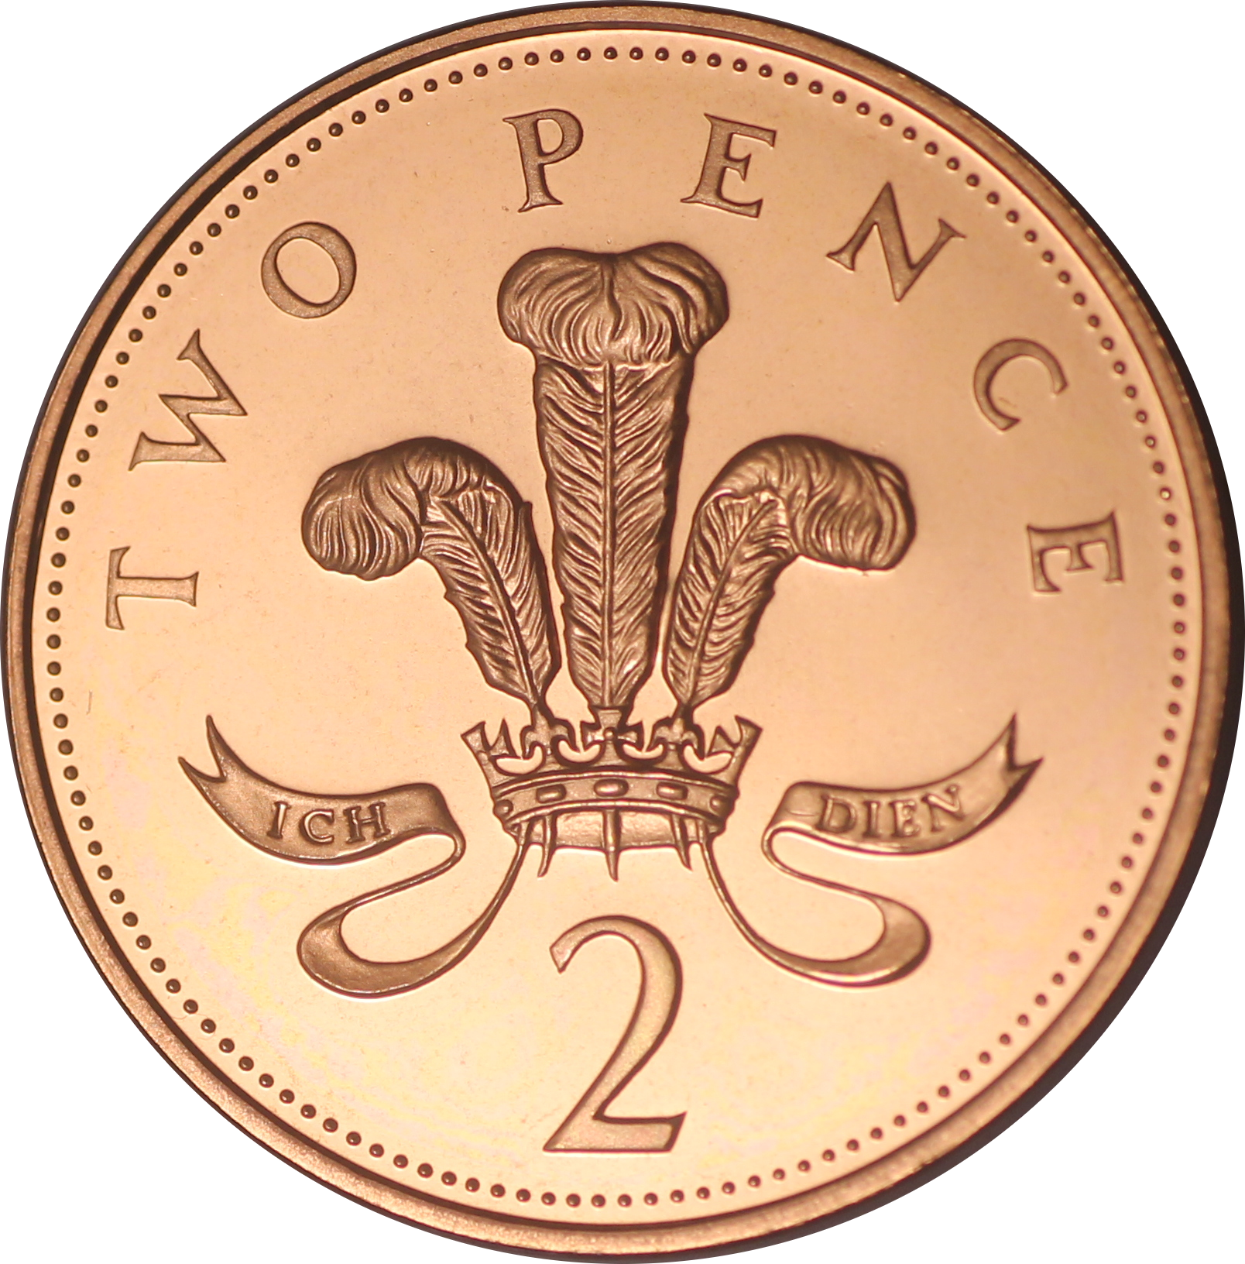
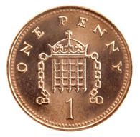
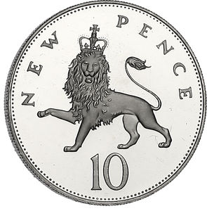

Mary, Mary, Quite Contrary
You will need some butterfly cards and a flower baseboard.

- Put 5 butterflies on one flower and 4 on the other. How many blue ones do you have?
- How many do you have all together?
- How many different ways can you make
9 by moving the butterflies between the flowers?
- Draw a butterfly and make symmetrical patterns
(mirror images) on each side.

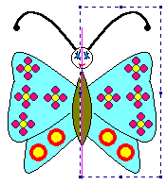

Ring-a-Ring of Rosies
Guess how many circles you can draw using a tin can on 1 piece of paper.

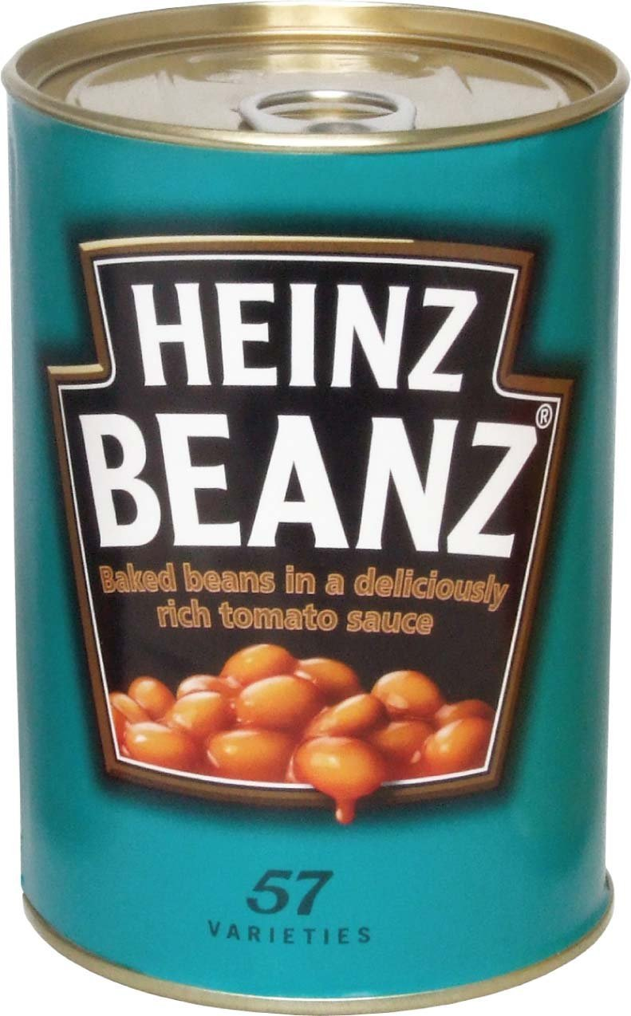
Write down your guess then draw around a tin to find out!

Were you right?

How many more or less was it?

One, Two, Buckle My Shoe
How many steps to walk from your bedroom to the kitchen?

Write down the number.

How many to walk from the kitchen to the front door?

Which is most? Which is least?

