Humpty Dumpty



You will need 6 cooled boiled eggs, 6 sandwich bags and 6 different things to fill the bags.

Fill each bag with a different material (e.g. cornflakes, cotton wool, dried beans, bubble wrap, marbles)

Place an egg in the middle of each bag and seal it.

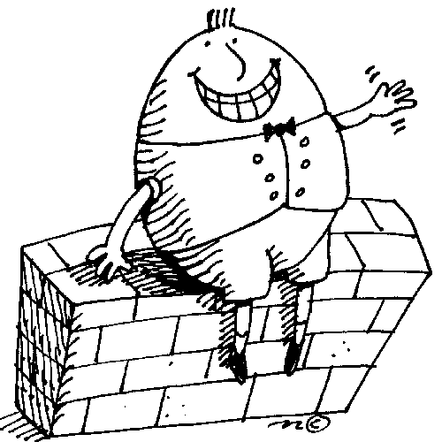Colour the first column on the Humpty Challenge sheet to predict if the egg will break if you drop the bag.

Test it and mark the results on the sheet.

Make some egg sandwiches with the eggs.

There was an Old woman



Who has the biggest shoes in your family?

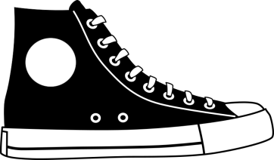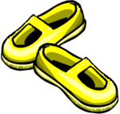

How did you find out?

Find the smallest and biggest shoes in the house.

How many times does the shortest shoe fit along the longest shoe?

Use the shoes to measure other items in your house.

Fruit stallRub a Dub Dub



You will need 6 shops baseboards, 6 sets of picture cards, price tags, penny coins

Talk about the different shops and what they sell.

Sort the picture cards into the shops which would sell these items. Could some be sold in more than on shop?

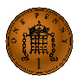

Choose a shop and put price tags on the items.

Take turns to use the penny coins to buy the items.

Look at some other examples of British coins.

How many pennies are the same value as each coin?

Wee Willie Winkie



You will need picture cards showing different times

of the day and a paper plate.

Talk about what is happening in the picture.

What happens first? What do you do next?

Use the start card at the beginning, then sort the  rest of the cards into a time line.

Use the paper plate and sort the pictures round the edges to show how the routines repeat each day.

Sort the cards into things you do in the day/night.

Are there some things which happen in both?

Hickory Dickory Dock



You will need a model clock.

The big hand points to the minutes and the little

hand points to the hour.

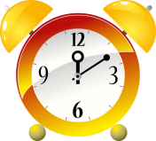When the big hand points to 12, it is “o’clock”

Set your clock to 1 o’clock.

Now set it to 3 o’clock.

Set challenges to make and read different hours.

How many different types of clock can you find in your house?

Little Miss Muffet



Find as many different spoons as you can.

Line them up in order of size.

Draw a picture of the largest spoon.

How many spoons did you find?

Write the number.

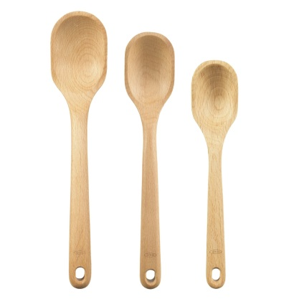

Baa Baa Black Sheep



You will need brambles, a baby

carrot, a slice of cheese, a stalk of celery.

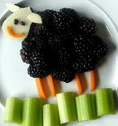

Follow the recipe card to make the black sheep.

Take a photo of your sheep or draw it before you eat it.

Jack and Jill



How many mugs of water does it

take to fill a pan?

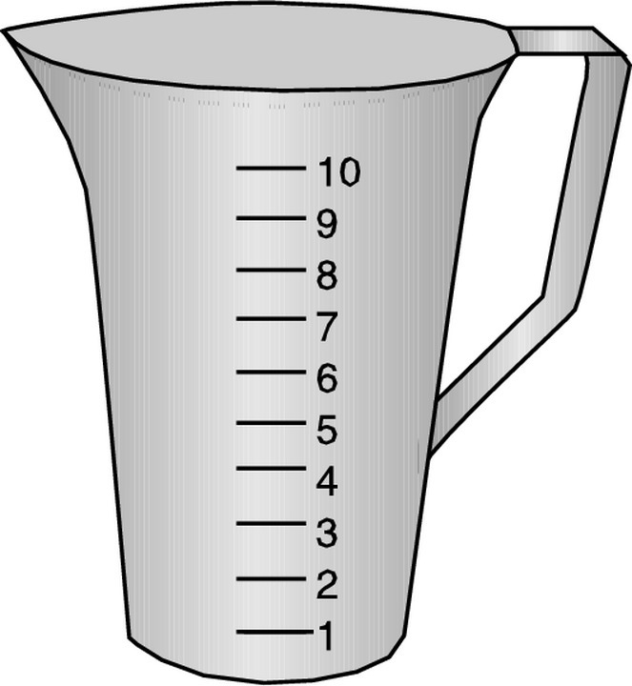

Guess how many jugs will fill a pan.

Write down your guess and then count.

Did you guess right?

How many more mugs are needed?



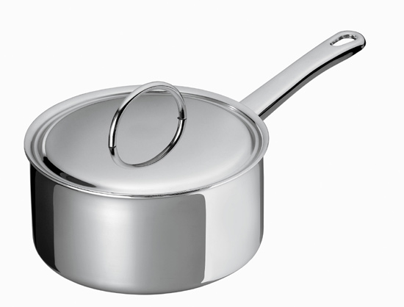

Old King Cole Bubble Prints



You will need food colour, white paper, a drinking straw, washing up liquid, container big enough to fit the paper, tap water.

Add one tablespoon of washing up liquid to one cup of water.

Pour into the container.

Add water as required to bring the depth to 6 – 12 mm or ¼ - ½ “

Add 1 drop of food colour to the mixture.

Blow gently with the straw to make bubbles.

Gently place the paper on top of the bubbles to make the print, taking care not to let it go or touch the liquid.

Leave face upwards until dry.

When it is dry, you can print another colour on top.

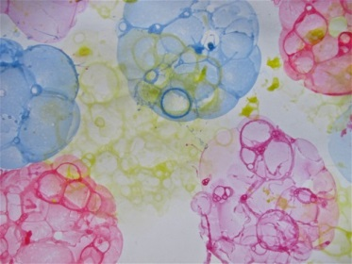

I’m a Little Teapot



**Measure the length of a table using hand spans**

How many spans long is it?

Can you guess how *wide* it is?

Measure the width with hand spans.

Can you find something which is shorter than the table?

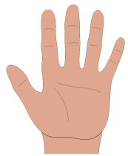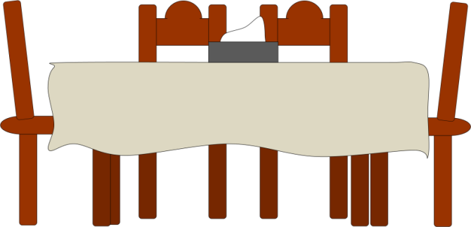

Little Jack Horner



Ask the people in your family which of these fruits they like best.

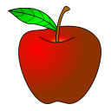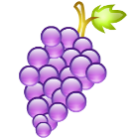Put a picutre of their chosen fruit onto the board in the colmun for that fruit.

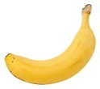Which fruit is the favourite?

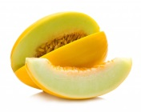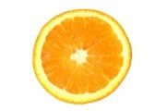How many like bananas best?

You could make a fruit salad using these fruits.

Pat–a-Cake



Follow the recipe to make your biscuits.

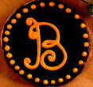What things can you find which start with the first letter of your name?

How many did you find?

Draw some of the items you found.

Hey Diddle Diddle



You will need the set of musical dominoes.

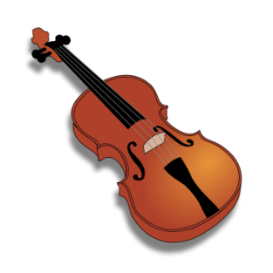

Follow the instructions to play the game.

Listen to some different types of music.

Can you name the musical instruments being played?

Make your own music using some pots and wooden spoon.

Hickety Pickety

How many different places can you see the number 3 at home?



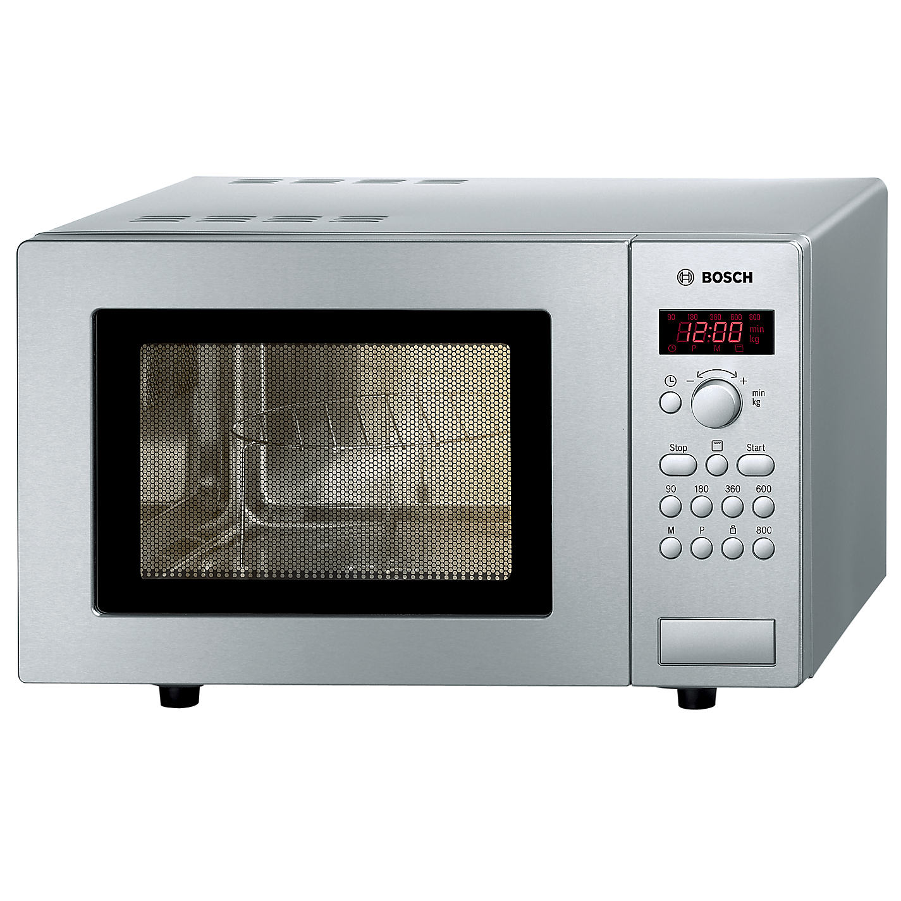

Draw a picture of all the things you can find with the number 3.

