**Card 1**

**Humpty Dumpty**

**Humpty Dumpty sat on a wall,**

**Humpty Dumpty had a great fall,**

**All the king’s horses**

**And all the king’s men,**

**Couldn’t put Humpty together again.**

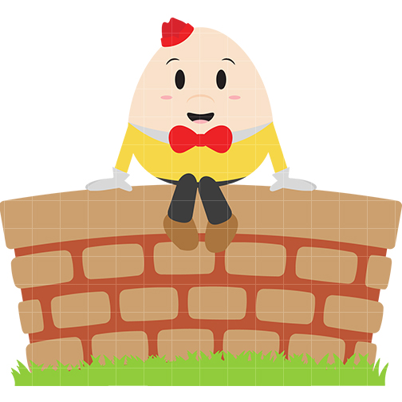

**Card 2** 2222

**The Old Woman who lived in a Shoe**

**There was an old woman,**

**Who lived in a shoe,**

**She had so many children,**

**She didn’t know what to do.**

**She gave them some broth**

**Without any bread.**

**She kissed them all gently**

**And put them to bed.**

[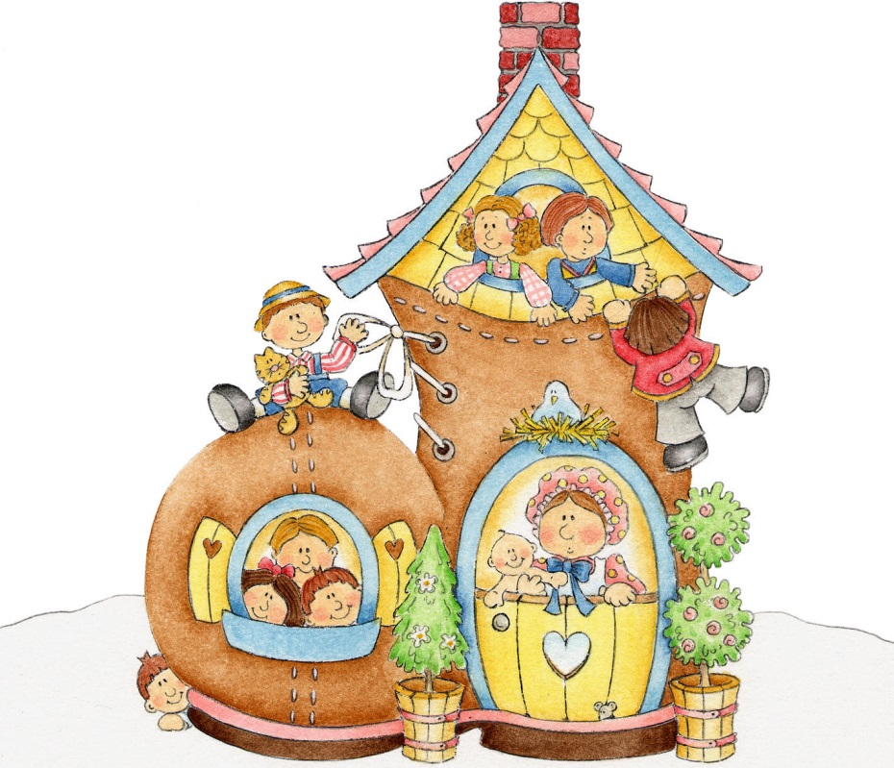](http://galleryhip.com/mother-goose-nursery-rhymes-cli)

**Card 3** 3333332222

**Rub-a-Dub-Dub**

[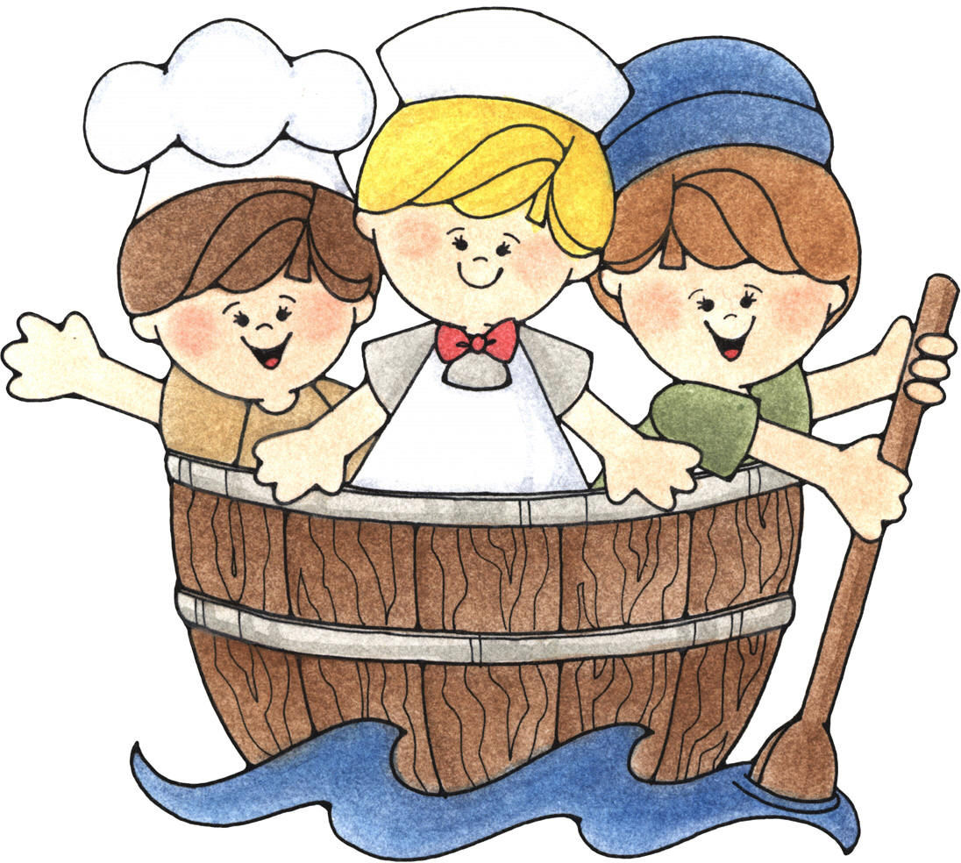](http://www.google.co.uk/url?sa=i&rct=j&q=&esrc=s&frm=1&source=images&cd=&cad=rja&uact=8&ved=0CAcQjRw&url=http://galleryhip.com/mother-goose-clip-art.html&ei=8mvLVJn2Gcr3aMDQgqAF&bvm=bv.84607526,d.ZGU&psig=AFQjCNFlkeK_fhwjH2JuTZfSW89b_kQT2g&ust=142270)

**Rub-a-Dub-Dub,**

**Three men in a tub,**

**And who do you think they be?**

**The butcher, the baker,**

**The candlestick-maker**

**And all of them went to sea.**

**Card 4** 3333332222

**Wee Willie Winkie**

**Wee Willie Winkie**

**Running through the town,**

**Upstairs and downstairs**

**In his night gown.**

**Chapping at the window,**

**Crying through the lock,**

**“Are all the children in their beds?**

**It’s past eight o’clock!”**

[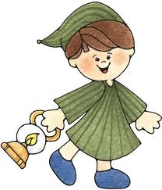](http://www.google.co.uk/url?sa=i&rct=j&q=&esrc=s&frm=1&source=images&cd=&cad=rja&uact=8&ved=0CAcQjRw&url=http://www.gopixpic.com/500/upstairs-downstairs-the-complete-series-40th-anniversary/http:%7C%7Cwww*tvshowsondvd*com%7Cgraphics%7Cnews3%7CUpstairsDownstairs_Complete40th*jpg/&ei=AGzLVI7oB5PaasrngrgM&bvm=bv.84607526,d.ZGU&psig=AFQjCNFlkeK_fhwjH2JuTZfSW89b_kQT2g&ust=142270)

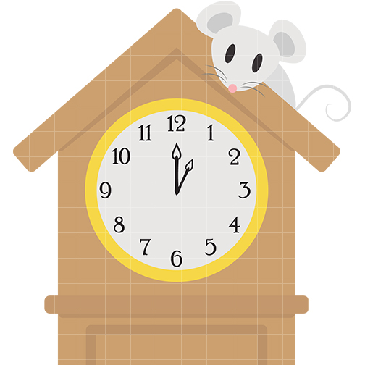

**Card 5** 3333332222

**Hickory, Dickory, Dock**

**Hickory, dickory, dock,**

**The mouse ran up the clock.**

**The clock struck one,**

**The mouse ran down.**

**Hickory, dickory, dock!**

**Card 6** 6666666666666663333332222

**Little Miss Muffet**

**Little Miss Muffet**

**Sat on her tuffet,**

**Eating her curds and whey.**

**Along came a spider**

**Who sat down beside her**

**And frightened Miss Muffet** **away!**

[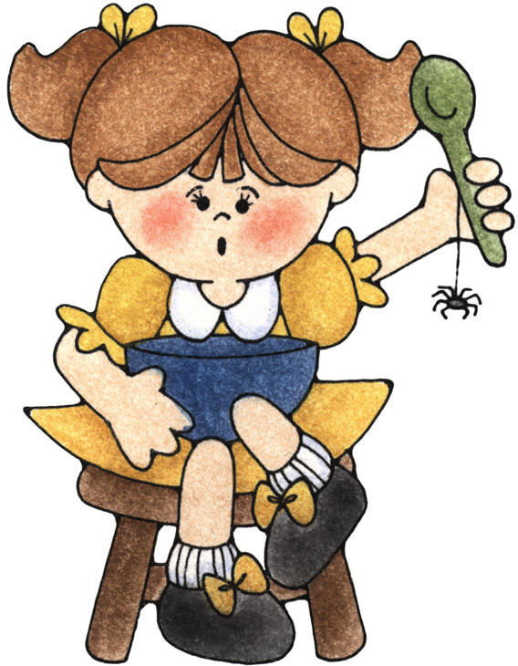](http://www.google.co.uk/url?sa=i&rct=j&q=&esrc=s&frm=1&source=images&cd=&cad=rja&uact=8&ved=0CAcQjRw&url=http://questgarden.com/145/80/3/120630181103/process.htm&ei=Z2zLVLiMIJHLaMSrgZAP&bvm=bv.84607526,d.ZGU&psig=AFQjCNHdXuBl7YAJ9_HEm4-Sz-RduXWvDA&ust=142270)

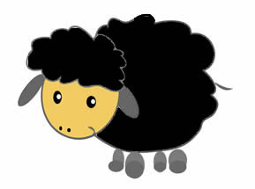

**Card 7** 6666666666666663333332222

**Baa Baa Black Sheep**

**Baa baa black sheep,**

**Have you any wool?**

**Yes sir, yes sir,**

**Three bags full.**

**One for the master,**

**One for the dame,**

**And one for the little boy**

**Who lives down the lane.**

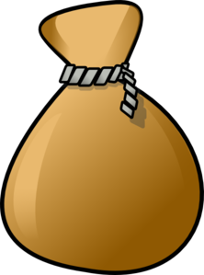

**3**

**2**

**1**

**Card 8** 6666666666666663333332222

**Jack and Jill**

**Jack and Jill went up the hill,**

**To fetch a pail of water.**

**Jack fell down and broke his crown,**

**And Jill came tumbling after.**

**Up Jack got and home did trot,**

**As fast as he could caper.**

**He went to bed to mend his head,**

**With vinegar and brown paper.**

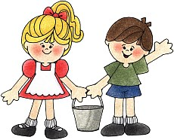

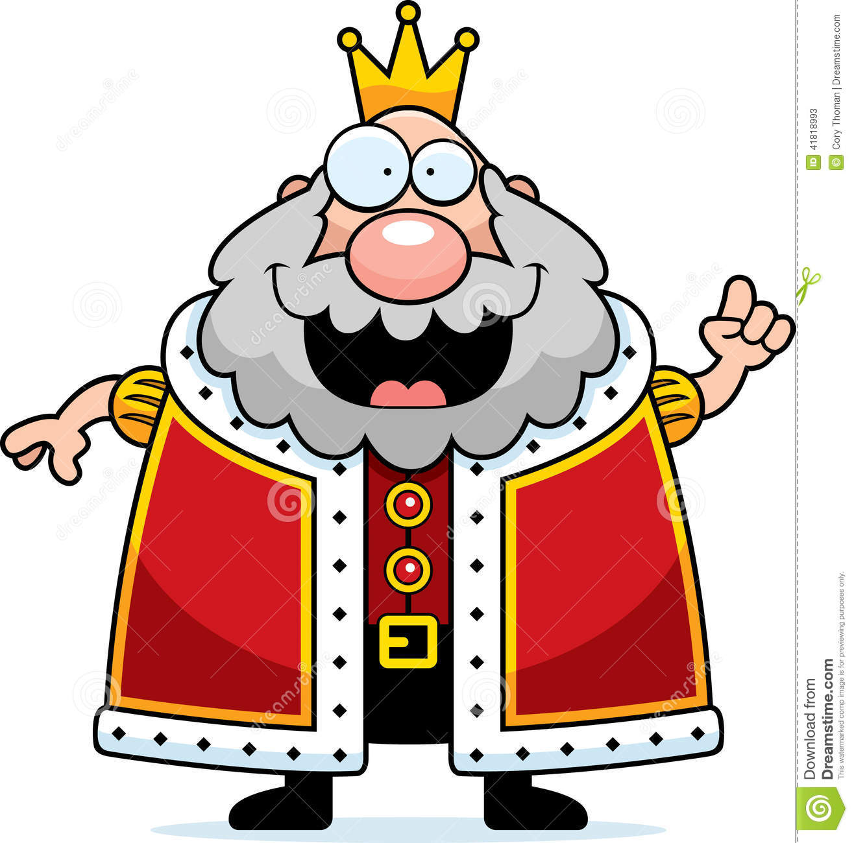

**Card 9** 6666666666666663333332222

**Old King Cole,**

**Was a merry old soul,**

**And a merry old soul was he.**

**He called for his pipe,**

**And he called for his bowl,**

**And he called for his fiddlers** **three.**

**Old King Cole**

**Card 10** 6666666666666663333332222

**I’m a Little Teapot**

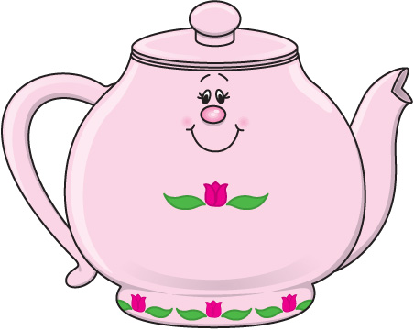

**I’m a little teapot,**

**Short and stout,**

**Here’s my handle**

**Here’s my spout.**

**When I hear the teacups,**

**Here me shout,**

**“Tip me up,**

**And pour me out!”**

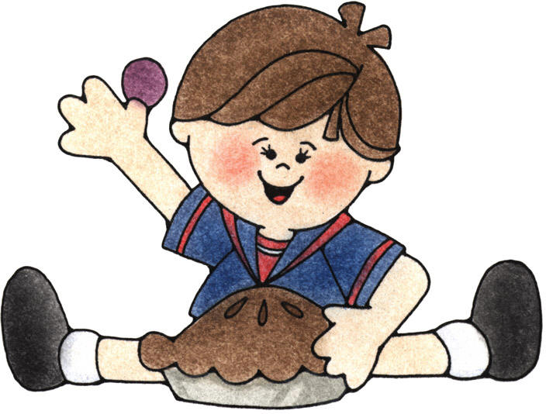

**Card 11** 6666666666666663333332222

**Little Jack Horner**

**Little Jack Horner,**

**Sat in a corner,**

**Eating a Christmas pie.**

**He put in his thumb,**

**And pulled out a plum,**

**And said,”What a good boy am I!”**

**Card 12** 6666666666666663333332222

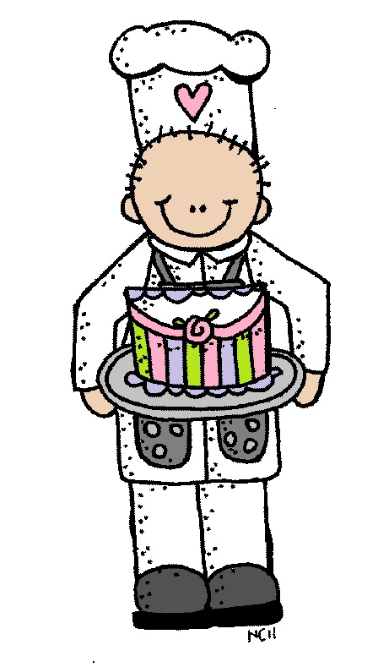

**B**

**Pat-A-Cake**

**Pat a cake, pat a cake, baker’s man,**

**Bake me a cake as fast as you can.**

**Pat it and roll it and mark it with ‘B’,**

**And put it in the oven for Baby and me!**

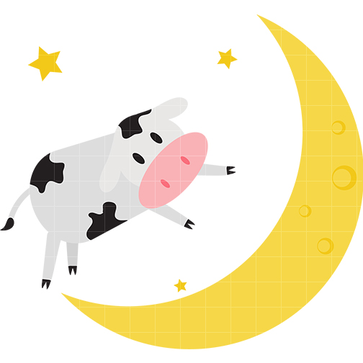

**Card 13** 6666666666666663333332222

**Hey, Diddle, Diddle**

**Card 14** 6666666666666663333332222

**Hickety, Pickety My Black Hen**

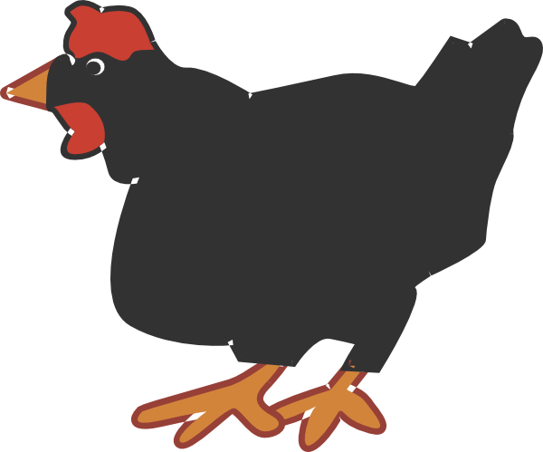

**Hickety, pickety, my black hen,**

**She lays eggs for gentlemen.**

**Sometimes nine and sometimes ten,**

**Hickety, pickety, my black hen**

**Hey, diddle, diddle,**

**The cat and the fiddle,**

**The cow jumped over the moon.**

**The little dog laughed to see such fun,**

**And the dish ran away with the spoon.**

